Basic DS Online Disclosure Guide (eBulkPlus)

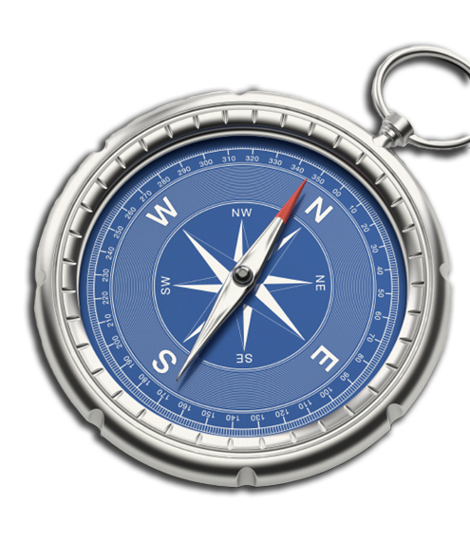
Applicant Guidance Notes

Contents
Applicant Guidance Notes 1
Logging onto the system 2
Statement of fair processing 5
Section 1 – About you 6
Section 2 – Address History 7
Section 3 – Additional Info 8
Section 4 – Confirmation and consent 9
Section 5 – Application Complete 10
Disclosure Scotland List of Acceptable Identification 11

Applicant Guidance Notes

An online basic Disclosure Scotland (DS) check can be completed by accessing the internet from any device that has this facility. This includes a smart phone, tablet, laptop or PC. It is supported on the latest versions of all modern browsers; however, we do not recommend access via Internet Explorer as this browser is unsupported both by our technology and soon by Microsoft also. If you do not own your own computer, you can go to any internet café or local library. Please be aware that you must complete your application form in full, as part completed applications form cannot be saved.

Starting your application

You can start your application one of two ways depending on how you have been invited by the employer requesting this check to be carried out on you.
Option 1 – via a direct link within an email invitation
If you have received an email invitation containing a direct link to completing your application, simply click the link contained in your email and skip to page 5 of this guide.

Option 2 – accessing our system through your browser
Please enter the following address in the web browser:
https://matrixscreening.com/xxxxx
If you are not taken directly to the ‘Start New Application’ page, please click on ‘Start Application’ in the box entitled ‘Basic Disclosure Application’ to enter the system and start your application.
You will now be taken to the basic routing screen in order to determine whether your basic applications needs to be processed by Disclosure Scotland or the DBS based on where you live/work.
For applicants based in Scotland who require a basic Disclosure Scotland check, the answers to these questions will point to ‘Scotland’.

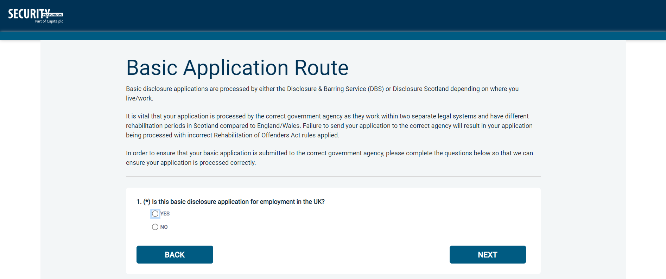
Once the questions have been answered, please click ‘Next’.

Please note at this stage of the process your login details are case sensitive.
- Enter the Organisation Reference that has been supplied to you by the company that you will be/are working for.
- Enter the Organisation Code that has been supplied to you by the company that you will be/are working for.

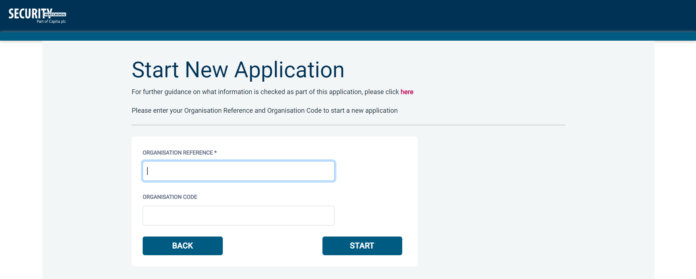

Once you have completed this section click ‘Enter’.

Statement of Fair Processing

You will now be taken to the ‘Statement of Fair Processing’ outlining the terms and conditions. Please read the statement and tick the box to confirm this has been read and agreed to.
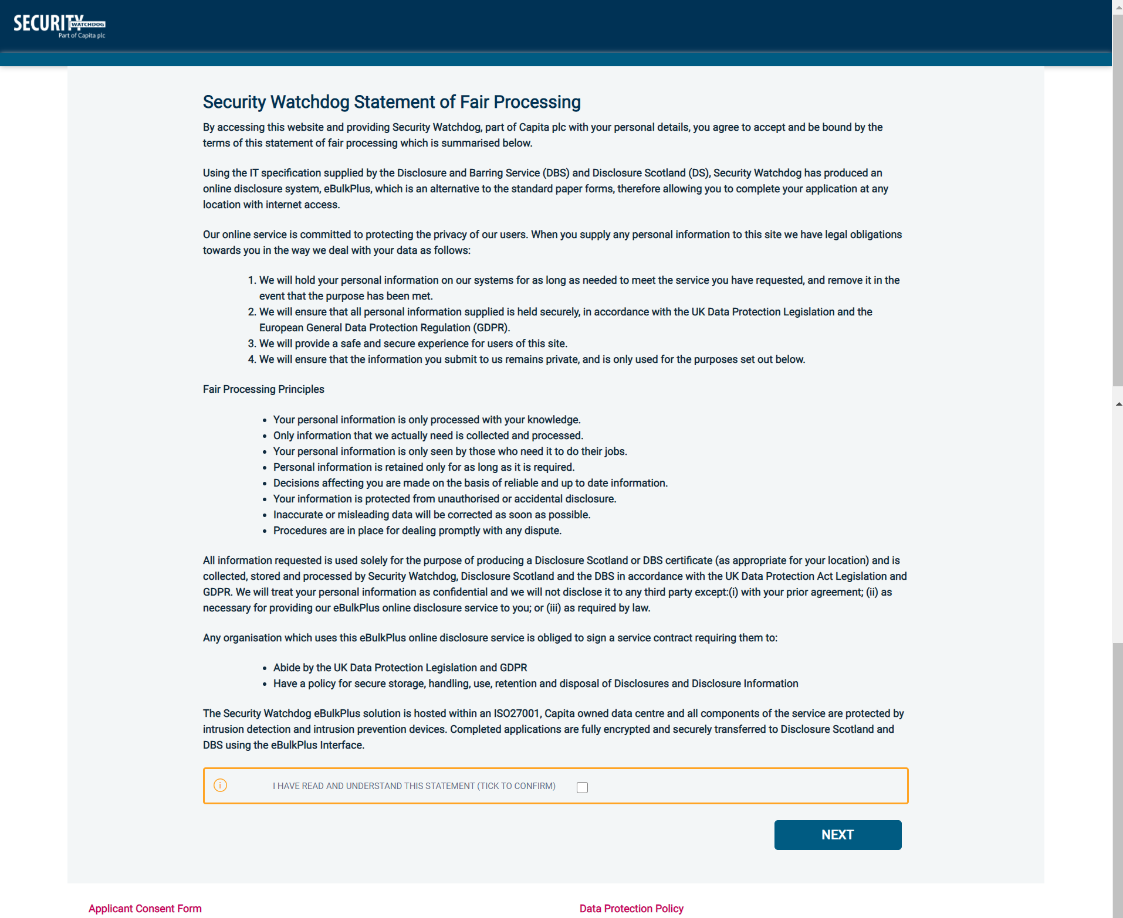
Once you have ticked the consent box please click ‘Next’
- The application form is a simple four step process. Please complete all fields.
- Mandatory fields are denoted by (*)
Mistakes on the application form will cause delays in processing

Section 1 – About you

Third Party Details
If you are completing the application on behalf of someone else, please ensure you answer ‘Yes’ to the first question within the ‘Third Party Details’ section. Please then provide your personal details within the ‘Third Party Details’ section but the details of the person you are completing it on behalf of, for the rest of the application.

Personal Details
Please enter your personal details.
If you have any middle name(s) ensure that you enter these details within the ‘Forename’ field, particularly those that appear on your identity documents, e.g. passport, driving licence, birth certificate, etc. Any missing information from this or any other section can severely delay the processing of your criminal record check.
If you are providing a contact telephone number, please DO NOT include any spaces between digits.

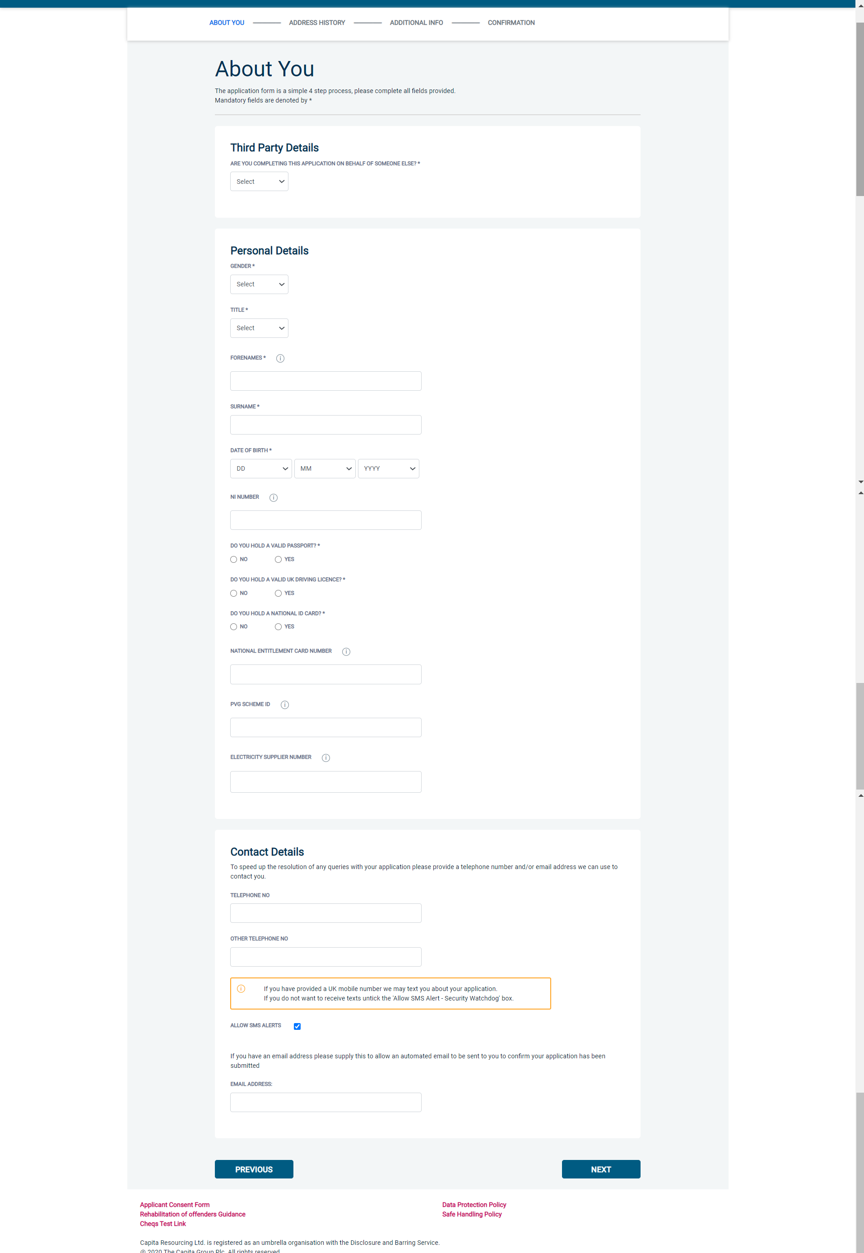

Once you have completed this section click ‘Next’.

Section 2 – Address History

Please enter your current address either using the address lookup tool or manually. If you have not lived at this property for more than five years, you will be taken to another screen. Here you will be required to add any additional addresses to ensure your address history goes back the required five years. Please note if you do not provide a minimum of five years address history, you will not be able to proceed to the next stage of the application process.
Address Dates
There cannot be any gaps/overlaps in your address history. Please ensure that the month and year of each address follows that of the previous address. Students who switch between their permanent residence and educational establishments must enter each address with dates consecutively e.g. parents’ address Dec 2009 – Jan 2010, university address Jan 2010 – March 2010, parents’ address March 2010 – April 2010 etc. Do not run addresses/dates simultaneously as your application form will be rejected by Disclosure Scotland. Once an address has been entered, you can edit any information by clicking on the ‘Edit’ button.

Postcode
Please ensure that all UK addresses have a full postcode; if you cannot remember your postcode please use the address lookup tool to populate the address by searching using the first line of your address.

No Fixed Abode UK
If you were of no fixed abode within the UK please enter the nearest hostel address to the location you were based.

Foreign Addresses/Travelling Overseas
If you have travelled overseas and cannot supply the address for a foreign country then please enter ‘no fixed abode’ for Address line 1. Please then enter the Town/City and Country of where you were residing within this period.

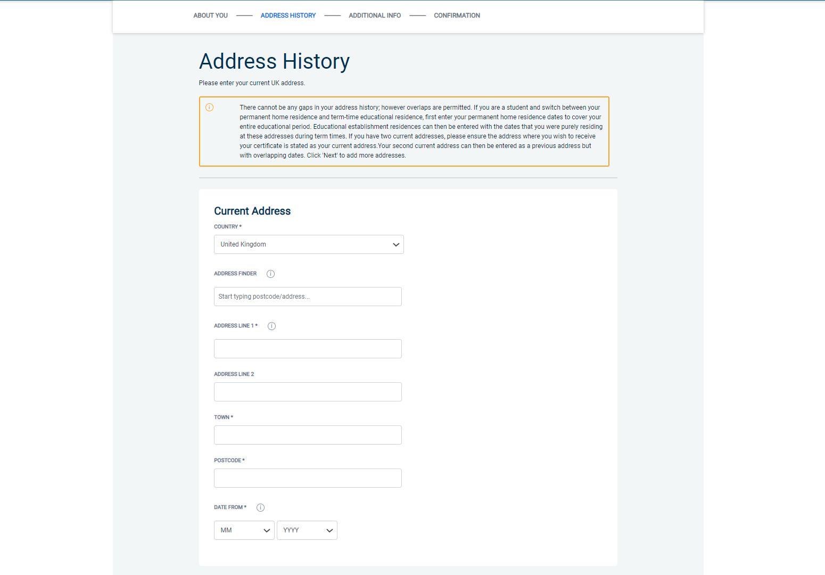
Once you have completed this section click ‘Next’

Section 3 – Additional Info

Other Details
- Enter details for your town of birth.
- Enter your Country of Birth
- Enter your Nationality at Birth
- Enter your Mother’s maiden (or family) name.

Known By Other Names
Please select ‘Yes’ or ‘No’ from the dropdown list.

Other names
Please provide details of any other names used at any time during your lifetime and the dates during which the names were used. Please enter each forename, middle name(s) and surname separately using the 'Add Name' button below. If you have used any aliases, e.g. William known as Bill, please also supply these details.
Failure to supply any additional information may cause your application to be delayed.
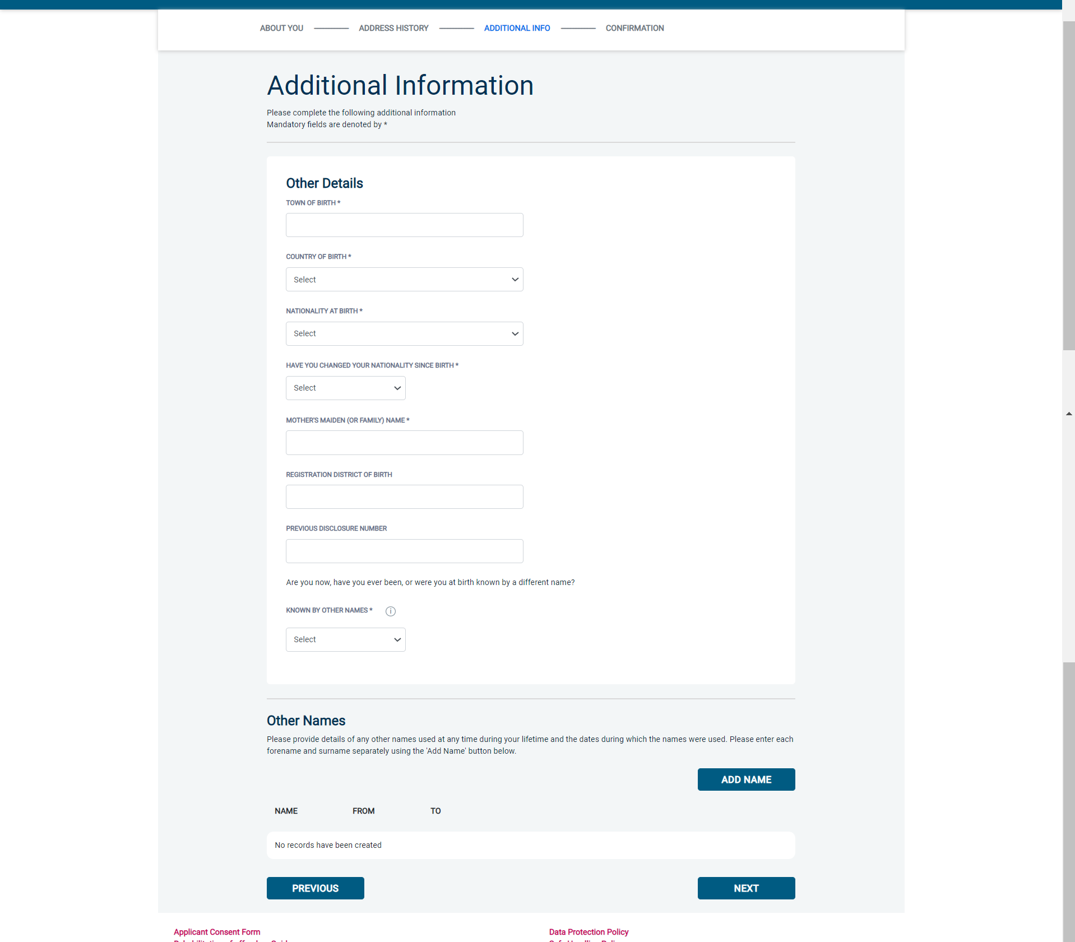
Once you have completed this section click ‘Next’

Section 4 – Confirmation and consent

Now please read through your application to ensure that there are no omissions/errors before you submit your application. If you wish to edit a section of your application click on ‘edit’ next to the section of the form that requires changes.
At the end of the application please make sure that you complete the Applicant Consent section.

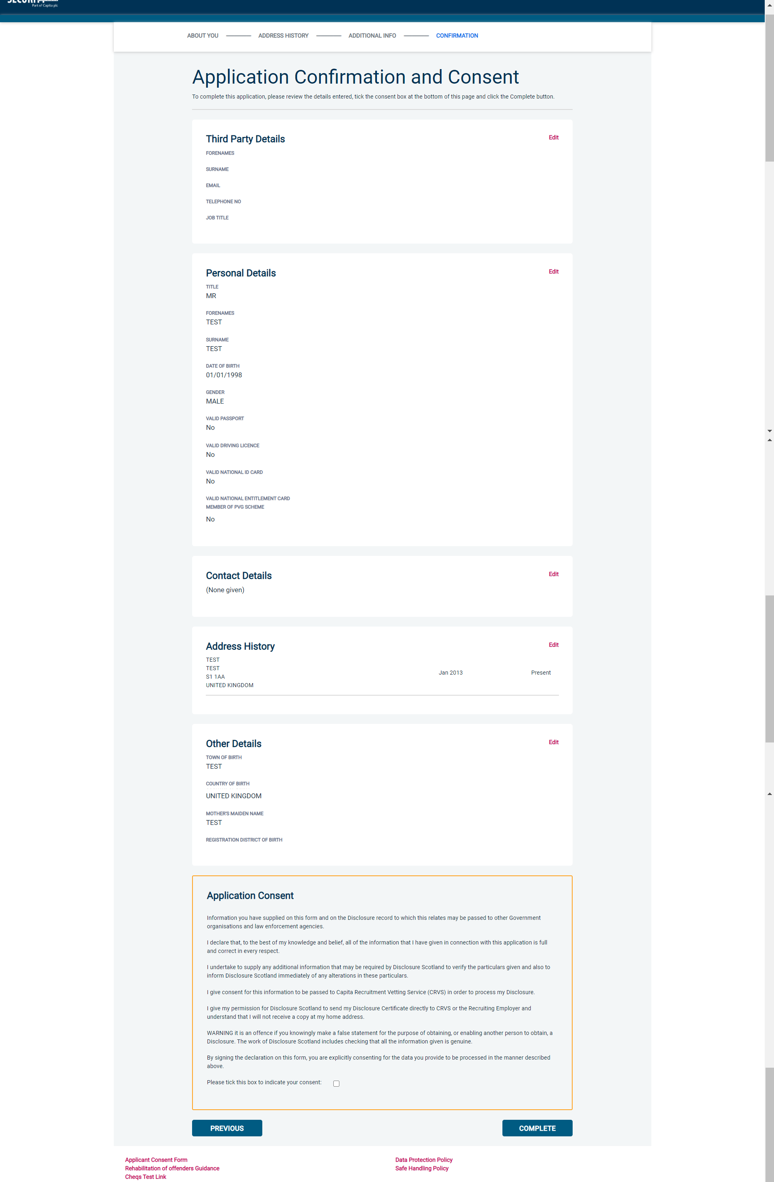
Now click ‘Complete’.

You have now completed your application form and you will be given a reference number. Please make a note of this number for reference purposes. If you entered an email address onto your application form you will receive a confirmation email containing these details.

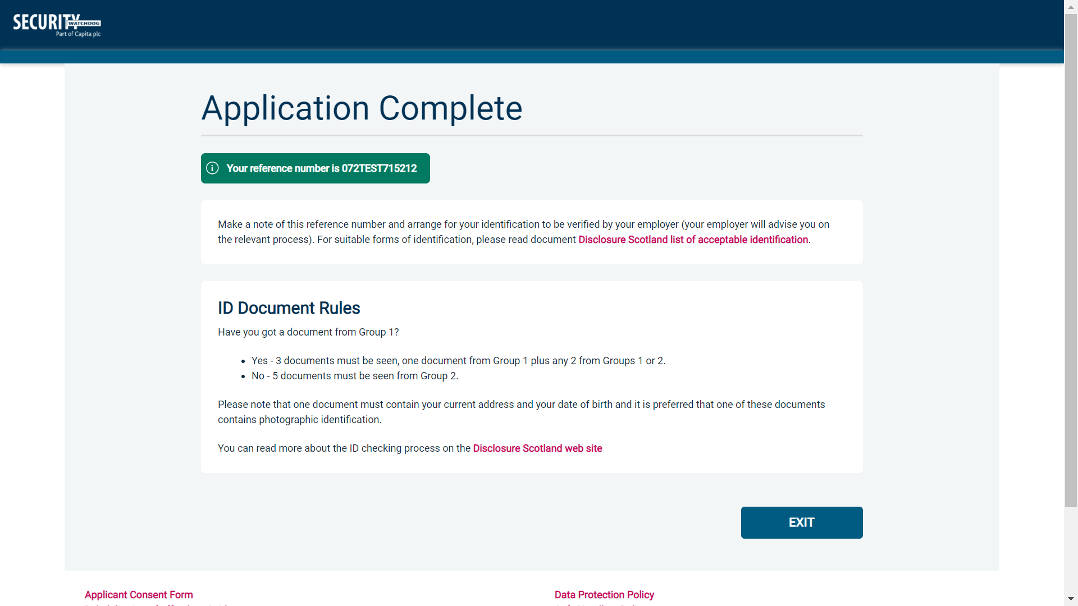

Your application will be processed by your employer once they have verified your identity. Please see below for guidance on identity verification.

Next step - Identity Verification
In line with Disclosure Scotland’s code of practice all applicants requiring a Disclosure Scotland check must have their identity verified.

How do I have my identity verified?
There are two ways in which your identity can be verified, either digitally and remotely via our certified identity service provider (IDSP) or by providing original identification to your employer. Your employer will inform you how they wish to verify your identity. If you are verifying your identity digitally, you will receive a unique link by email to upload your documents and a selfie to our IDSP platform. If you are verifying your identity manually, please provide original identification to your Company’s Nominated Person (usually Recruitment or HR Manager) and provide identification as listed in the acceptable ID table (see table below). Your application form will be processed by your employer once they have verified your identity, and then sent onto Disclosure Scotland.

CONTACT DETAILS
Please contact XXX if you have any queries regarding the DS application process. If you experience any technical issues with the online system, please contact XXX. Lines open 9.00am-5.30pm Monday to Friday. Alternatively you can contact us by e-mail at XXX

Disclosure Scotland List of Acceptable Identification

For all applicants
(2 documents to be seen)

1 ID document
1 further proof of address document

Combination of documents must confirm name, DOB & current address.

If unable to supply required documents, basic check cannot be submitted.

Identity Documents

- Current valid Passport
- Biometric Residence Permit (UK)
- Current Driving Licence – photo card (Full or Provisional)
- Birth Certificate (UK / Isle of Man / Channel Islands)
Full or short form acceptable including those issued by UK authorities overseas, such as Embassies, High Commissions & HM Forces. (Photocopies are not acceptable)
- Adoption Certificate (UK / Channel Islands)
- Marriage / Civil Partnership Certificate (UK / Channel Islands)
- HM Forces ID Card (UK)
- Fire Arms Licence (UK / Isle of Man / Channel Islands)
- NHS Card
- EEA National ID Card
- National Identity Card from a country outside the European Economic Area (EEA)

Proof of Address Documents
Issued within the last 12 months
- Mortgage Statement
- Bank/Building Society Statement
Online statements are acceptable however Monzo statements are not acceptable
- Bank/Building Society Account Opening Confirmation Letter (UK)
- Credit Card Statement (Online statements are acceptable)
- Financial Statement e.g. pension, endowment, ISA (UK)
- P45/P60 Statement (UK / Channel Islands)
- Council Tax Statement (UK / Channel Islands)
- Tenancy Agreement (must be typed, not handwritten)
- Utility Bill - Not Mobile Phone (Online statements are acceptable)
- Insurance policy document or letter
- TV Licence letter (UK / Isle of Man / Channel Islands)
- Benefit Statement (UK) e.g. Child Allowance, Pension
- Document from Central/ Local Government/ Government Agency/ Local Authority (UK / Channel Islands)
e.g. DWP, Employment Service, HMRC, Job Centre, NHS
- Letter from Head Teacher or College Principal (16-19 year olds in full time education in the UK)
- Current Driving Licence – photo card (Full or Provisional)
- Fire Arms Licence (UK / Isle of Man / Channel Islands)

