Basic Online Disclosure Guide (eBulkPlus)

Countersignatory Guidance Notes

Contents
Countersignatory guidance notes 4
Section A – How to Login 4
Section B – setting up 7
Section C – getting started 16
Section D – transmission to DBS/DS & tracking 23
Section E – Basic DBS results with content 25
Section E – Basic DBS clear results 27
Section E – Disclosure Scotland results 29
Section E – Right to Work application results 31
Section F – reports 33
Section G – find an application 36
Section H – internal actions / housekeeping 37
DBS List of Acceptable Identification 40
Disclosure Scotland List of Acceptable Identification 42

Countersignatory guidance notes

Our eBulkPlus online Disclosure and Barring Service (DBS) & Disclosure Scotland (DS) checks can be completed by accessing the internet from any device that has this facility. This includes a smart phone, tablet, laptop or PC. It is supported on the latest versions of all modern browsers; however, we do not recommend access via Internet Explorer as this browser is unsupported both by our technology and soon by Microsoft also.

You have been granted access to eBulkPlus in the role of a Countersignatory. A Countersignatory will be able to view all applications that have been created on the system within their particular Registered Body (RB). A Countersignatory will be able to edit an application prior to submission to the DBS/Disclosure Scotland and will be able to view all applications that are in progress and completed by the DBS/Disclosure Scotland.

Section A – How to Login

Please enter the following address into your web browser:

*Web address to be inserted by website hosted user https://matrixscreening.com/xxxxx/

You will now be on the main login page that shows three white boxes. Please note at this stage of the process, your login details are case sensitive.

- Click on ‘Application Management’.
- Enter your company Organisation Reference - this will have been supplied to you in an automated email (if you cannot remember this please click on the ‘Forgotten your login details?’ icon at the bottom of the screen to be sent a reminder)
- Enter your Username
- Enter your Date of Birth (for first initial login please ensure you enter the default date of birth 01 Jan 1998. Failure to do so will deny you access to the system)

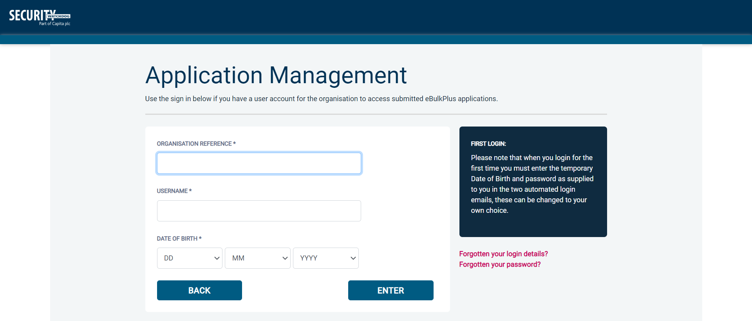
Screen Shot 1

- Once you have completed this section click ‘Enter’

- Enter your password (this will be supplied to you in an automated email) – see screen shot 2 (if you cannot remember this please click on the ‘Forgotten your password?’ icon at the bottom of the screen to be sent a new one-time password).
If you have difficulty gaining access to the system please contact XXX on XXX, however please ensure the first time you login that you have not been denied access because of entering your own date of birth. (The first time you login you must enter the temporary default date of birth, 01 Jan 1998.)

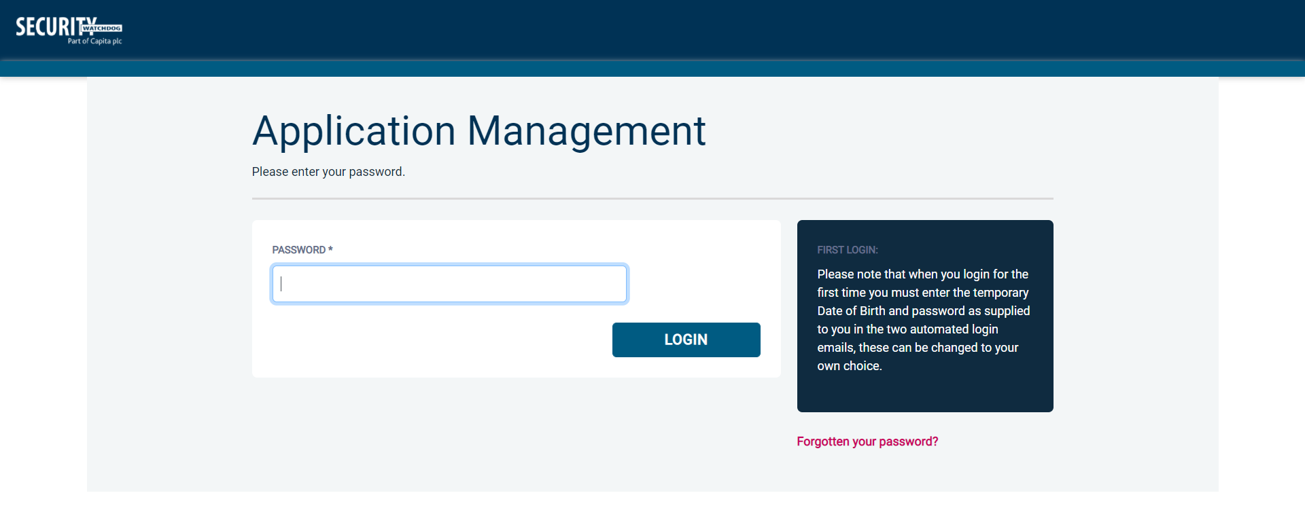
Screen Shot 2

- Please note, after initial login you will be required to set your own password and enter your own date of birth for future login purposes
- Please re-enter into the ‘Current Password’ field the temporary password you received in your initial email and then create your own unique password (see Screen Shot 3 below)
- The password you create must be between 8 & 30 characters containing at least one upper case letter, one lower case letter, one special character and at least one number.
- Please then enter a date of birth of your choice for future login purposes
- Please then click ‘Update’.

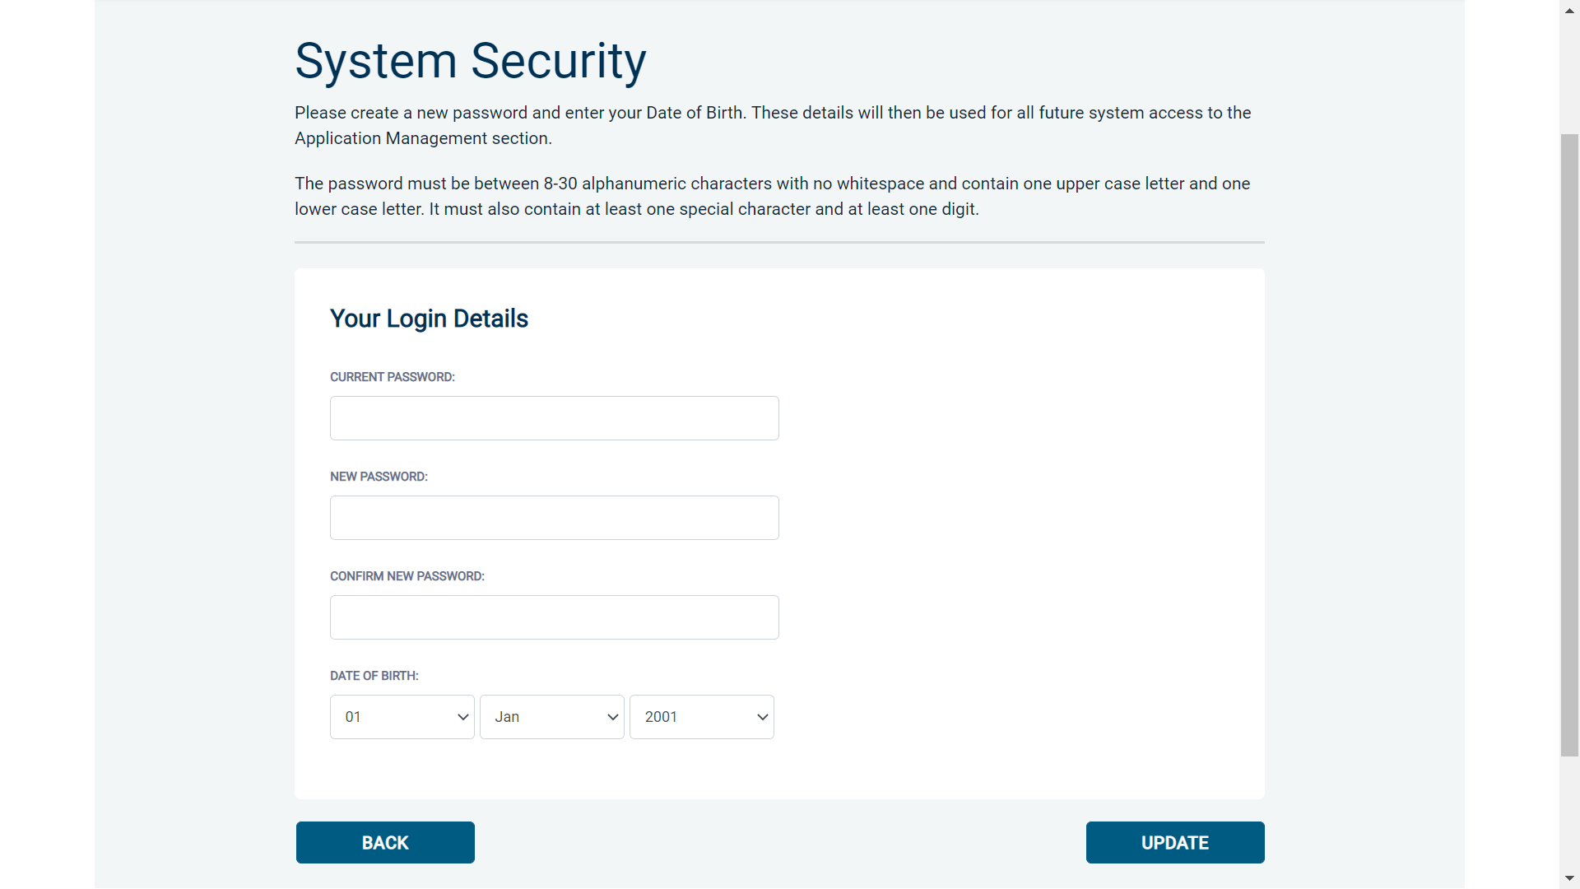
Screen Shot 3

- If you have successfully created your own password, you will now be able to enter the system by clicking the ‘Click here to enter System’ (see screen shot 4 below) icon in the green box (please note you do not need to re-enter your password details once the green box has appeared)

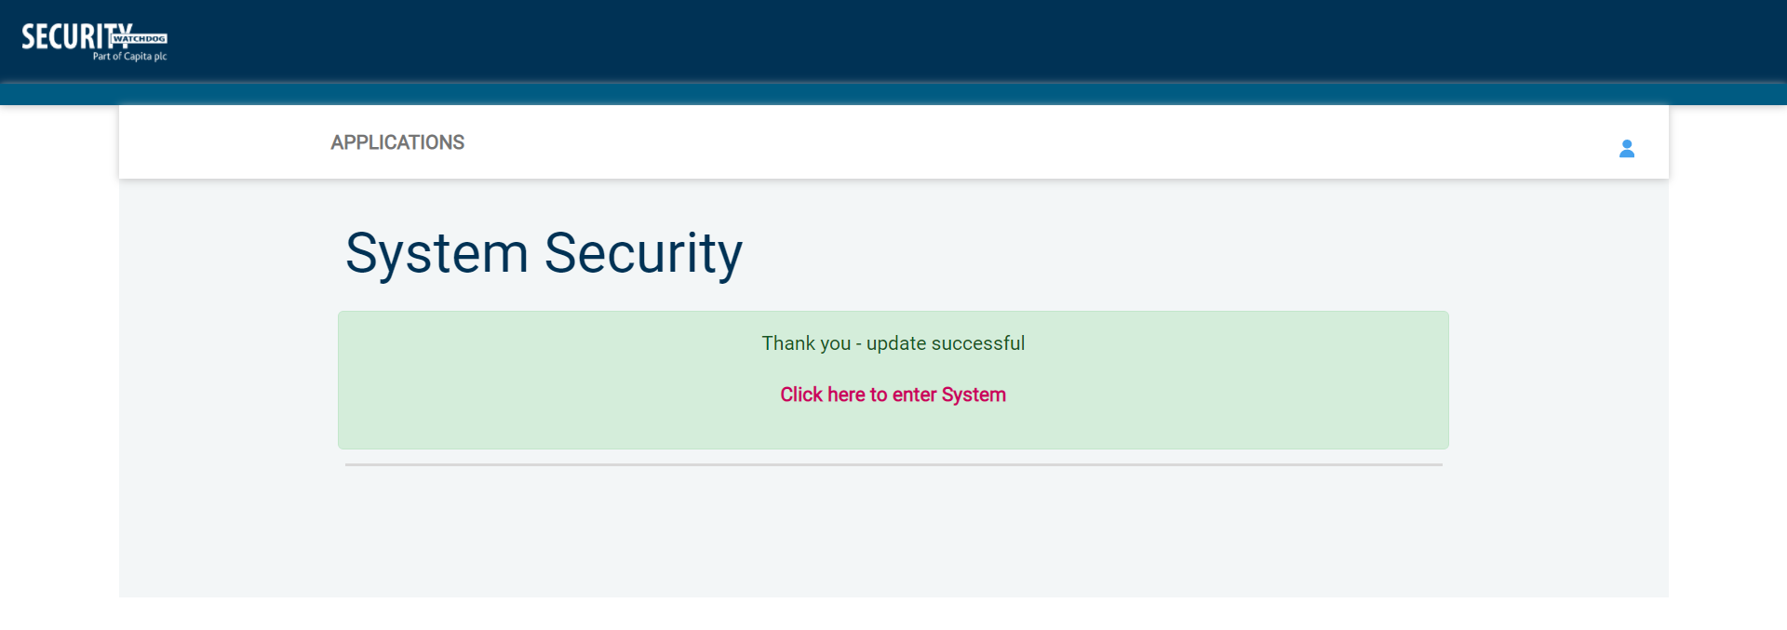
Screen Shot 4

- This will now take you to the main eBulkPlus Home Page called the ‘Dashboard’ (see Screen Shot 5 below)

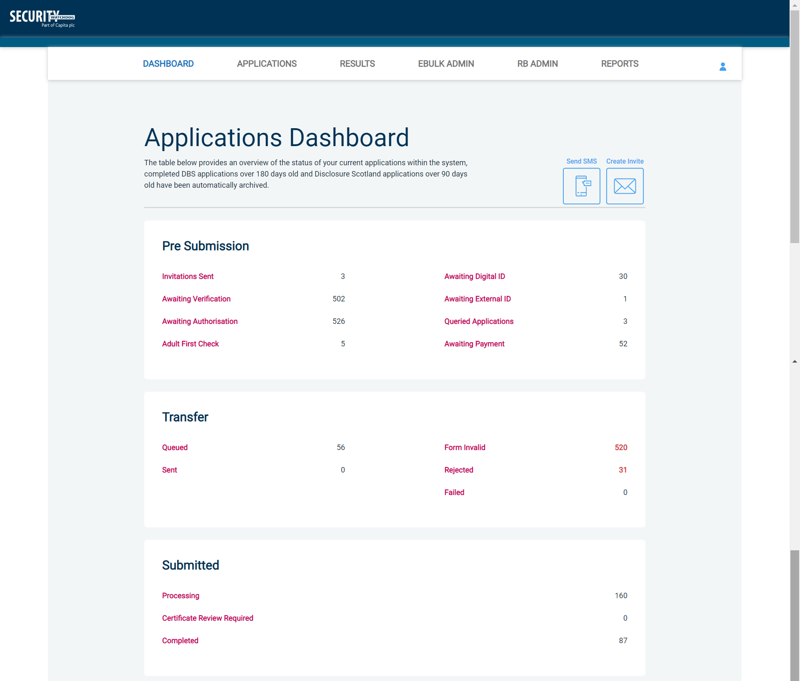
Screen Shot 5

Section B – setting up

Lead Countersignatory (LCS) – you will have access to the whole system.
Countersignatory (CS) – your Lead Countersignatory will inform you if you have full or partial access to the system.
Countersignatories can be set up with full access to the whole processing system. They can also be allocated the following additional roles:
- RB Admin (setting up new organisations/subdivisions/users)
- eBulkPlus Admin (dealing with transfers/transfer failures to DBS/DS)
- Run reports
- View/upload content certificates

It is down to the Lead Countersignatory to determine which level of access you are granted.

THE ONLINE DISCLOSURE PROCESS IS AS FOLLOWS
Applicant completes online form | ID Documents verified by ID Checker/ Applicant Manager | Completed forms are countersigned, vetted & sent by RB, CS or LCS to DBS/DS | Completed results are available to view electronically. Applicants will receive Disclosure Certificate in the post.

SETTING UP AN ORGANISATION/USER/TEMPLATES/JOB ROLE
Step 1 - From the main eBulkPlus Home Page called the ‘Dashboard’ click on ‘RB Admin’ – see screen shot 6

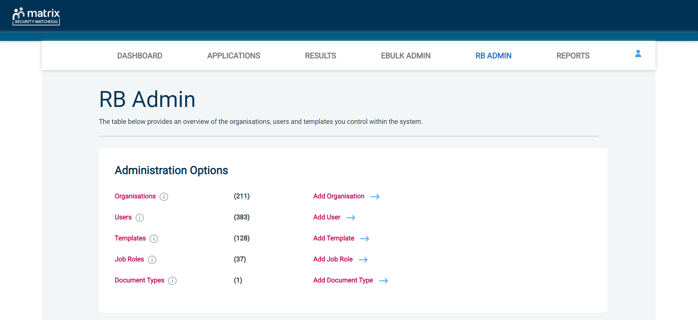
Screen Shot 6

Step 2 - Adding an organisation on the system
- Click on ‘Add Organisation’
- Follow on screen instructions (see screen shots 7 & 8)
- Click ‘Save’ and then click on ‘Back’ located within the green box at the top of the screen

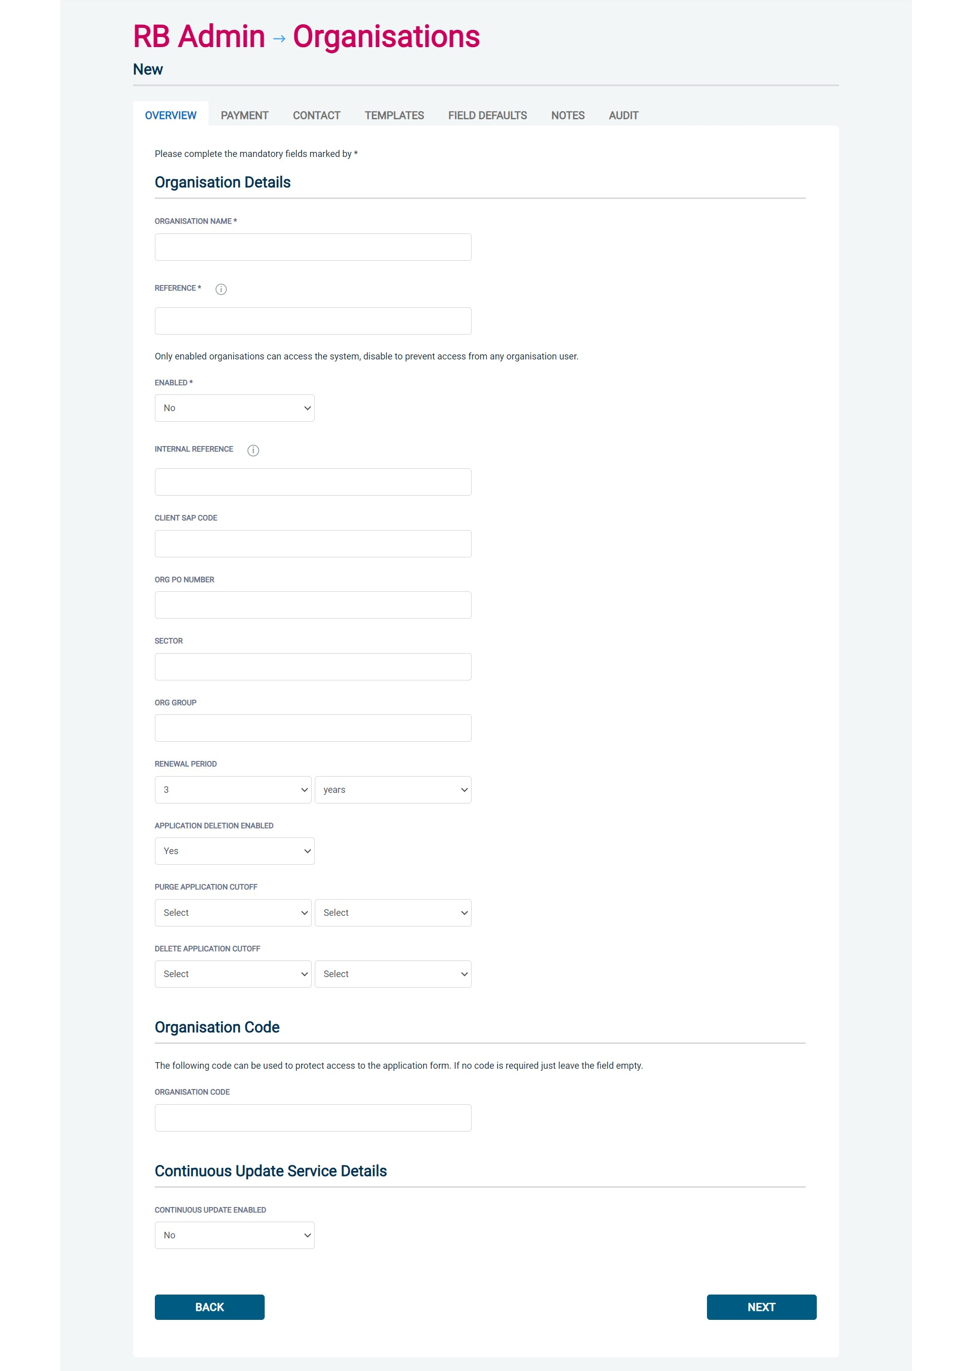
Screen Shot 7

Screen Shot 8 below – continuation of screen shot 7

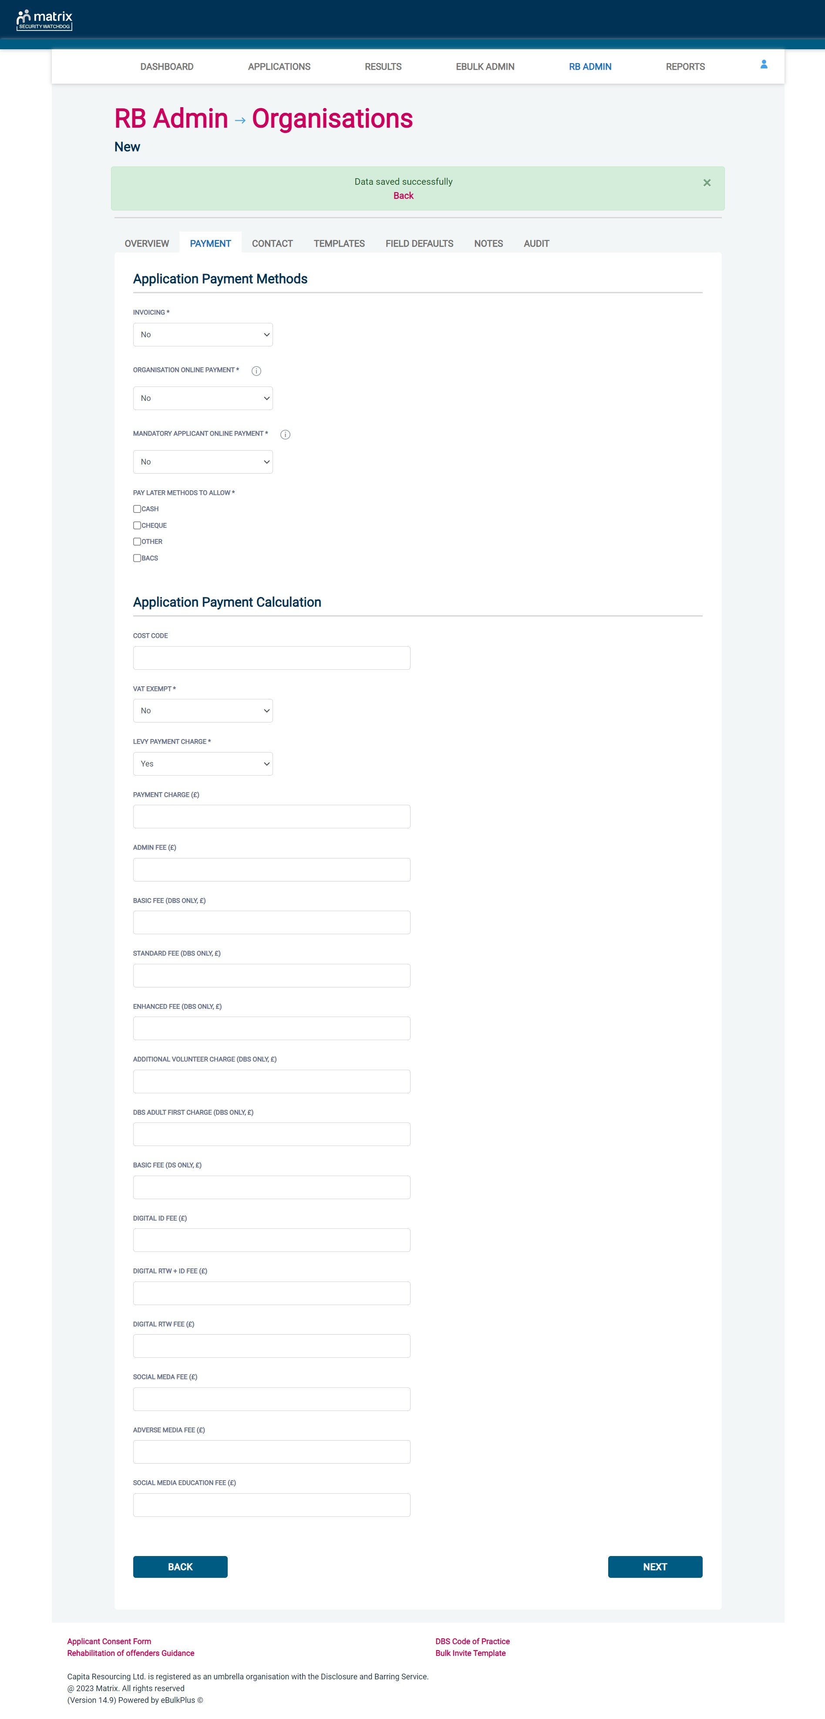
Step 3 - Adding a user to an organisation.
- Within RB Admin click on ‘Add User’ (see screen shot 6)
- To add a user to your organisation you must enter their details (see Screen Shot 9). Now follow the on screen instructions to add other Countersignatories, ID Checkers (verify ID only – no access to Section Y), Applicant Managers (can view the application, verify ID and approve) and Primary Applicant Managers (can view the application, edit the application, verify ID and approve). Remember to select the additional roles and privileges you want your users to have, if at all:
- Report Access – Access to run reports
- View Certificate Access – Ability to view uploaded content certificates
- View and Upload Certificate Access – Ability to view, upload and remove content certificates
- View Results – Ability to view certificate result status (e.g. Clear or Unclear)
- Reset ID Check – Ability to reset an ID Check if completed and saved incorrectly
- System Banner Access – Ability to configure and manage the system banner & it’s content
- Click ‘Save’ and then click on the word ‘Back’ located in the green box at the top of the screen.

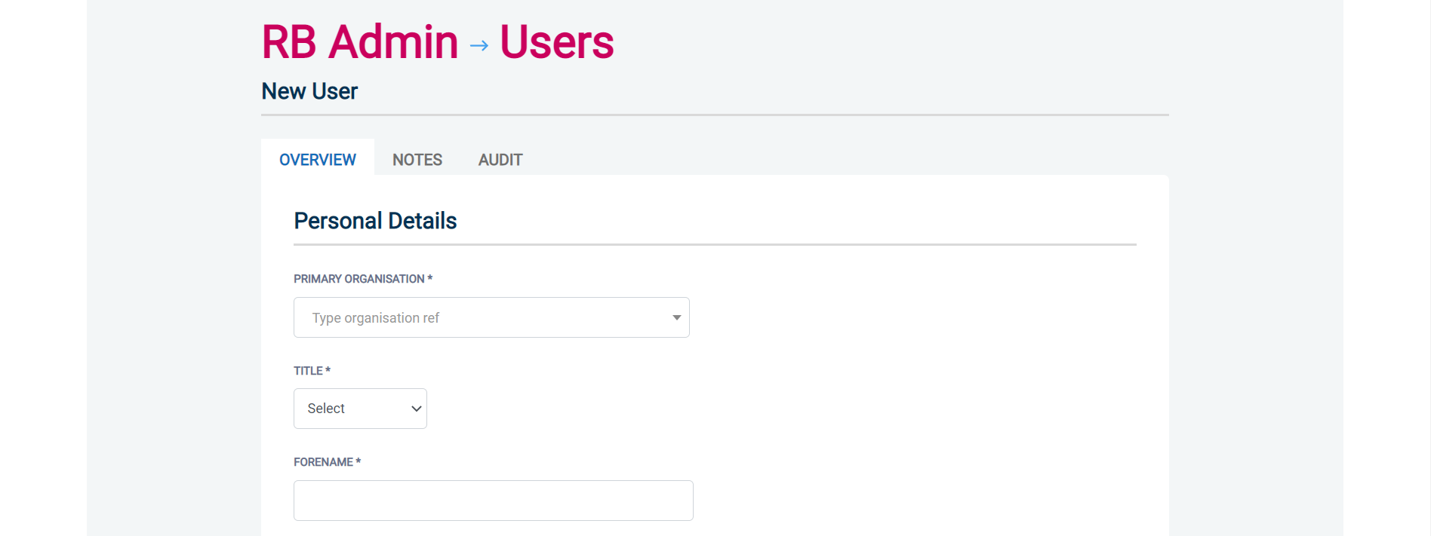
Screen Shot 9

Step 4 – Linking a user to multiple organisations.
There is a facility to link a user up to a number of organisations/divisions under one single login. This access privilege can be achieved by creating a new user on eBulkPlus and then linking that user’s access privileges to the relevant organisations/divisions.
To complete this process, follow the steps below:
- Within RB Admin click on ‘Users’ and select the relevant record (see screen shot 6)
- Click on ‘Link Organisations’ or ‘Autolink to Organisation Group’, depending on linking requirements (see screen shot 10 below)

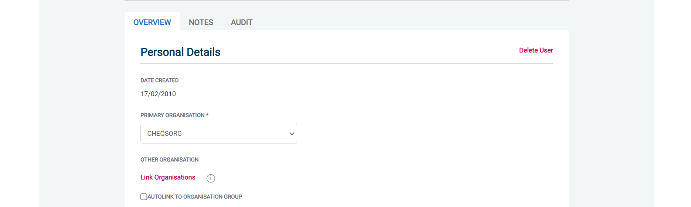
Screen Shot 10
Link Organisations - Once a user’s details have been saved, you can select the ‘Link Organisations’ icon. The next stage of the process is to select the organisations (listed by their organisation reference) that a user requires access to (see screen shot 11 below). Once all relevant organisations have been selected press the save button.
Screen Shot 11

Autolink to Organisation Group (see screen shot 10) – Giving a user account this facility means that they will be automatically linked to all organisations that share the same ‘Org Group’ as the organisation the user account was created under. Clicking the ‘Autolink to Organisation Group’ tick option removes the option of manually linking a user to organisations via the usual method of ticking the relevant organisations from the list provided and automatically links them to all organisations within their ‘Org Group’.

Any user that has been linked to a number of organisations will now be able to view all applications that have been created on eBulkPlus via the Dashboard. If a user is already created on eBulkPlus, all that is required to amend their access privileges is to go into each individual user and link them to the required organisations and then save this information. A user that has been granted access to multiple organisations will always use the Primary Organisation Reference (this will be the initial organisation the user was created under) to gain access to eBulkPlus.

Step 5 - Setting up the content for Template Letters/Emails
- Within RB Admin tab you can set up your organisation’s content on template letters/emails. Click on ‘Add Templates’ (see screen shot 6)
- Follow the on-screen instructions (see example in screen shot 12 below)
- Click ‘Save’ and then click on the word ‘Back’ located within the green box at the top of the screen.

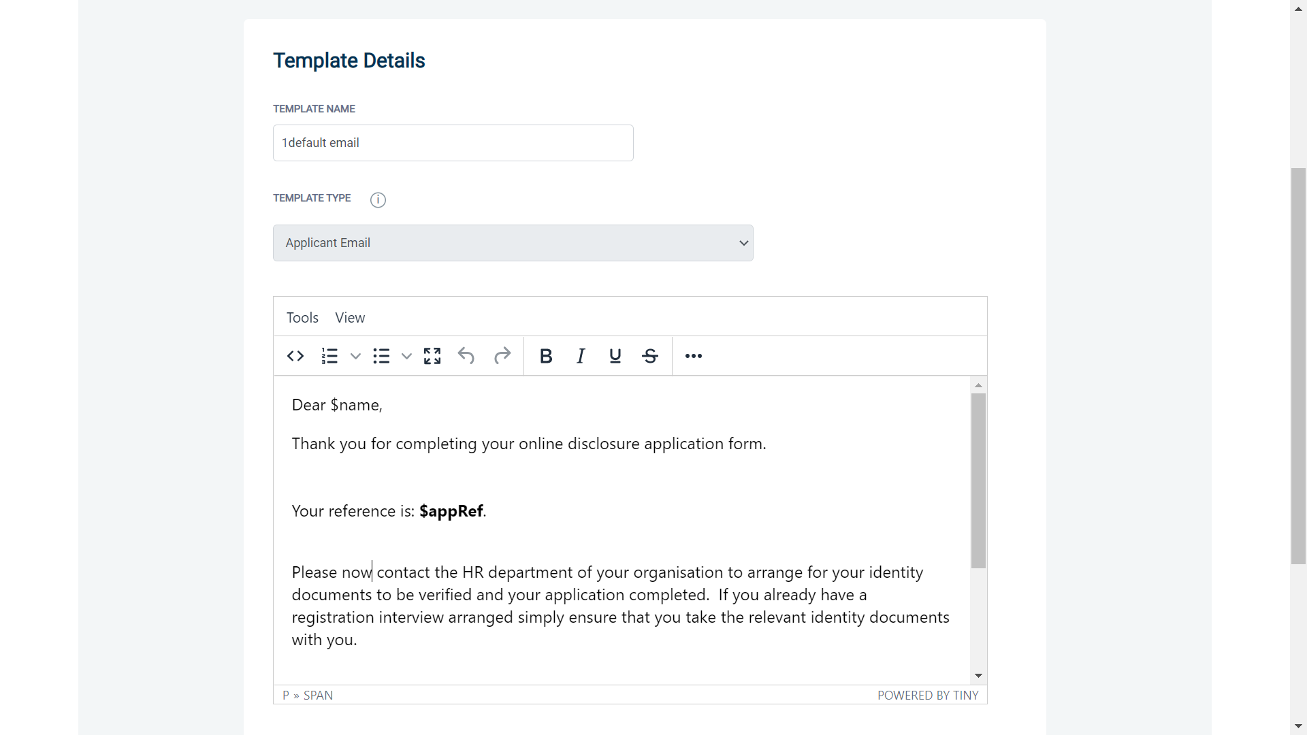
Screen Shot 12

Step 6 - Setting up pre-set Job Roles for an Organisation
- Within RB Admin, you have the facility to create pre-set job roles with specific Section Y values that can be then used for organisations on eBulkPlus to provide them with a dropdown list of pre-set job roles to choose from rather than keying in the ‘Position Applied For’ manually when completing a DBS application. To do this click on ‘Add Job Role’ (see Screen Shot 6)
- Enter the job details and any Section Y values for this job role if required
- Click ‘Save’ and then click on the word ‘Back’ located within the green box at the top of the screen.

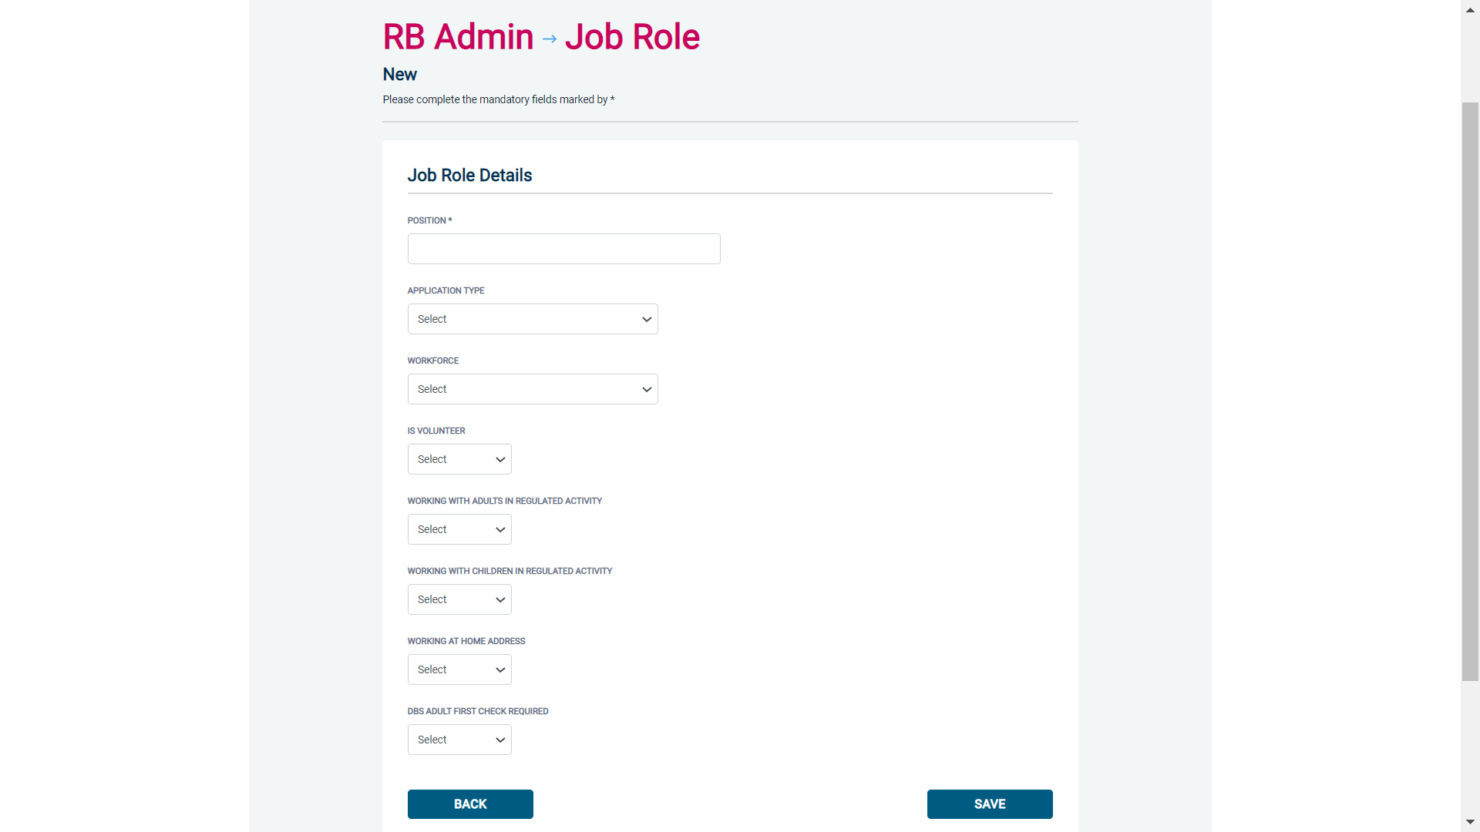
Screen Shot 13

- To make any pre-set job roles active on an organisation, this is done by answering ‘Yes’ to the ‘Fixed List of Positions Applied for’ question within the ‘Field Defaults’ section of an organisation page
- Then tick all the relevant job roles that you wish to be available for this organisation. When submitting a DBS application for this organisation, the applicant will be provided with a drop-down list of job roles with only the job roles ticked for this organisation (see Screen Shot 14).

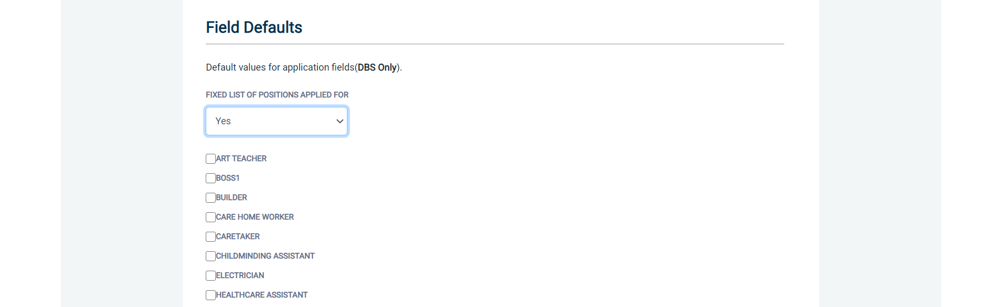
Screen Shot 14

Step 7 – Adding/amending the system whitelisting options
- Within RB Admin, you have the facility to upload your own business logo and corporate colours, these changes will take effect once the relevant cache and DNS propagation takes place across user ISPs and networks.
- Upload the logo file, which must be in SVG format. This will determine the logo that is displayed in the upper left corner of the application.
- Enter the HEX code values for your corporate colours in the primary, secondary and tertiary colour fields. These will determine the colour of the following elements;
  - Primary Colour – this colour determines the main colour of the system header and the colour of all page headings
  - Secondary Colour – this colour determines the colour of the system header accent trim and the colour of all buttons
  - Tertiary Colour – this colour determines the colour of all system links and anchors
- Finally, click ‘Save’

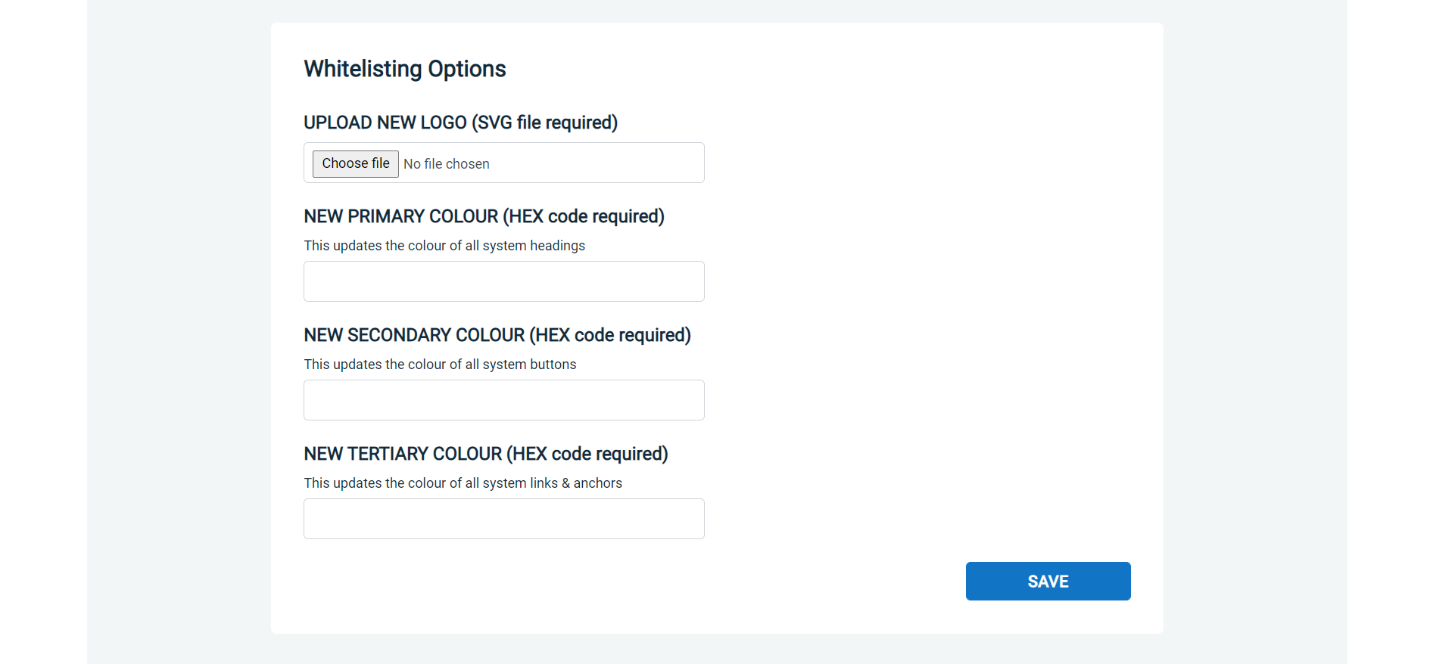
Screen Shot 15

Step 8 – Configuring/managing the system banner
- Within RB Admin, if you have been granted the privilege, you can manage the system banner and its content within the System Banner Section
- To turn the system banner on, change the system banner enabled radio button from NO to YES
- Enter the text you wish to be displayed within the banner in the Banner Text section, this allows for up to 150 characters to be entered
- If you would like the banner message to link to an external URL outside of the system, this can be entered in the Banner URL field. Please note – the URL entered must include the http:// or https:// prefix.
- Enter the HEX code values for your corporate colours in the Banner Colour and Banner Text Colour fields
- Finally, click ‘Save’
Once the banner has been configured and enabled, it will be displayed to users the next time the system is rebooted, which happens twice daily. Once active, the banner will be displayed at the top of the screen to all users across all screens until it is turned back off.

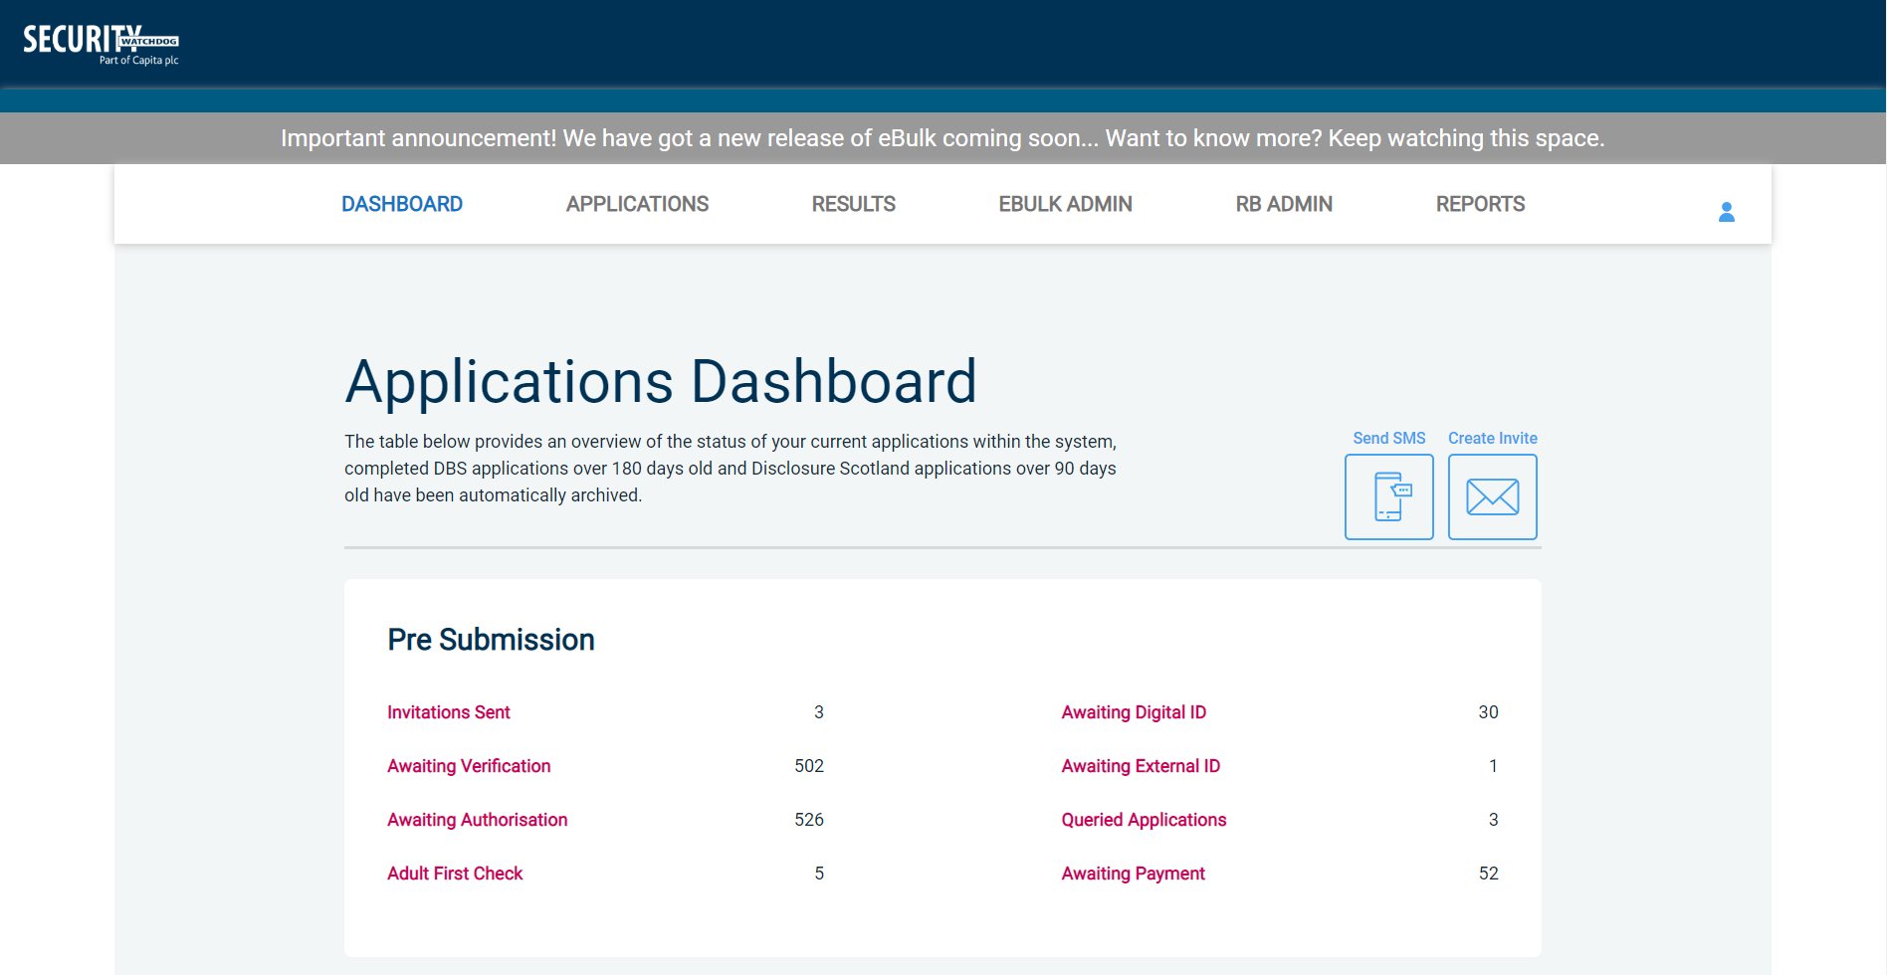
Screen Shot 16

Section C – getting started

Applicants
- You will be supplied with Applicant Guidance Notes (similar to these). An applicant can submit their application either by following a link in a system-generated email invite, or by accessing the system through a browser and logging in with organisation details provided to them
- Before you hand these out to your applicants, please tailor them to suit your organisation
- Once your applicant has received their guide, they can start the DBS/DS/Right to Work process and complete their application form

Inviting applicants to submit their application form
You can generate an email invite to an applicant(s) inviting them to submit their application, from within the eBulk dashboard. This can be done by clicking the ‘Create Invite’ button at the top of the dashboard.

You will be taken to the invitation page where you can generate your invite (screenshot 17 below).

- You will need to select the ‘Organisation’ that you wish the applicant to create their application under, you will be able to select any organisations that you are linked to. You will then need to select the level of check that you require the applicant to submit from the ‘Channel’ drop-down field below (DBS/Disclosure Scotland/Right to Work).
- You are then required to enter the applicant’s forename, surname and email address into the boxes provided. If you wish to invite more than one applicant to create this specific level of check for this specific organisation you can click the ‘Add Candidate’ button as many times as required to invite multiple applicants.

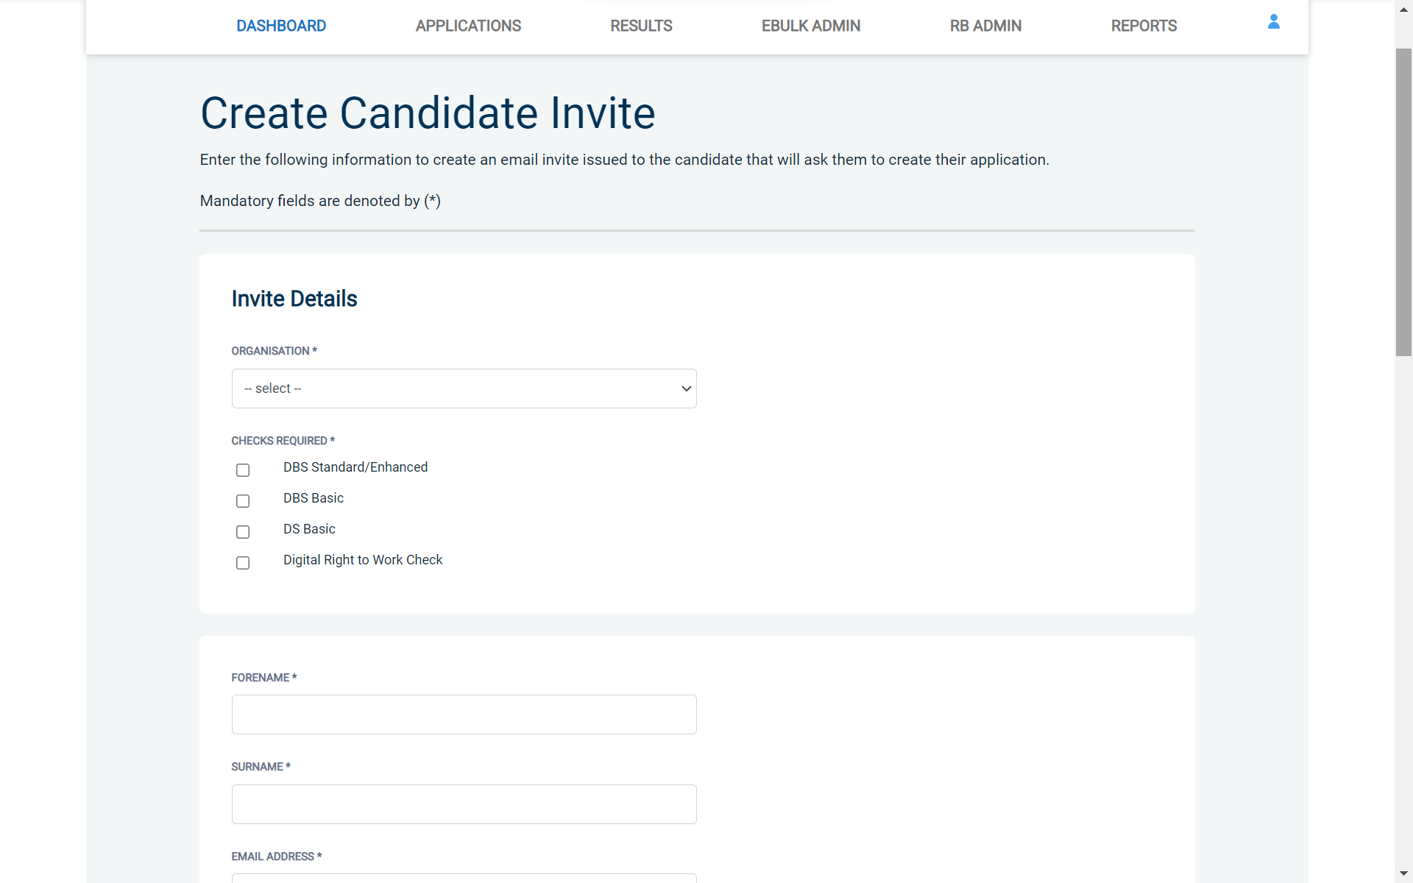
Screen Shot 17

- If you need to invite a large list of individuals, you can use the ‘Bulk Upload’ feature instead allowing you to upload a spreadsheet of applicants to be invited (screenshot 18 below). If you wish to use this feature, please leave the forename, surname, and email address fields blank and instead upload a pre-created spreadsheet. A blank template is provided in the eBulk footer if required. The spreadsheet must contain 3 columns only (Forename, Surname, Email address), any invalid data contained in the spreadsheet when uploaded will fail validation and be highlighted to you at the top of the screen.

Screen Shot 18

- Next, you are required to select a template from the ‘Email Template’ drop-down field (screenshot 19 below). You will be able to choose from either a ‘New Starter Invite Email’ or a ‘Renewal Invite Email’ if you are creating a DBS/DS application or a ‘Digital RTW Check Invite Email’ if you are creating a Right to Work application. Selecting one of these will populate the content of the invite email on-screen for you to review and amend if required. The pre-populated wording of these templates will either be the default wording coded into our system or a bespoke template for your organisation.
- Finally, click ‘Send’ to generate the invite to issue the invite to the applicant(s) entered.

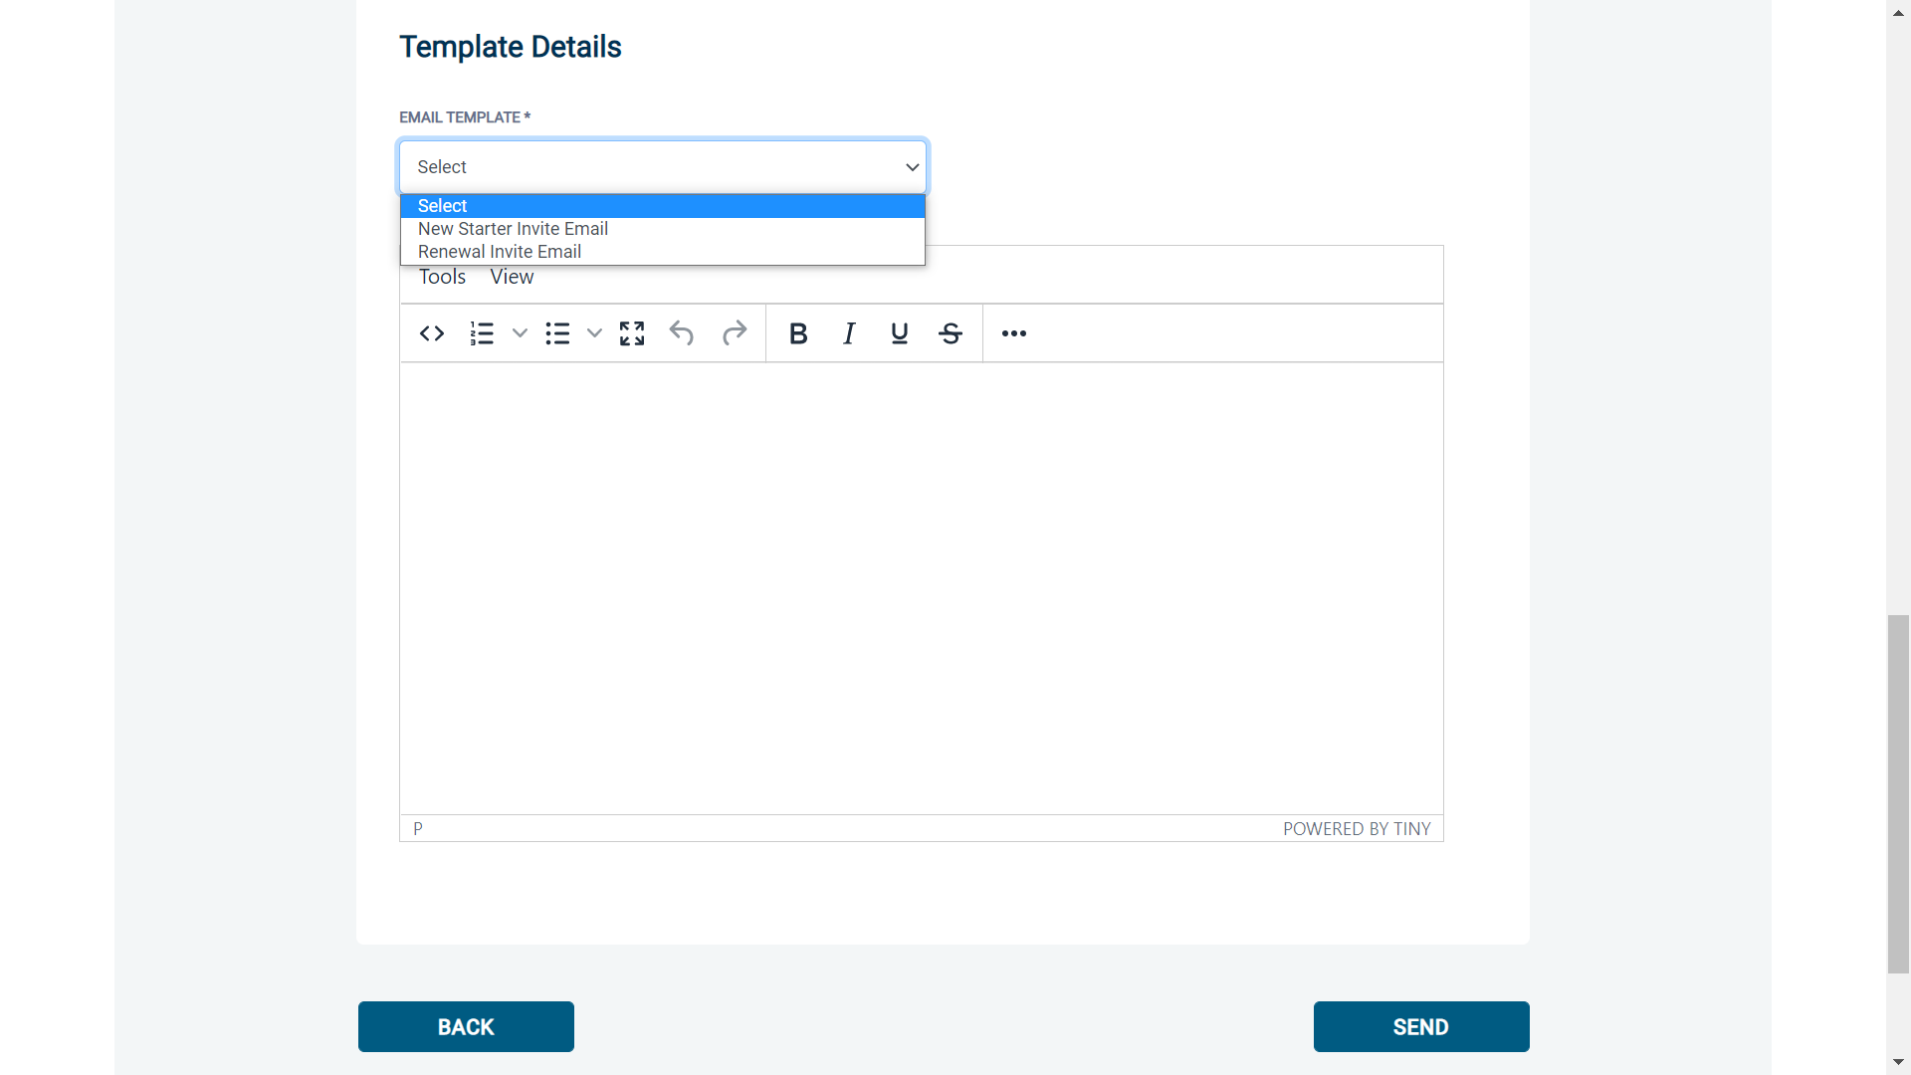
Screen Shot 19

ID verification /Authorisation
- You will also be supplied with ID Checker & Primary/Applicant Manager Guidance Notes. Again, these can be tailored to suit your organisation.
- Your ID Checkers and Primary/Applicant Managers will be required to login to the system to see if there are any forms waiting for ID verification on an application form (see screen shot 19 below). As soon as they have completed this stage you will notice when you login to the system that you have application forms waiting to be countersigned.

Screen Shot 20

Step 1 - Opening an application form
- Click on an applicant’s reference number to open their application form (see screen shot 21 below).

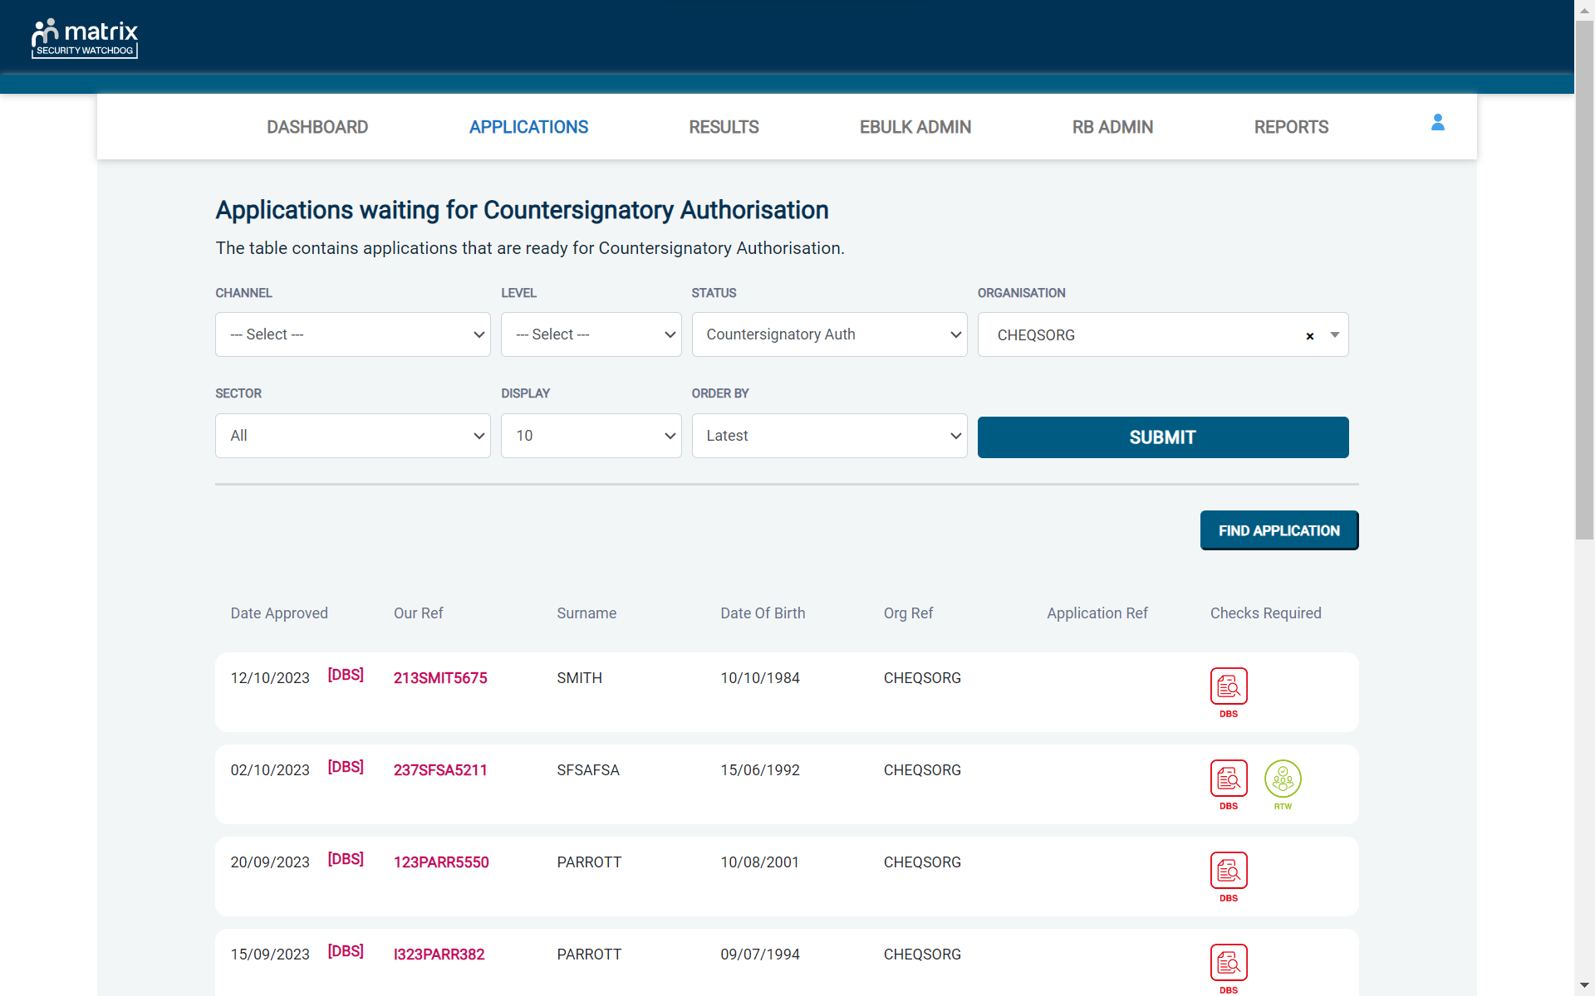
Screen Shot 21

Step 2 - Viewing a completed application form – see screen shot 22 below
- You will now see an applicant’s completed form (see screen shot 22 below). Across the top of the form there are four tabs:
- Overview, Application, Notes & Audit

Step 3 - Countersigning an application.
- Click on the Application tab. This will give you an opportunity to view and check the applicant’s application form in detail. Please note that at any time you can ‘edit’ an applicant’s application form if necessary. You will have an opportunity to retract a countersigned application up until it is transferred to the DBS/Disclosure Scotland. You can also click on the Audit tab to view an audit trail recording users who have accessed the different sections within the application

Key things to check for:
- Job role is written in full and no abbreviations are used (DBS Basic only)
- Correct gender has been entered
- Stand-out spelling errors in the names and address sections

If you are happy with the form, then you can countersign the application. If you wish to withdraw an application just click on the ‘Withdraw’ button (see Screen Shot 22).
*Do not withdraw an application by clicking ‘Delete’ unless performing a right to erasure request under the UK General Data Protection Regulation*
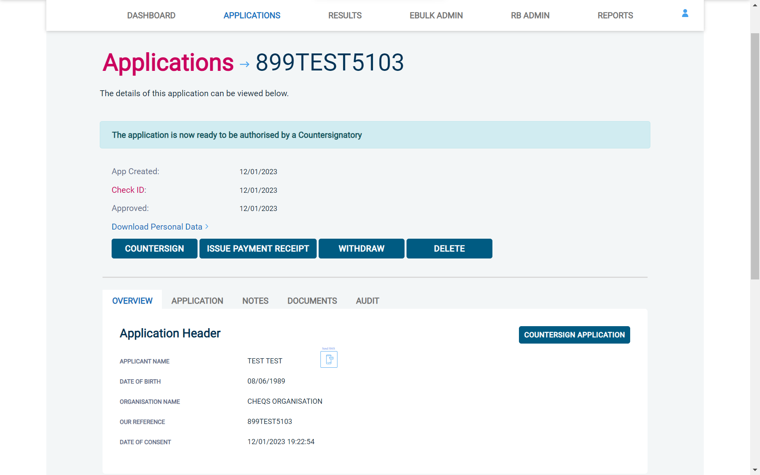
Screen Shot 22

NB. An application form can be withdrawn at any time up to and including Countersignatory stage. However, once a form has been electronically transferred to the DBS or Disclosure Scotland it cannot then be withdrawn without incurring the DBS/Disclosure Scotland charge.

Step 4 – Flagging a query on an application
If you require further clarification on any sections of an application or wish for an application to be put on hold temporarily, then a query can be flagged.
- To flag a query, this is done by clicking on the ‘Notes’ tab once in an application and clicking ‘Add Note’. Once the details of the query have been entered, simply click the ‘Save & flag as query’ button instead of the ‘Save’ button. This will flag the application as having a query on it and make a record in the ‘Query Applications’ folder on the Dashboard (see Screen Shot 23 below)

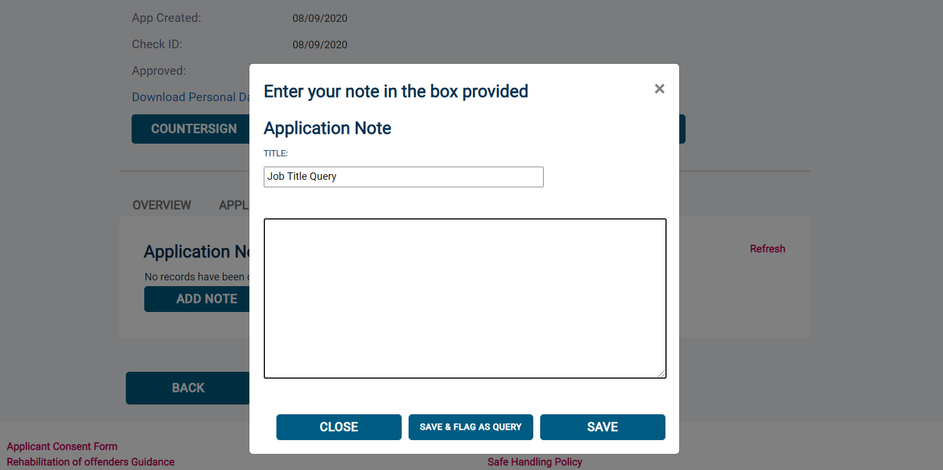
Screen Shot 23

- Once the query has been resolved, the query flag can be removed. To remove a query on an application, click back into the ‘Notes’ tab on the application and click ‘Edit’ against the note made containing the query. You can now update the note to confirm the query has been resolved and click the ‘Save & remove as query’ button. This will save the note and move the application out of the ‘Query Applications’ folder (see Screen Shot 24 below).

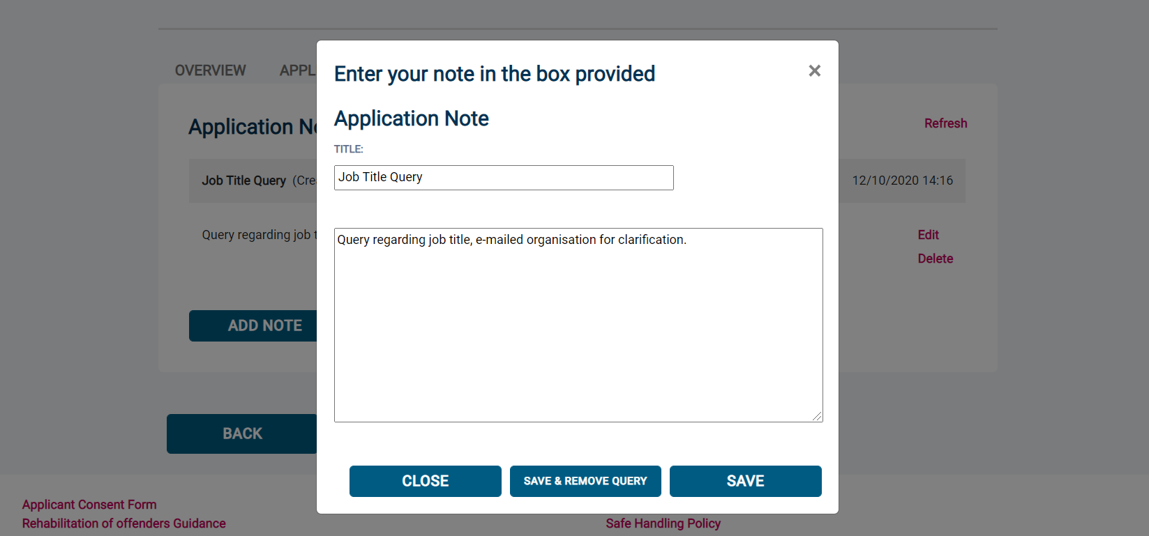
Screen Shot 24

Any user of the system can view the applications currently being queried by clicking into the ‘Query Applications’ folder from the Dashboard. If the user hovers over the ‘DBS’ or ‘DS’ icon in the Date Created tab, they will be able to see the description of the query title that has been stated in the ‘Notes’ field (see Screen Shot 25 below).

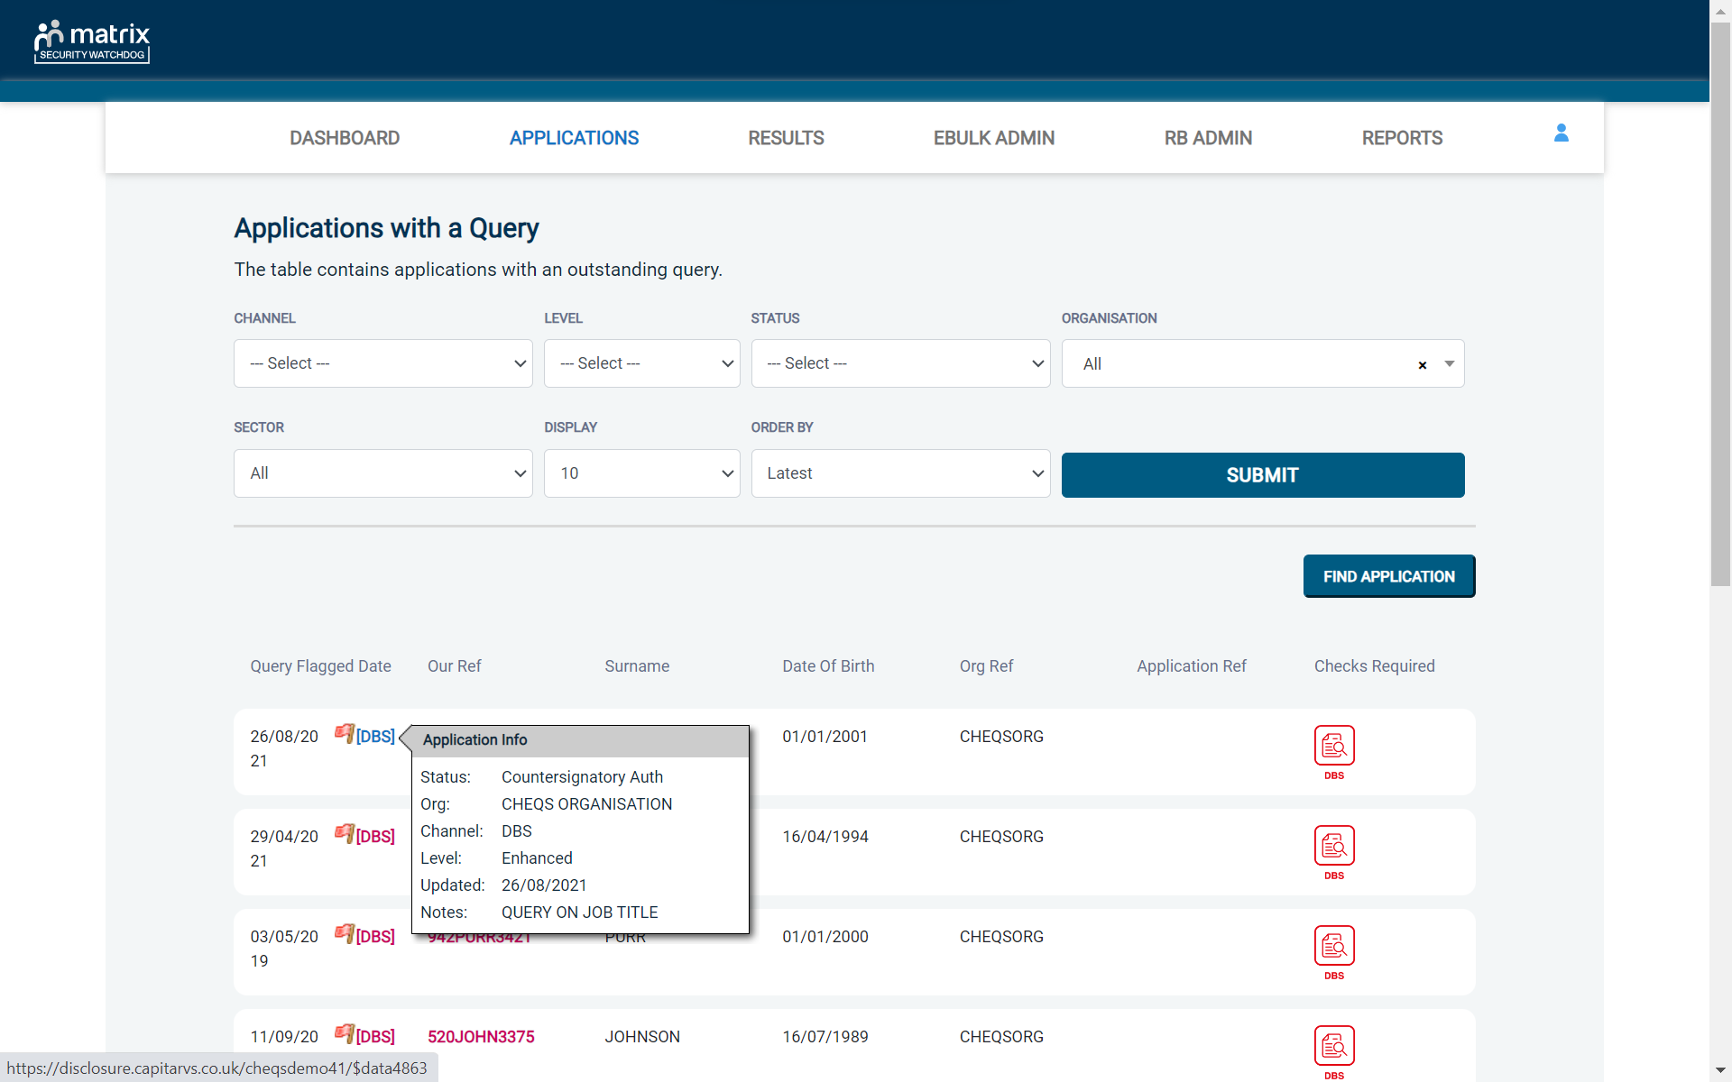
Screen Shot 25
A user with Countersignatory or Primary Applicant Manager level access can view the information about the query by clicking into an application from the ‘Query Applications’ folder. Once in the application, the user can click the ‘Notes’ tab to view a more detailed description of the query.

*PLEASE NOTE: A USER WITH APPLICANT MANAGER ACCESS WILL NOT BE ABLE TO VIEW THE NOTES TAB ON AN APPLICATION - ONLY A COUNTERSIGNATORY OR PRIMARY APPLICANT MANAGER CAN VIEW THIS*

If you did need to email the person who checked the ID on an application to raise or resolve a query, this can be done through eBulkPlus without the need to navigate away from the application you have the query on. To use this facility, click on the ‘Overview’ tab of an application. The person who checked the ID on the application and the date it was checked will be outlined at the bottom of the ‘Overview’ screen. Next to the person’s name will be their email address - the email address can be clicked to open a new email screen within Outlook and the person’s email address will be pre-populated (see Screen Shot 26 below).

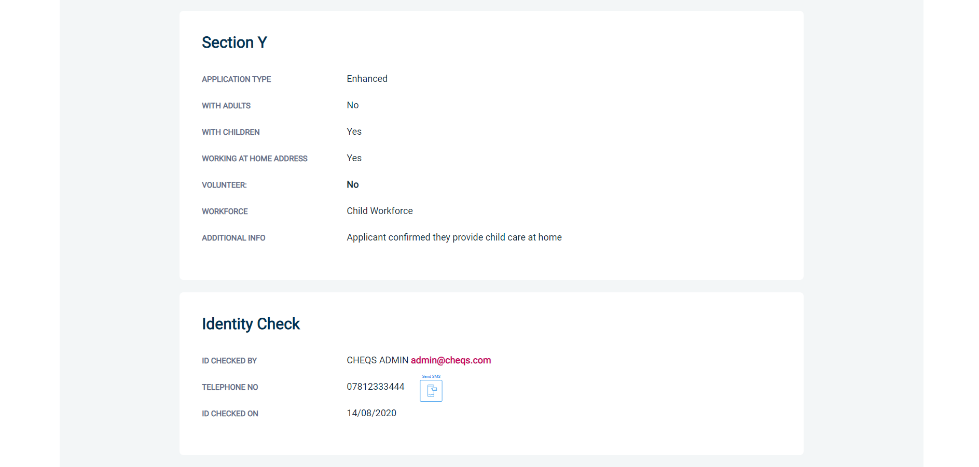
Screen Shot 26

Section D – transmission to DBS/DS & tracking

Step 1 - Transfer to the DBS – see Screen Shot 27
- As soon as a form has been countersigned it will move from the ‘Awaiting Authorisation’ section into the ‘Queued’ section on the Dashboard, ready for electronic transfer to the DBS/Disclosure Scotland.
Screen Shot 27

Step 2 - Tracking of applications in progress with DBS/Disclosure Scotland – see screen shot 28
- From the Dashboard you will see towards the bottom of the screen, a box called ‘Submitted’.
Screen Shot 28

- To track an application with the DBS or Disclosure Scotland, click on ‘Processing’ - this will take you to a screen which will show all the applications that are being processed by the DBS and Disclosure Scotland (see Screen Shot 29). From here you will be able to see when applications were submitted and how long they have been in progress.

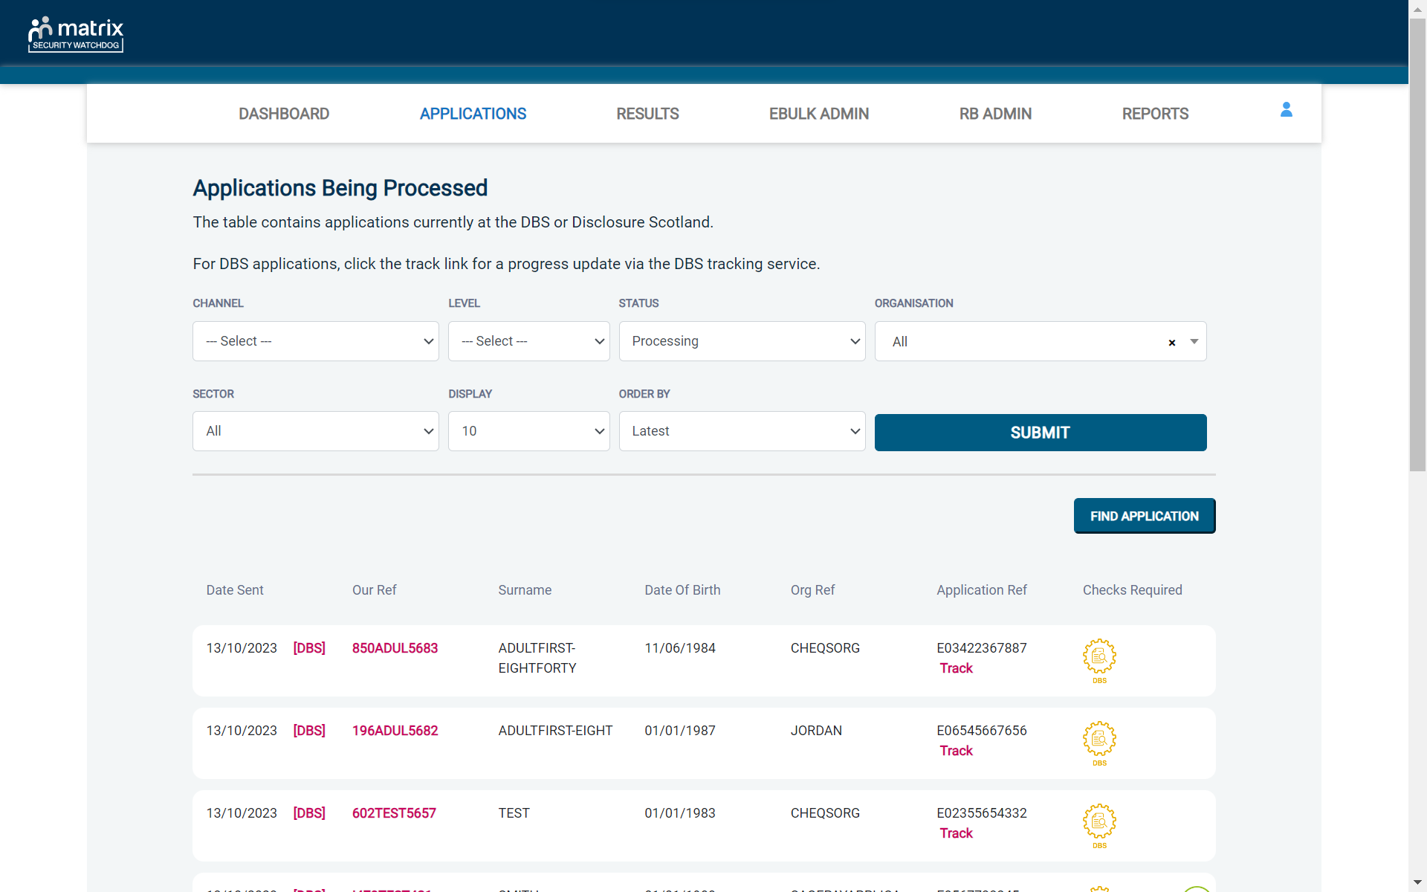
Screen Shot 29

Section E – Basic DBS results with content

Step 1 - Notification – see screen shot 29
The DBS will send notification online once an application has been completed. To view a result please return to the Dashboard and click on ‘Completed’ in the Submitted section.
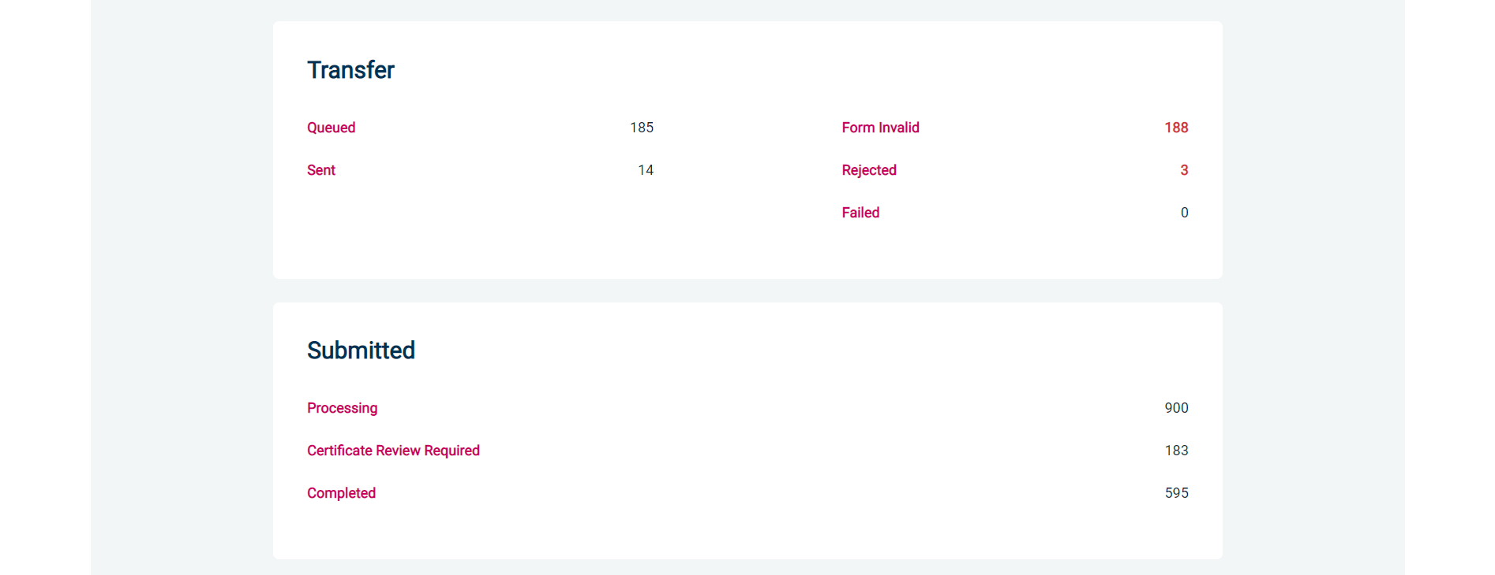
Screen Shot 29

Step 2 - Viewing a Certificate result with content – see screen shot 30
- To view the information of a certificate e.g., certificate issue date, reference number and result status, click on the applicant’s reference number (see screen shot 30). This information will stay in the ‘Completed’ folder for 180 days from the issue date of the certificate
- Certificate results with content will state “Please wait to view applicant certificate” in the Status column – This means the certificate contains information and you will have to view the applicant’s certificate to see this information.

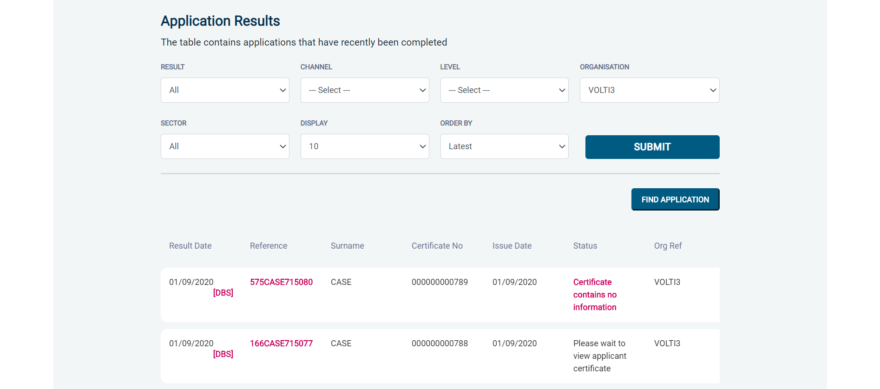
Screen Shot 30

Step 3 – Indicating sight of the applicant’s certificate – see screen shot 31
To help an organisation keep track of which applicants have brought their certificate in and been viewed by the organisation, the system is able to record the date the applicant’s certificate has been seen by their organisation. As a Countersignatory, you are able to add this date on to an application to indicate that their certificate has been sighted.

To add a date, or to view whether a date has been added to indicate sight of an applicant’s certificate, click on the reference number of the application from the ‘Complete’ folder or the ‘Certificate Review Required’ folder (see screen shot 30 above). Once in the application, the date can be added in the ‘Applicant’s Certificate Seen’ section of the Processing Details box on the right of the screen. Adding this information will remove the application from the ‘Certificate Review Required’ folder (see Screen Shot 31 below).

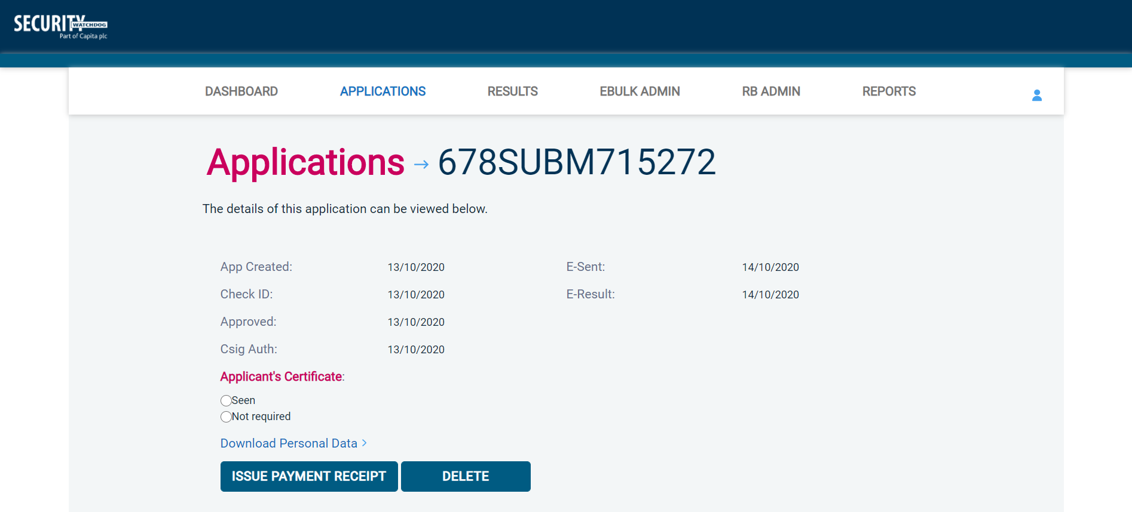
Screen Shot 31

Section E – Basic DBS clear results

Step 1 - Notification – refer to Screen Shot 29 above
- The DBS will send notification online once an application has been completed. To view a result, please return to the Dashboard and click on ‘Completed’ in the Submitted section.

Step 2 - Viewing a clear certificate result– see Screen Shot 32
- To view the information of a certificate e.g., certificate issue date, reference number and result status, click on the applicant’s reference number (see Screen Shot 32). This information will stay in the ‘Completed’ folder for 180 days from the issue date of the certificate.

Clear certificate results will state “Certificate contains no information” in the status column – This means the certificate contains no criminal convictions, cautions, warnings or reprimands.

Screen Shot 32

Step 2 - Viewing a Result Snapshot for clear applications – see Screen Shots 32 & 33
- As a Countersignatory you can click on the ‘Certificate contains no information’ wording in the status column to view a Result Snapshot for this application (see Screen Shot 33 below).

Please note that the Result Snapshot is for information purposes only, and it does not represent a DBS certificate or act as a DBS certificate alternative. The information contained within the snapshot is not to be viewed by or passed to any individual who does not have the appropriate authority to view it.

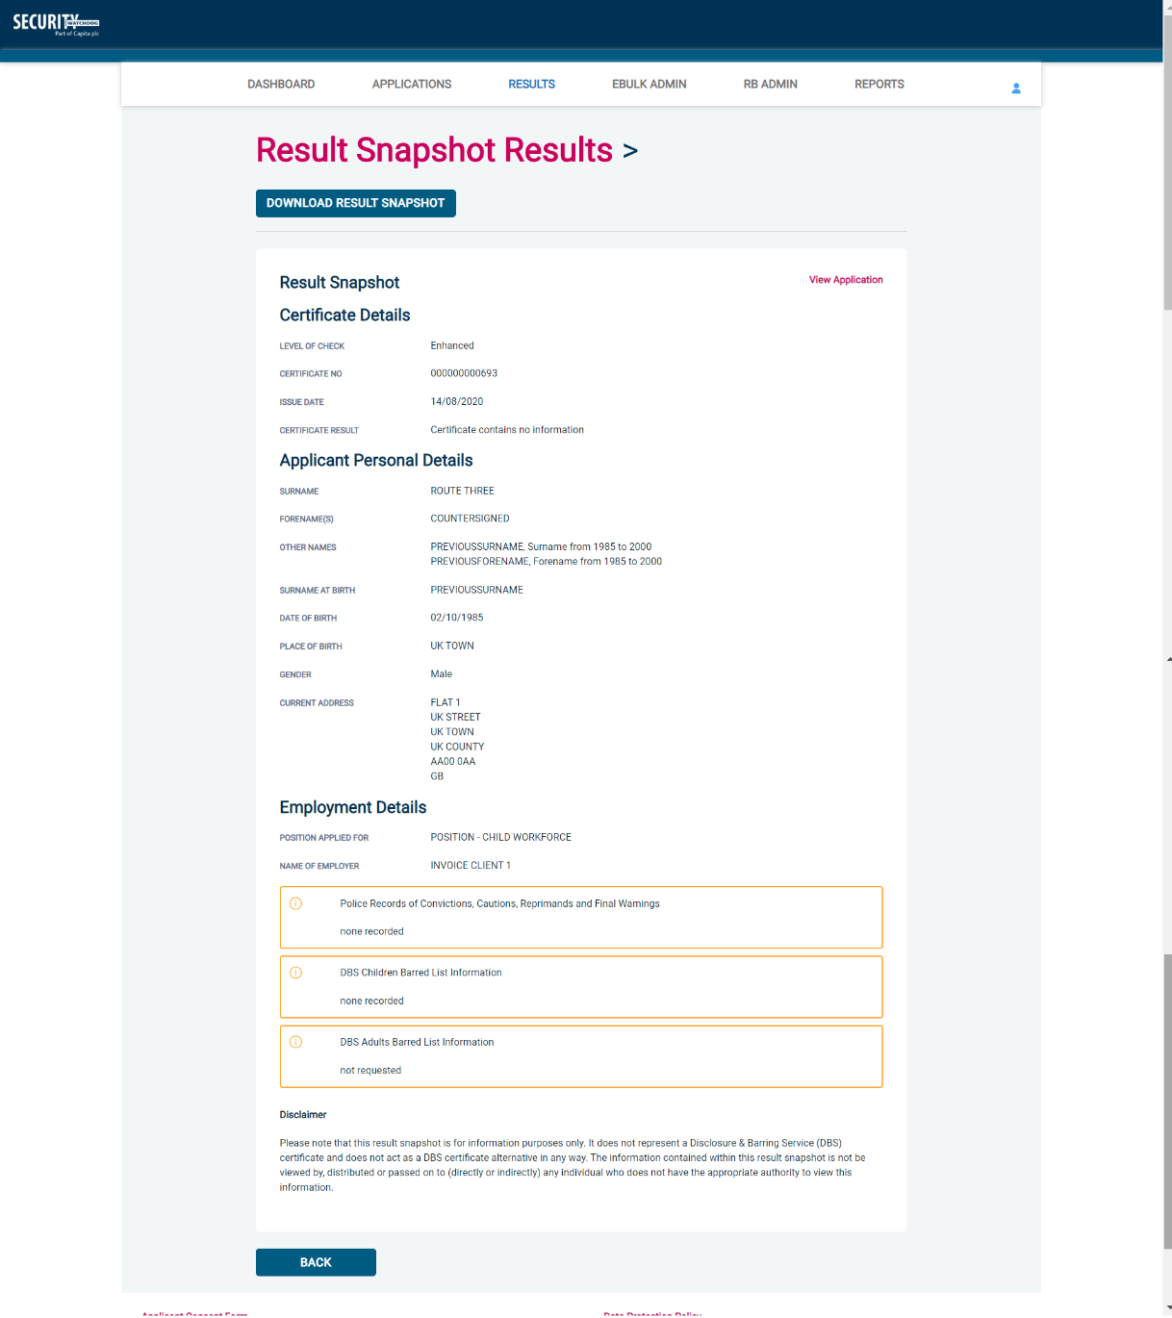
Screen Shot 33

As the Registered Body/Employer does not receive a copy of a completed DBS certificate, we advise that you have sight of the applicant’s certificate regardless of the status outcome on eBulkPlus. However, this is for your organisation to decide based on your own internal policies. For completed applications with a result status of “Please wait to view applicant certificate” you must view the applicant’s certificate before making a recruitment decision.

Section E – Disclosure Scotland results

Step 1 - Notification – see screen shot 34
DS will send notification online and post the disclosure certificate to the Countersignatory once a disclosure has been completed. To view a disclosure result, click on ‘Completed’ from the Dashboard (see screen shot 34 below).

Screen Shot 34

Step 2 - Viewing disclosure results – see screen shots 35 & 36
- To view the information of a certificate e.g., certificate issue date, reference number and result status, click on the applicant’s reference number (see screen shots 35 & 36). This information will stay in the ‘Completed’ folder for 90 days from the issue date of the certificate.

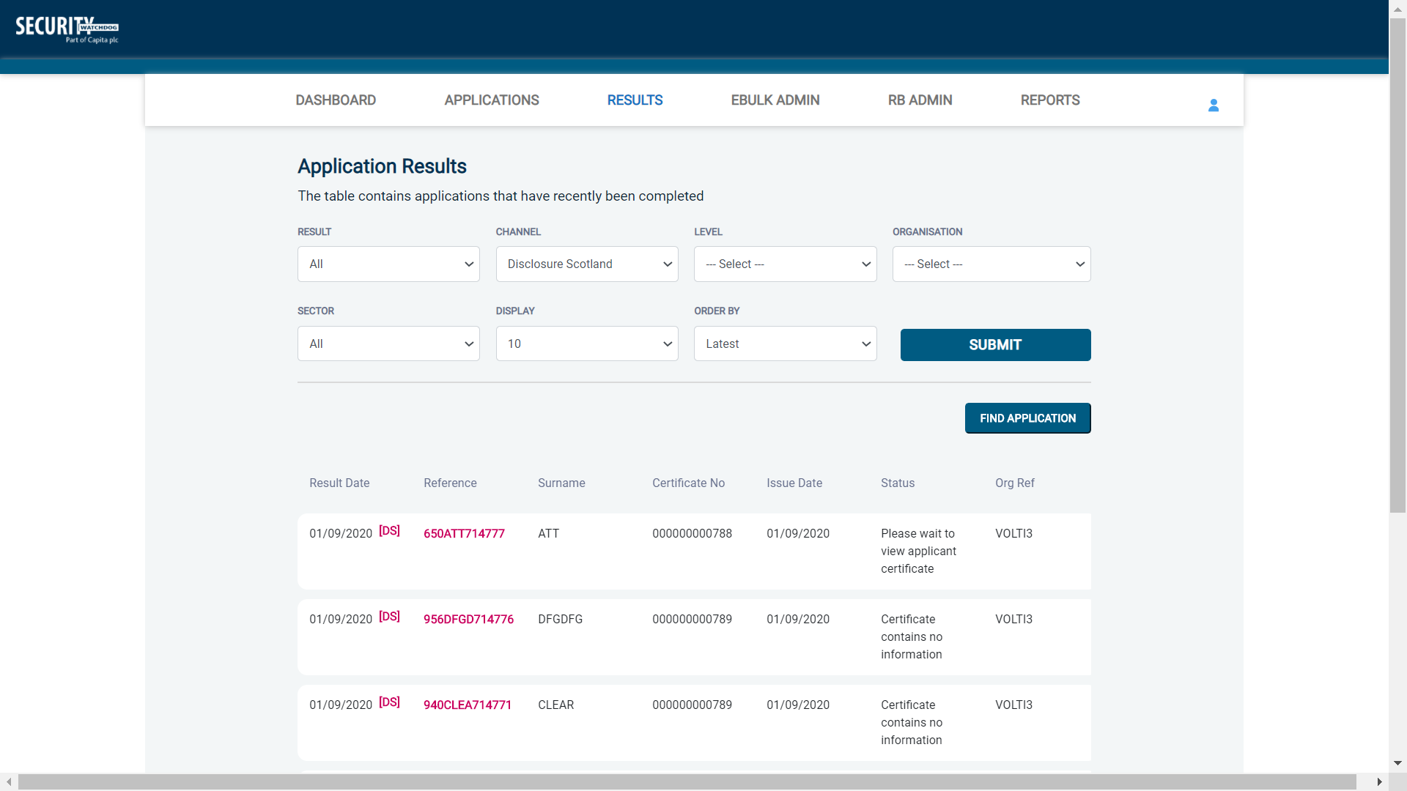
Screen Shot 35

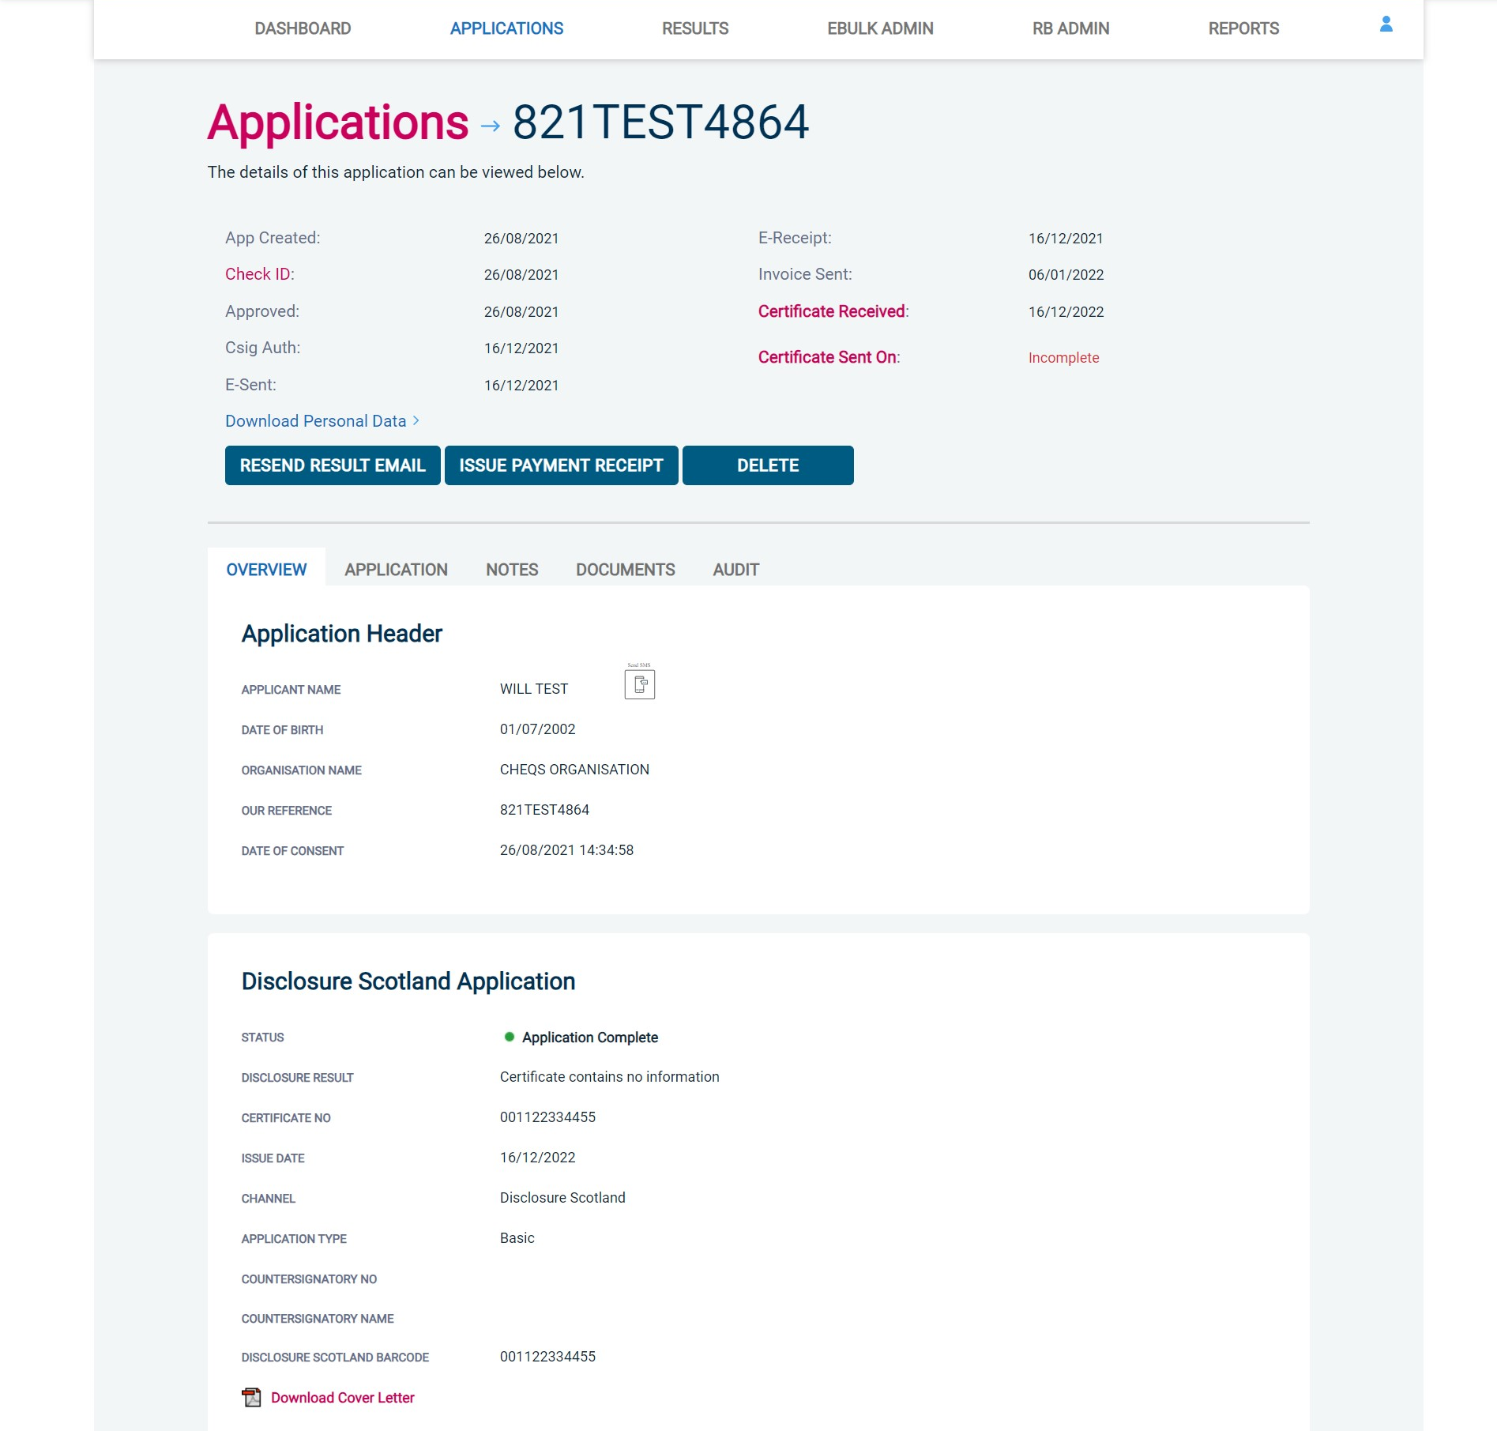
Screen Shot 36

If you wish to post a hard copy of the certificate to the client then you can click ‘Download Cover Letter’ from the Overview screen. This will open a PDF letter with the name and address of the primary contact for that organisation, which can be printed to accompany the certificate (see screen shot 37 below). You will also need to update the ‘Disclosure Sent On’ date on the right-hand side of the screen to log on the system the date the certificate was posted.

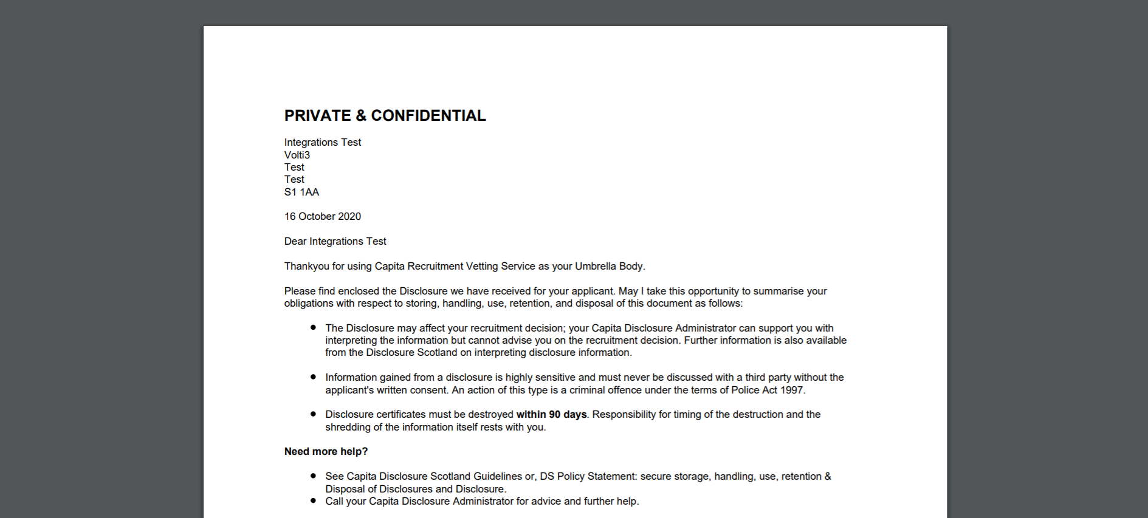
Screen Shot 37

Section E – Right to Work application results

Step 1 - Notification – refer back to screen shot 29 above.

- An automated email will be issued once a digital Right to Work check has been completed. To view a result for a Right to Work application, please return to the Dashboard and click on ‘Completed’ in the Submitted section.

Step 2 - Viewing a Right to Work result– see screen shot 36.

- To view the result of the Right to Work check, click on the applicant’s reference number (see screen shot 38). This information will stay in the ‘Completed’ folder for 365 days from the issue date of the digital ID report. To download the full PDF report, click ‘Download Digital ID Report’ (see screen shot 39).

- Digital Right to Work results will state one of the following results in the ‘Status’ column;

  - Pass – The applicant’s Right to Work has been successfully established
  - Fail – The applicant’s Right to Work has not been successfully established, you will need to download the Digital ID Report to understand why
  - See Report – The applicant’s Right to Work check has been carried out and involved a share code as the applicant is of non-UK origin. You will need to download the Digital ID Report to get the full detail of their Right to Work status

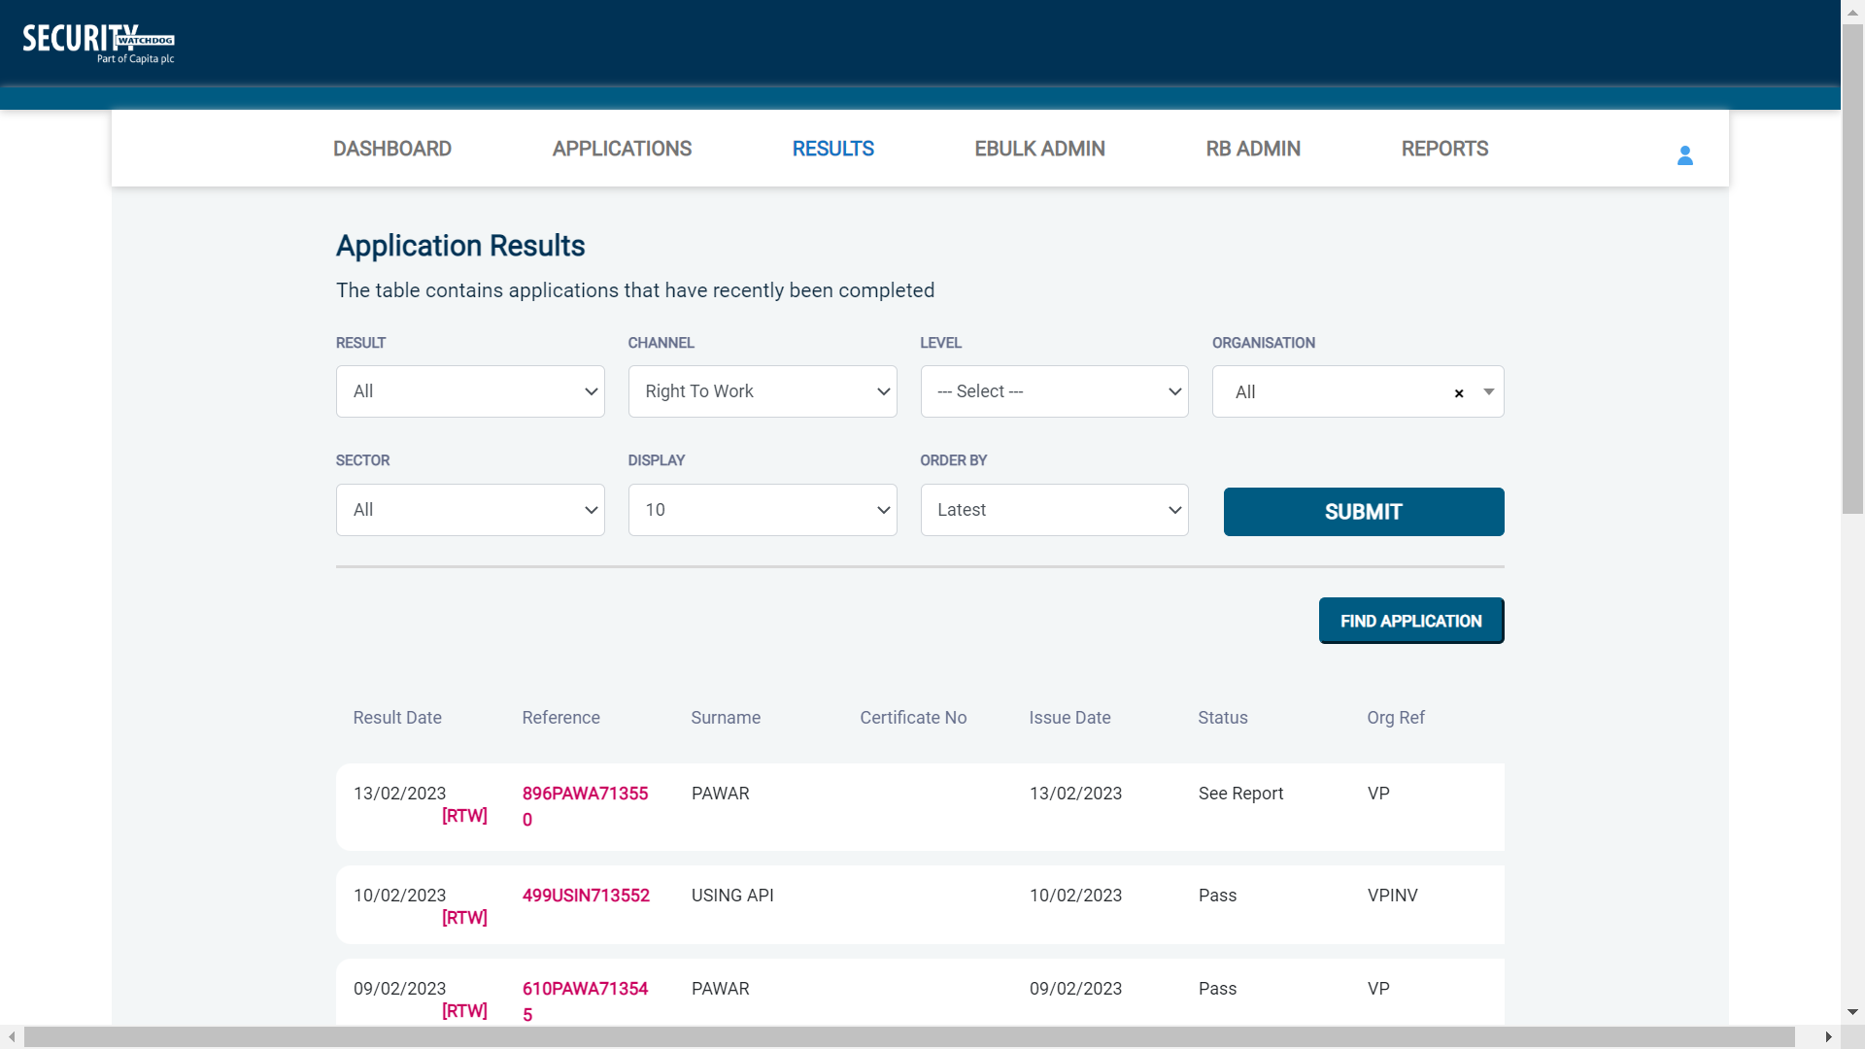
Screen Shot 38

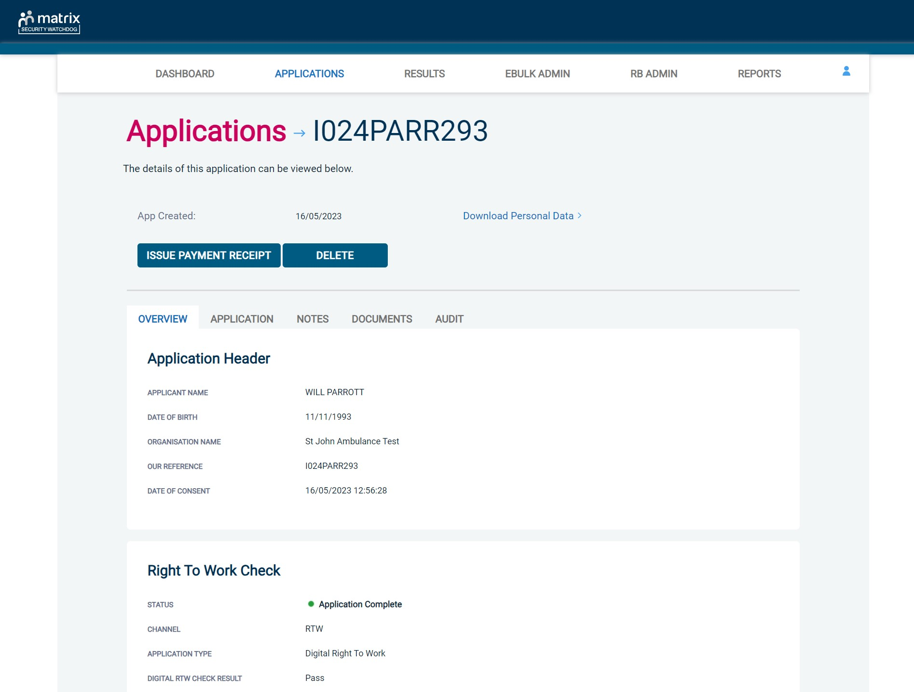
Screen Shot 39

Section F – reports

Step 1 - Running a report – see screen shot 40
- To run a report, you need to return to the Dashboard, select the tab ‘Reports’ and then select the report you wish to run. There are currently a series of main standard reports that you can choose from, however it is also possible to run a customised report (please note that if you only process Standard/Enhanced DBS checks, you can ignore the lower section of the reports screen containing Basic Disclosure report information).

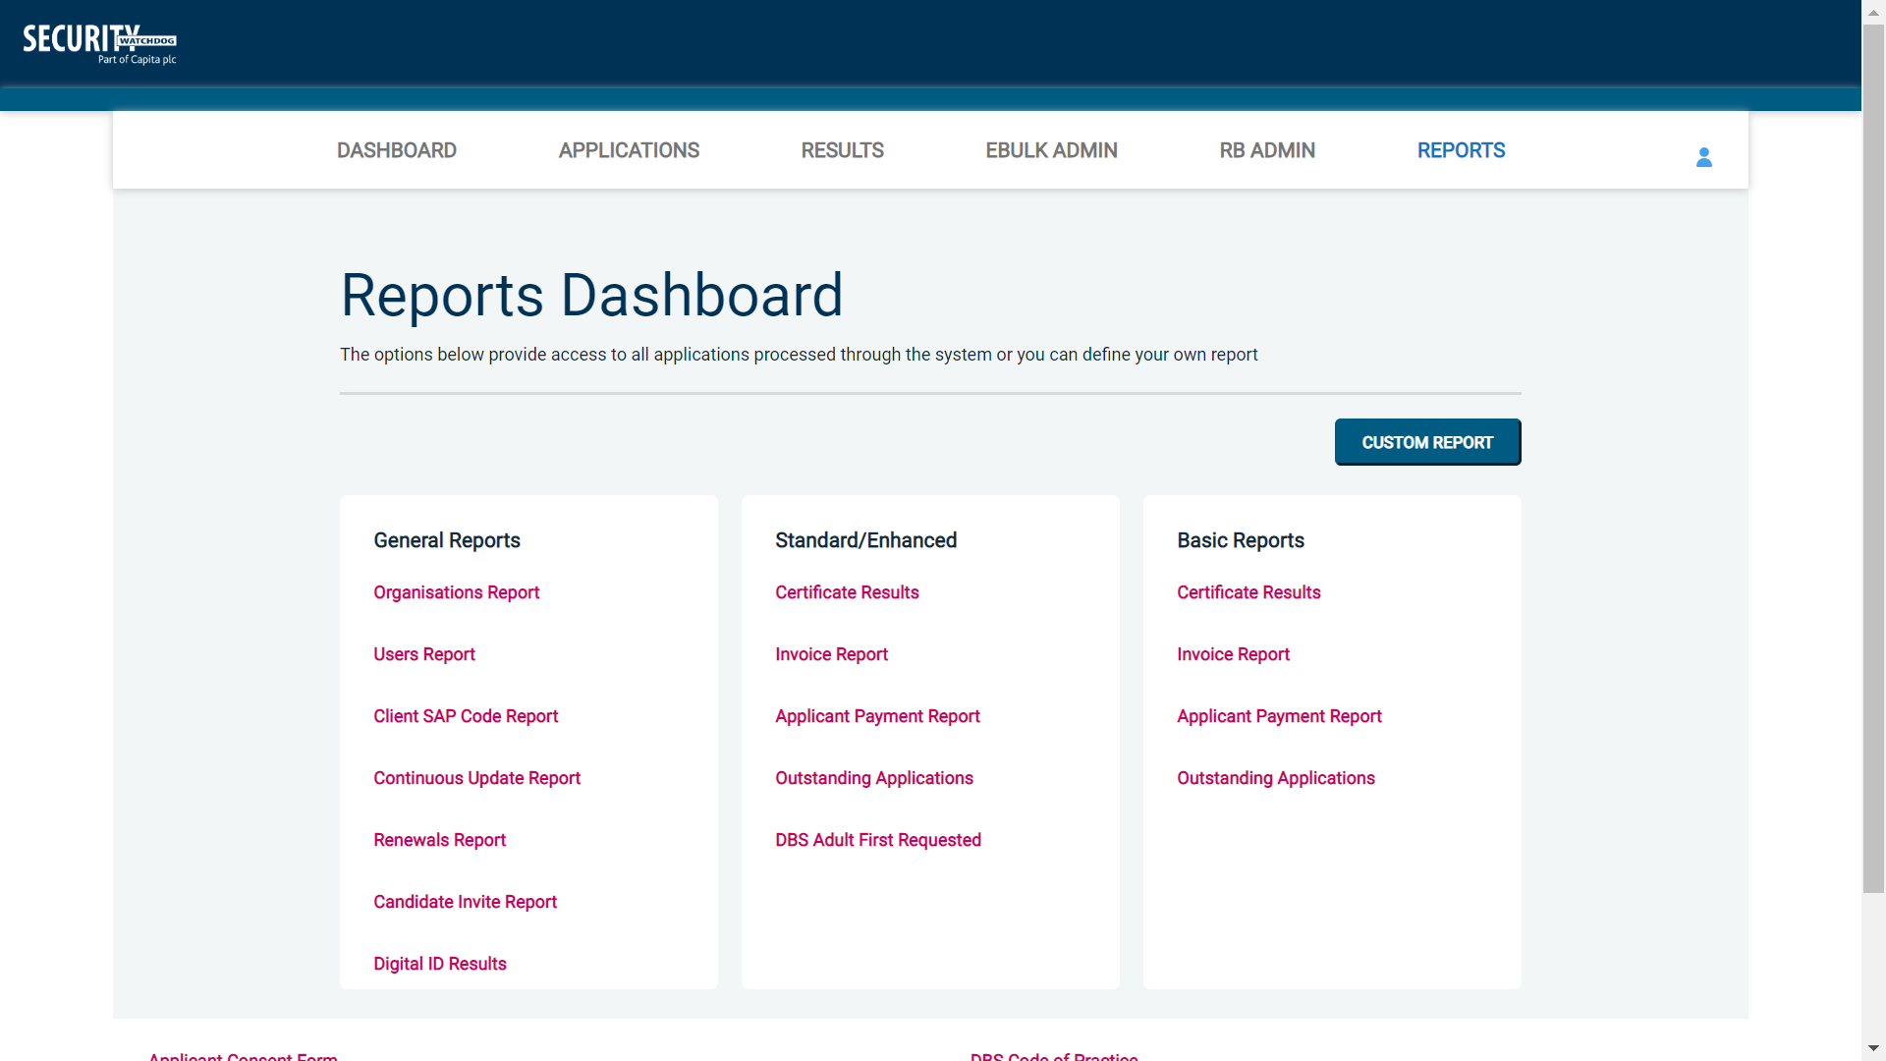
Screen Shot 40

Stage 2 – Invoice Report – see screen shot 40 above
This report will allow monthly invoice reports to be run and can be filtered by a specific organisation on the eBulkPlus system or can be run for all organisations. The report can be used to capture applicant and organisation data with the addition of:
- Basic Fee
- Cost Code
- Organisation Postcode
- Admin Fee
- VAT
- Total application price
In order for the system to be able to capture the above data, each organisation on eBulkPlus will require additional data to be entered at set-up stage. A section will be visible on an organisation’s record entitled ‘Application Payment Calculation’ (see Screen Shot 41 below).

* Please note that all organisations currently set up on your eBulkPlus system will need the Application Payment Calculation section manually updating on their organisation set-up page (screen shot 41 below). Without this data entered into an organisation’s record, it will not be captured in the invoice report *
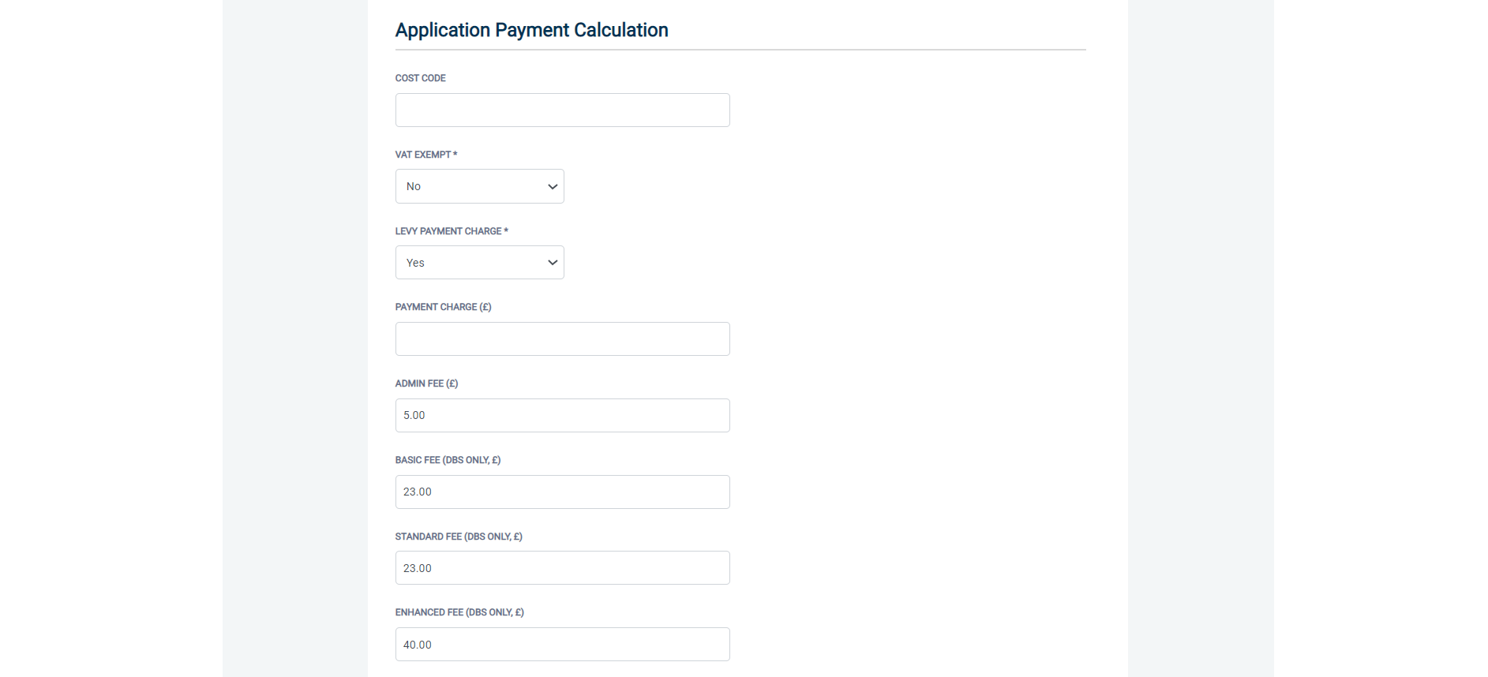
Screen Shot 41

Applications that are already at ‘Awaiting Authorisation’, ‘Processing’ or ‘Completed’ stage before their organisation’s set-up page is updated with the Payment Details will not be captured in an invoice report. Only applications currently at the ‘Awaiting Verification’ stage when the organisation set-up page is updated, will then be captured in an invoice report, once submitted to the DBS.

Stage 3 – Organisations and Users Reports – see Screen Shot 40 above
These reports allow organisation and user data to be extracted from the eBulkPlus system.

The organisation report will provide full organisation information on all organisations created between the dates specified which can be exported into an Excel spreadsheet if required (see Screen Shot 42 below).

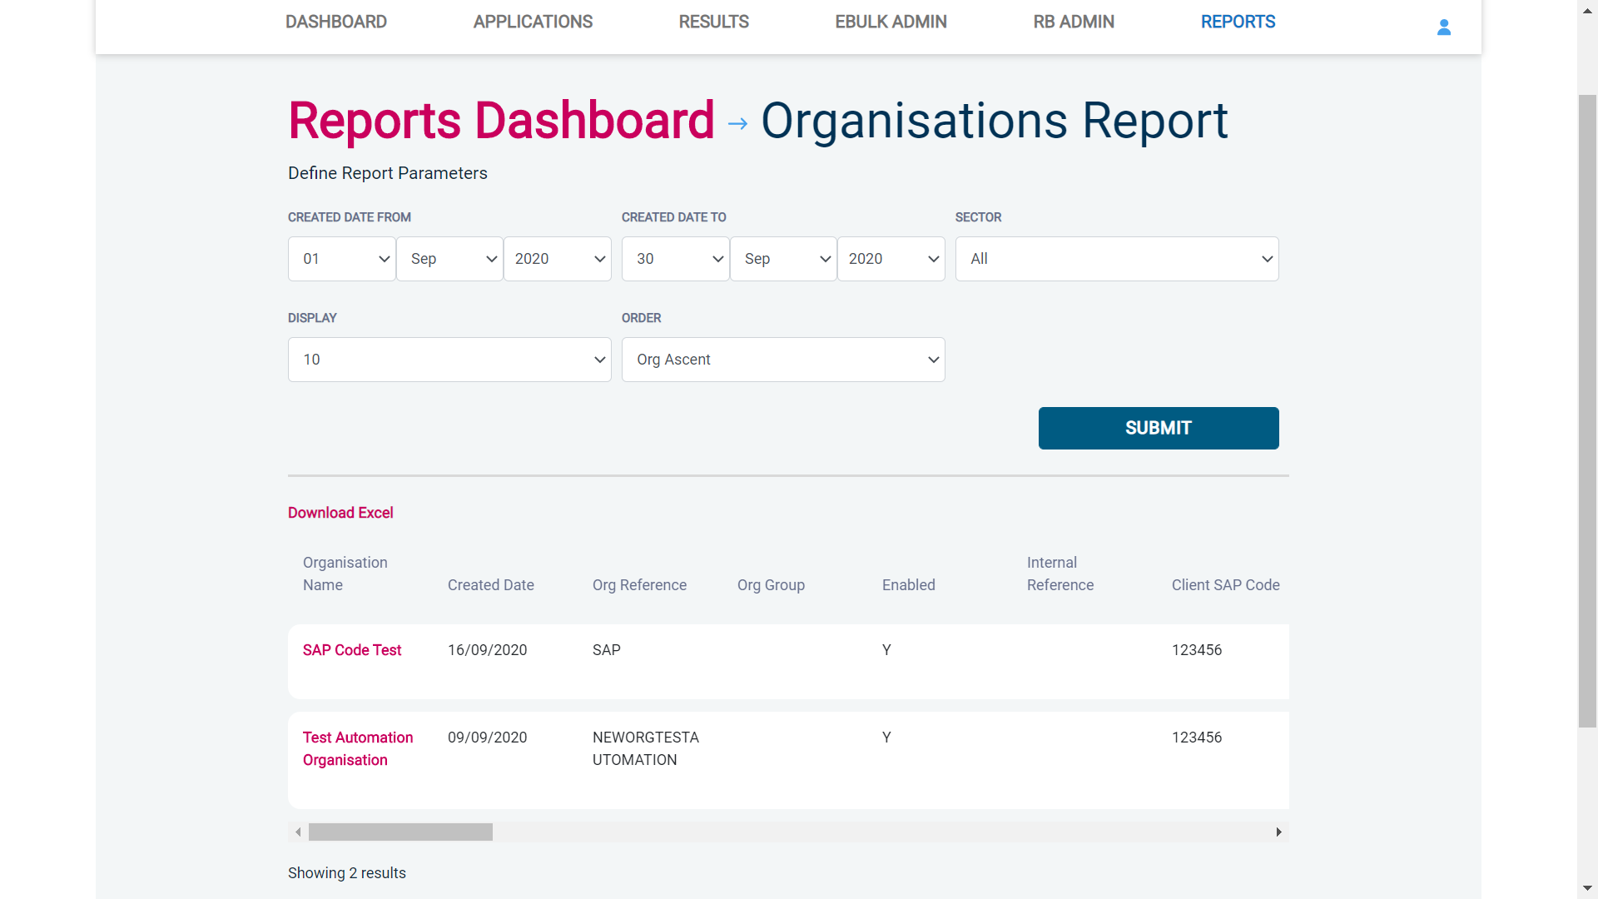
Screen Shot 42

The users report will provide full user information on all users created between the dates specified which can be exported into an Excel spreadsheet if required (see Screen Shot 43 below).

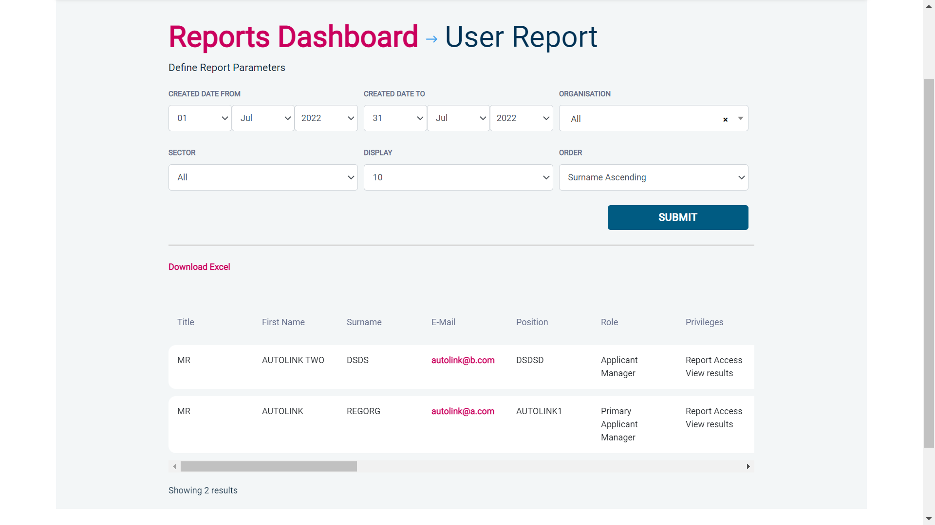
Screen Shot 43

Stage 4 - Customised Reports and selecting field headings – see screen shot 44
To run a customised report, you can select the field headings and date criteria that you wish the report to contain. For example, this is an ideal opportunity to run a report when carrying out re-checks on your staff, or for capturing cost codes for invoicing purposes. All reports can be printed or saved into an Excel spreadsheet (.CSV file) or PDF document.

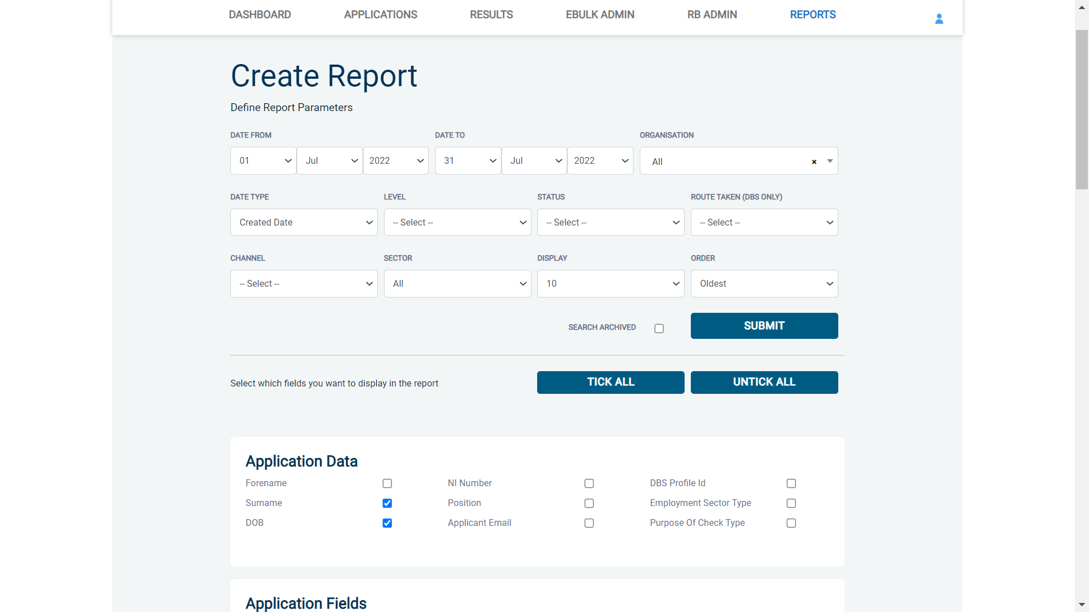
Screen Shot 44

Section G – find an application

Step 1 - Finding an individual application – see screen shot 45
- To find an individual application pre or post DBS processing, select from the Dashboard the Applications tab and then click on ‘Find Application’.

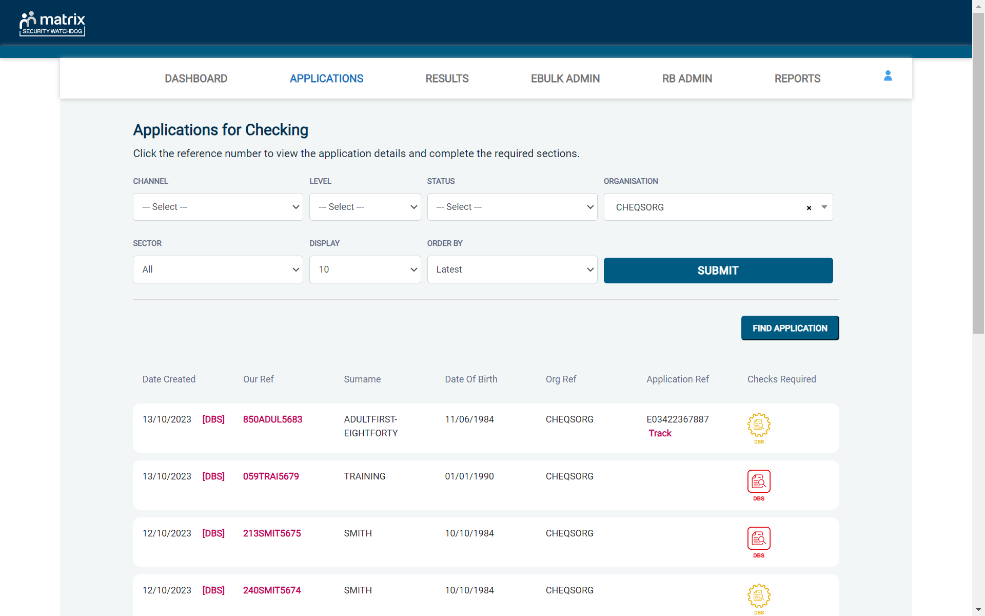
Screen Shot 45

A box will appear for you to enter as much of the applicant’s details as you have available. E.g., if you only enter the surname without date of birth or DBS reference, it will bring up a list of every applicant with that surname; however if you enter their date of birth as well, this will then define the search results accordingly. If you tick the ‘Search Archived’ button, this will display applications that have been archived from the system.

Screen Shot 46

Section H – internal actions / housekeeping

Resetting a user’s password
Once a user has been set-up on eBulkPlus, there is a facility to reset a user’s password in the event they have forgotten their original password, or they suspect their password may be compromised.
To reset a user’s password, complete this process by following the steps below:
- Within RB Admin click on ‘Users’ and select the relevant user that requires the password reset
- Click on ‘Reset Password’ (see screen shot 10). Once selected and confirmed, this will send a new one-time password to the user’s email address that is detailed within their user account details.

Resetting a user’s date of birth
Once a user has been set-up on eBulkPlus, there is a facility to reset a user’s date of birth in the event they have forgotten the date of birth their account has been set to, or suspect they may have entered their date of birth incorrectly at initial login.
To reset a user’s date of birth, complete this process by following the steps below:
- Within RB Admin click on ‘Users’ and select the relevant user that requires the date of birth reset
Click on ‘Reset Date of Birth’ (see screen shot 9). Once selected and confirmed, this will send a new temporary date of birth to the user’s email address that is detailed within their user account details.

Deleting / disabling a user from accessing eBulkPlus
If a user has been set-up on eBulkPlus but has never logged onto the system for whatever reason, and will not be accessing the system going forward, it is important to remove the access privileges previously given in these instances to ensure 100 per cent security of the system.
To delete a user from the system, complete this process by following the steps below:
- Within RB Admin click on ‘Users’ and select the relevant user that requires the password reset
- Click on ‘Delete User’ (see screen shot 10). Once selected and confirmed, this will completely remove the user’s privileges to access the system
- NB. If a user has accessed eBulkPlus previously but no longer needs access to the system, it is advisable not to delete users from the system in these instances due to future auditing requirements. In this scenario, just set the users access to ‘No’ in regard to enabling a user to access eBulkPlus (see screen shot 10)

Withdrawing an application from eBulkPlus
An application form can be withdrawn at any time on eBulkPlus up to and including Countersignatory stage. To delete an application from the system, complete this process by following the steps below:
- Within Applications select the relevant application that needs removing from the system as per the usual procedures.
- Click on ‘Withdraw’.
- Enter the reason for withdrawal and click ‘Confirm’. Once confirmed, this will completely remove the application from eBulkPlus.
NB. Once a form has been electronically transferred to the DBS it cannot then be withdrawn without still incurring the DBS charge.

Withdrawing applications in ‘Processing’
Any applications that have been withdrawn by DBS can be removed from the system by opening the application and clicking the ‘Withdraw’ button and enter the reason for withdrawal.
If an application is withdrawn in error, this will need to be re-input on the system as this cannot be re-instated once it has been withdrawn.

Amending applications on eBulkPlus
Due to Countersignatories/Primary Applicant Managers only having the privilege to amend application forms, it will be necessary from time to time for ID Checkers and Applicant Managers to contact you to amend an application to enable the necessary pre-processing steps to be taken prior to countersigning.
If, for example, a middle name is missing on an application, or an applicant’s date of birth has been entered incorrectly, these will need to be amended before the ID verification on that application form can be completed.
To amend or add any personal information on an application in eBulkPlus, complete this process by following the steps below:
- Within Applications select the relevant application that needs amendments as per the usual procedures
- Click on ‘Edit’ in relation to the section where the amendment(s) are necessary
- Make the necessary amendment(s) to the application and then click on ‘Save & Return’.
As soon as amendments are made to an application this will enable the ID verification to be recommenced and completed by an ID Checker or Applicant Manager.

Deleting applications – GDPR right to erasure request
As a Countersignatory, you can perform a right to erasure request under the UK General Data Protection Regulation. To satisfy a request, you can permanently delete an eBulk application that leaves no trace of its existence in either the front-end system or back-end database. The only data that will be retained after an application has been ‘deleted’ is a reference number for the application, the date it was deleted and by which user.
To delete an application as part of a right to erasure request, please complete the following steps below;
- Within Applications select the relevant application that needs to be permanently deleted
- Click on ‘Delete’
- Confirm that you wish to do so by proceeding on the pop-up box displayed
Download Personal Data – GDPR data portability request
As a Countersignatory, you can perform a data portability request under the UK General Data Protection Regulation. To satisfy a request, you can download an applicant’s personal data into an XML file that you can then securely send to the individual making the request. Please note, it is your responsibility once you have downloaded the file, to ensure it is securely transferred and disposed of accordingly.
To download an applicant’s personal data as part of a data portability request, please complete the following steps below;
- Within Applications select the relevant application that you wish to download the personal data from
- Click on ‘Download Personal Data’
- This will download an XML file of that data in your browser for you to securely transfer
An audit trail will be kept within the ‘Audit’ tab of an application showing any user that has downloaded the personal data of an application. A log will be kept detailing the name of the user that performed the function, as well as the date and time it was performed.

ALL USERS – PLEASE LOG OFF AT THE END OF YOUR SESSION. IF A SESSION IS INACTIVE FOR MORE THAN TEN MINUTES YOU WILL BE AUTOMATICALLY LOGGED OFF DUE TO SECURITY REASONS.

CONTACT DETAILS
If you experience any technical issues on downtime regarding eBulkPlus, please contact XXXXX on XXXXX. Alternatively, you can contact us by e-mail at XXXXX. Please note any general user access issues or queries should be attempted to be dealt with by the Registered Body before escalating to Security Watchdog.

DBS List of Acceptable Identification

For paid non-UK nationals only

(3 documents to be seen)

1 Primary Document
2 Supporting Documents from Group 1, 2a or 2b.

Combination of documents must confirm name, DOB & current address.

If unable to satisfy this route, DBS check cannot be submitted.

Route 2 – UK applicants only
(3 documents to be seen plus an External ID Check)

1 document from Group 2a.
2 further documents from Group 2a or 2b.

Combination of documents must confirm name, DOB & current address.

If unable to satisfy Route 2, proceed to Route 3/Fingerprints.

Route 1 – For all applicants except paid non-UK nationals
(3 documents to be seen

1 document from Group 1.
2 further documents from Group 1, 2a or 2b

Combination of documents must confirm name, DOB & current address.

If unable to satisfy Route 1, proceed to Route 2/Fingerprints.

Fingerprints

Paper application form required (unable to process online).

Attendance at a local Police Station for fingerprints to be taken.
Route 3 – For UK applicants only
(5 documents to be seen)

A UK Birth Certificate issued after birth.
4 further documents, 1 from Group 2a, 3 from 2a or 2b.

At least one of the documents must show the applicant’s current address.

If unable to satisfy Route 3, proceed to Fingerprints.

Group 1
Primary Identity Documents
- Current valid Passport
- Biometric Residence Permit (UK)
- Current Driving Licence – photo card (UK / Isle of Man / Channel Islands) (Full or Provisional)
- Birth Certificate (UK / Isle of Man / Channel Islands) (Issued within 12 months of birth)
Full or short form acceptable including those issued by UK authorities overseas, such as Embassies, High Commissions & HM Forces. (Photocopies are not acceptable)
- Adoption Certificate (UK / Channel Islands)

Paid Non-UK Nationals
Primary Documents
- A current passport or passport card showing that the holder is a national of the Republic of Ireland.
- A current document issued by the Home Office to a family member of an EEA or Swiss citizen, and which indicates that the holder is permitted to stay in the United Kingdom indefinitely.
- A current Biometric Immigration Document (Biometric Residence Permit) issued by the Home Office to the holder indicating that the person named is allowed to stay indefinitely in the UK or has no time limit on their stay in the UK.
- Online evidence of immigration status. Either via the View and Prove service or using the BRP or BRC online service. Issued by the Home Office to the employer or prospective employer, which indicates that the named person may stay in the UK and is permitted to do the work in question. Must be valid. Note: this includes the EUSS digital status confirmation.
- A current passport endorsed to show that the holder is exempt from immigration control, is allowed to stay indefinitely in the UK, has the right of abode in the UK, or has no time limit on their stay in the UK.
- A current Immigration Status Document issued by the Home Office to the holder with an endorsement indicating that the named person is allowed to stay indefinitely in the UK or has no time limit on their stay in the UK, together with an official document giving the person’s permanent National Insurance number and their name issued by a government agency or a previous employer.
- A current passport endorsed to show that the holder is allowed to stay in the UK and is currently allowed to do the type of work in question.
- A current Biometric Immigration Document (Biometric Residence Permit) issued by the Home Office to the holder which indicates that the named person can currently stay in the UK and is allowed to do the work in question.
- A current document issued by the Home Office to a family member of an EEA or Swiss citizen, and which indicates that the holder is permitted to stay in the United Kingdom for a time limited period and to do the type of work in question.
- A frontier worker permit issued under regulation 8 of the Citizens’ Rights (Frontier Workers) (EU Exit) Regulations 2020.
- A current Immigration Status Document containing a photograph issued by the Home Office to the holder with a valid endorsement indicating that the named person may stay in the UK, and is allowed to do the type of work in question, together with an official document giving the person’s permanent National Insurance number and their name issued by a government agency or a previous employer.
- A document issued by the Home Office showing that the holder has made an application for leave to enter or remain under Appendix EU to the immigration rules on or before 30 June 2021 together with a Positive Verification Notice from the Home Office Employer Checking Service.
- An Application Registration Card issued by the Home Office stating that the holder is permitted to take the employment in question, together with a Positive Verification Notice from the Home Office Employer Checking Service.
- A Positive Verification Notice issued by the Home Office Employer Checking Service to the employer or prospective employer, which indicates that the named person may stay in the UK and is permitted to do the work in question.

Group 2a  Trusted Government Documents | Group 2b  Financial & Social History Documents
- Current Driving Licence – photo card only (All Countries except Group 1) (Full or Provisional)  - Current Driving Licence – paper version (UK / Isle of Man / Channel Islands) (Full or Provisional)  - Birth Certificate (UK / Isle of Man / Channel Islands) (Issued after the time of birth)  - Marriage / Civil Partnership Certificate (UK / Channel Islands)  - HM Forces ID Card (UK)  - Fire Arms Licence (UK / Isle of Man / Channel Islands)  - Immigration document, work permit or VISA (Issued outside of UK) (Valid only for roles whereby applicant is living and working outside of UK.) | - Mortgage Statement (UK) **  - Bank/Building Society Statement (UK / Channel Islands) *  Monzo statements or statements printed from the internet are not acceptable  - Bank/Building Society Account Opening Confirmation Letter (UK) *  - Credit Card Statement (UK) *  - Financial Statement e.g. pension, endowment, ISA (UK) **  - P45/P60 Statement (UK / Channel Islands) **  - Council Tax Statement (UK / Channel Islands) **  - Utility Bill (UK) - Not Mobile Phone *  - Benefit Statement (UK) e.g. Child Allowance, Pension *  - Document from Central/ Local Government/ Government Agency/ Local Authority giving entitlement (UK / Channel Islands) *  e.g. DWP, Employment Service, HMRC, Job Centre, Social Security  - EEA National ID Card – must be valid  - Cards carrying the PASS accreditation logo (UK / Isle of Man / Channel Islands) – must be valid  - Irish Passport Card – must be valid (Cannot be used with an Irish Passport)  - Letter from Head Teacher or College Principal (16-19 year olds in full time education in the UK)  - Non-UK Bank/Building Society Statement *  Branch must be located in the country in which the applicant lives and works  - Letter of Sponsorship from future employer  Non-UK only – valid only for applicants residing outside UK at time of application
Please note if a document in the List of Valid Identity Documents is:
- Denoted with * - issued in the last 3 months
- Denoted with ** - issued in the last 12 months

Disclosure Scotland List of Acceptable Identification

For all applicants
(2 documents to be seen)

1 ID document
1 further proof of address document

Combination of documents must confirm name, DOB & current address.

If unable to supply required documents, basic check cannot be submitted.

Identity Documents

- Current valid Passport
- Biometric Residence Permit (UK)
- Current Driving Licence – photo card (Full or Provisional)
- Birth Certificate (UK / Isle of Man / Channel Islands)
Full or short form acceptable including those issued by UK authorities overseas, such as Embassies, High Commissions & HM Forces. (Photocopies are not acceptable)
- Adoption Certificate (UK / Channel Islands)
- Marriage / Civil Partnership Certificate (UK / Channel Islands)
- HM Forces ID Card (UK)
- Fire Arms Licence (UK / Isle of Man / Channel Islands)
- NHS Card
- EEA National ID Card
- National Identity Card from a country outside the European Economic Area (EEA)

Proof of Address Documents
Issued within the last 12 months
- Mortgage Statement
- Bank/Building Society Statement
Online statements are acceptable however Monzo statements are not acceptable
- Bank/Building Society Account Opening Confirmation Letter (UK)
- Credit Card Statement (Online statements are acceptable)
- Financial Statement e.g. pension, endowment, ISA (UK)
- P45/P60 Statement (UK / Channel Islands)
- Council Tax Statement (UK / Channel Islands)
- Tenancy Agreement (must be typed, not handwritten)
- Utility Bill - Not Mobile Phone (Online statements are acceptable)
- Insurance policy document or letter
- TV Licence letter (UK / Isle of Man / Channel Islands)
- Benefit Statement (UK) e.g. Child Allowance, Pension
- Document from Central/ Local Government/ Government Agency/ Local Authority (UK / Channel Islands)
e.g. DWP, Employment Service, HMRC, Job Centre, NHS
- Letter from Head Teacher or College Principal (16-19 year olds in full time education in the UK)
- Current Driving Licence – photo card (Full or Provisional)
- Fire Arms Licence (UK / Isle of Man / Channel Islands)

