Basic DS Online Disclosure Guide (eBulkPlus)

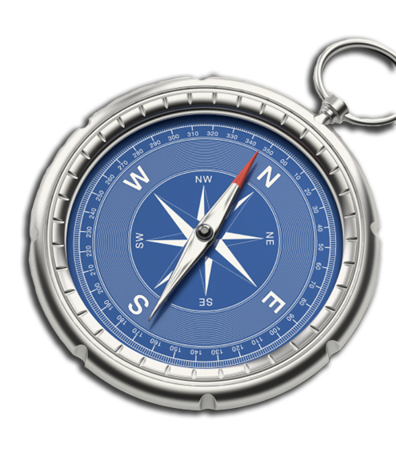
ID Checker Guidance Notes

Contents
ID checker guidance notes 3
Logging onto the system 3
Section A – How to login 3
Section B – How to verify ID 6
Disclosure Scotland List of Acceptable Identification 9

ID checker guidance notes

The eBulkPlus online basic Disclosure Scotland (DS) checks can be completed by accessing the internet from any device that has this facility. This includes a smart phone, tablet, laptop or PC. It is supported on the latest versions of all modern browsers; however, we do not recommend access via Internet Explorer as this browser is unsupported both by our technology and soon by Microsoft also.
You have been granted access to eBulkPlus in the role of an ID Checker. An ID Checker can view all applications created under the organisation or specific division they have been created under. The ID Checker can stipulate what ID has been seen in relation to an applicant. The ID Checker will then need to advise an Applicant Manager or Countersignatory (where applicable) within their organisation or division to approve the application for countersigning.

Logging onto the system

Please enter the following address into your web browser:
https://matrixscreening.com/xxxxx
You will now be on the main login page, which shows three white boxes. NB *Please note at this stage of the process, your login details are case sensitive.
- Enter your company Organisation Reference - this will have been supplied to you in an automated email (if you cannot remember this please click on the ‘Forgotten your login details?’ icon at the bottom of the screen to be sent a reminder).
- Enter your Username.
- Enter your Date of Birth (for first initial login please ensure you enter the default date of birth 01 Jan 1998. Failure to do so will deny you access to the system).

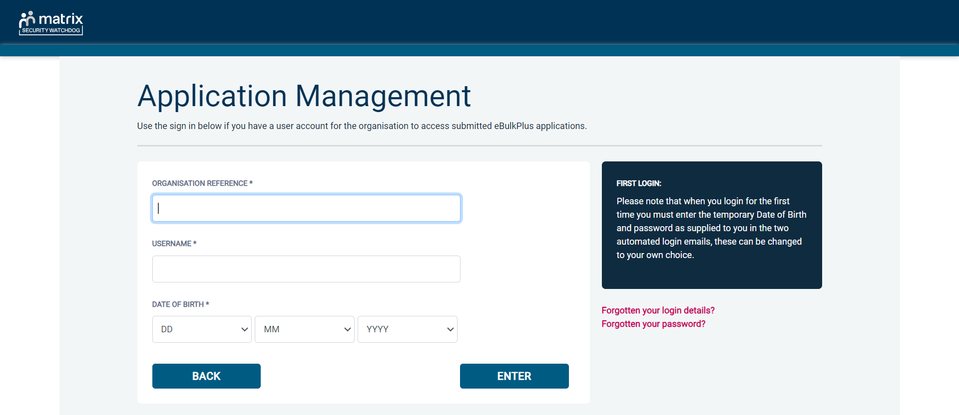
Screen Shot 1

- Once you have completed this section click ‘Enter’.

- Enter your password (this will be supplied to you in an automated email) – see screen shot 2. (If you cannot remember this please click on the ‘Forgotten your password?’ icon at the bottom of the screen to be sent a new one-time password).

If you still have difficulty gaining access to the system please contact XXX, however please ensure the first time you login that you have not been denied access because of entering your own date of birth. The first time you login you must enter the temporary default date of birth 01 Jan 1998.
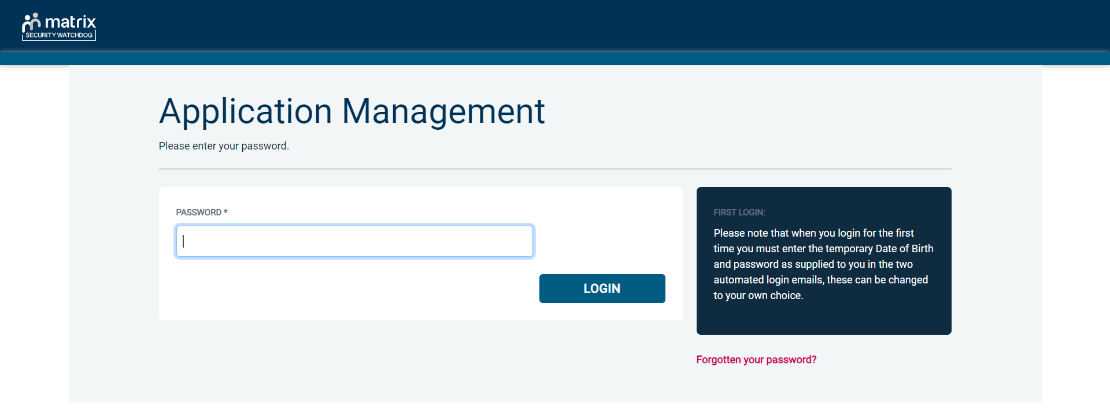
Screen Shot 2
- Please note, after initial login you will be required to set your own password and enter your own date of birth for future login purposes.
- Please re-enter into the ‘Current Password’ field the temporary password you received in your initial email and then create your own unique password – see screen shot 3 below.
- The password you create must be between 8 & 30 characters containing at least one upper case letter, one lower case letter, one special character and at least one number.
- Please then enter a date of birth of your choice for future login purposes.
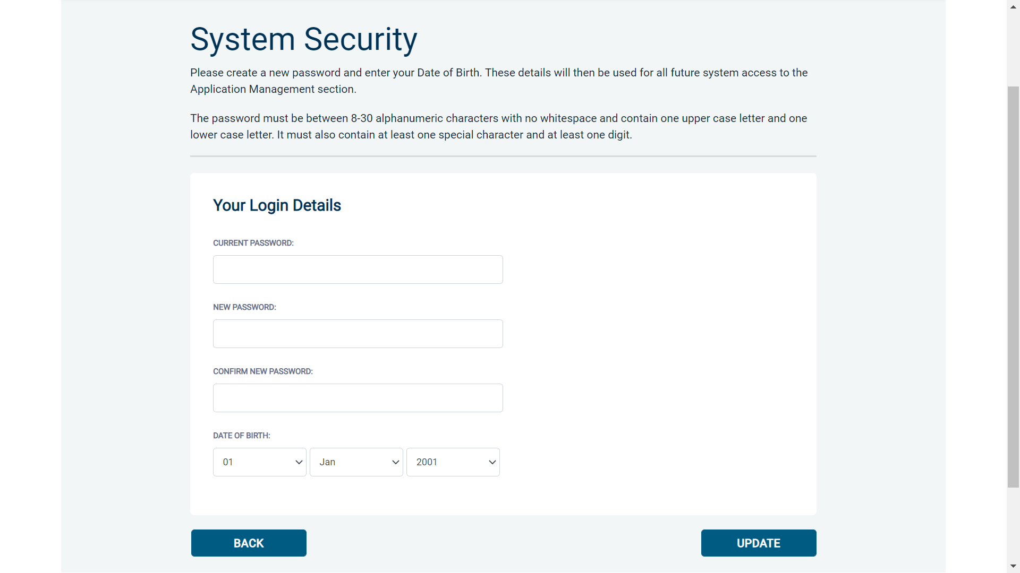
Screen Shot 3
- Please then click ‘Update’

- If you have successfully created your own password, you will now be able to enter the system by clicking the ‘Click here to enter System’ icon in the green box (please note you do not need to re-enter your password details once the green box has appeared).
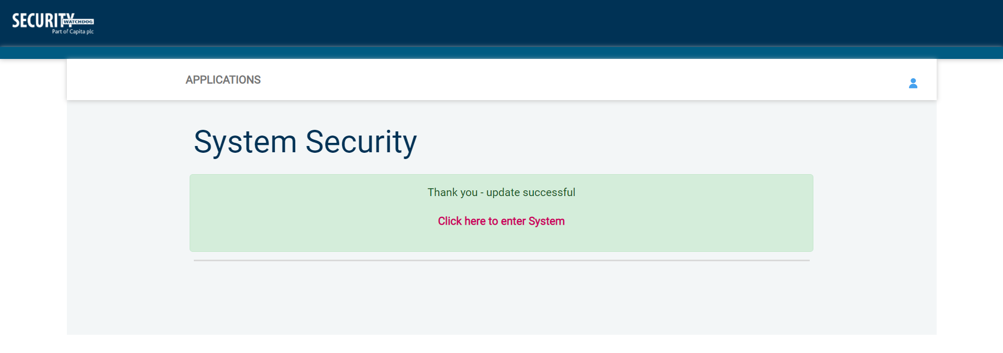
Screen Shot 4
- This will now take you to the eBulkPlus homepage containing a list of ‘Applications for ID Checking’. Please note the list may contain both DBS and Disclosure Scotland applications. DBS applications are marked with ‘DBS’ and Disclosure Scotland applications are marked with ‘DS’.
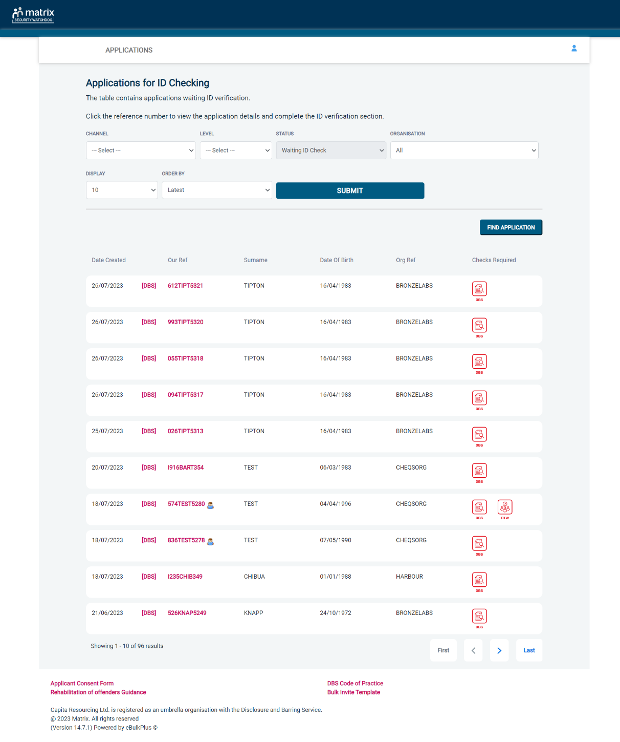
Screen Shot 5

Section B – How to verify ID

Step 1 - On the Applications page, click on the relevant applicant’s reference number to open the application form (see screen shot 6 below).

Screen Shot 6

Step 2 - You will now see two tabs (overview and application), and you will need to check the applicant’s completed form (screen shot 7 & 8 below).

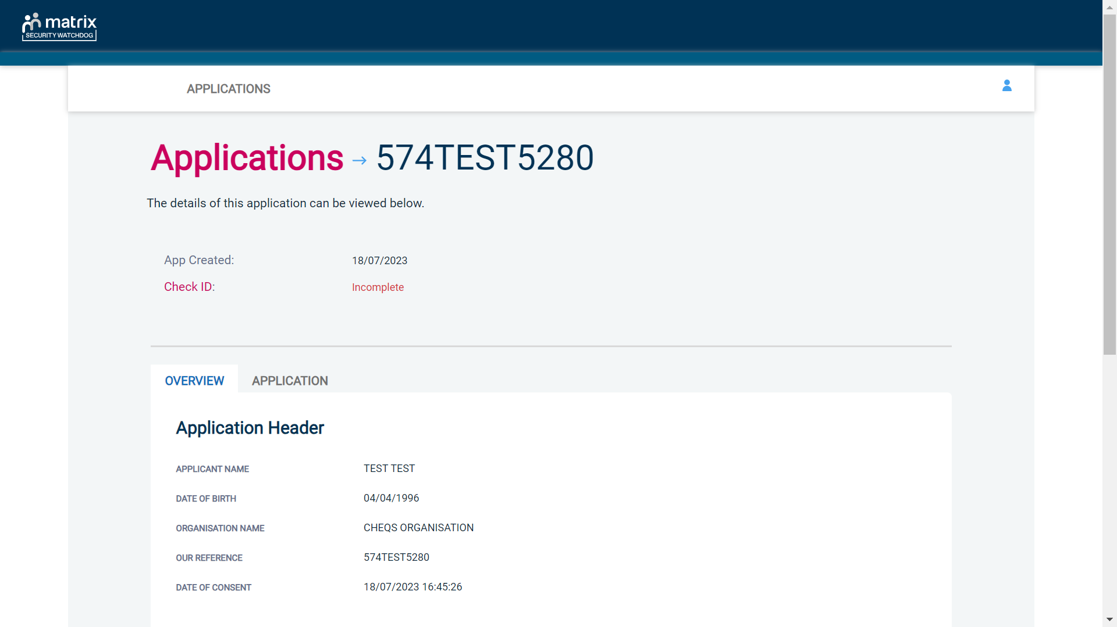
Screen Shot 7
Step 3 - To view the application details entered by the applicant, click on the ‘Application’ tab. Here you can see the entire application submitted by the applicant. This can be used to ensure the correct job role has been entered and to verify any ID given by the applicant in a previous surname or previous address (see screen shot 8).

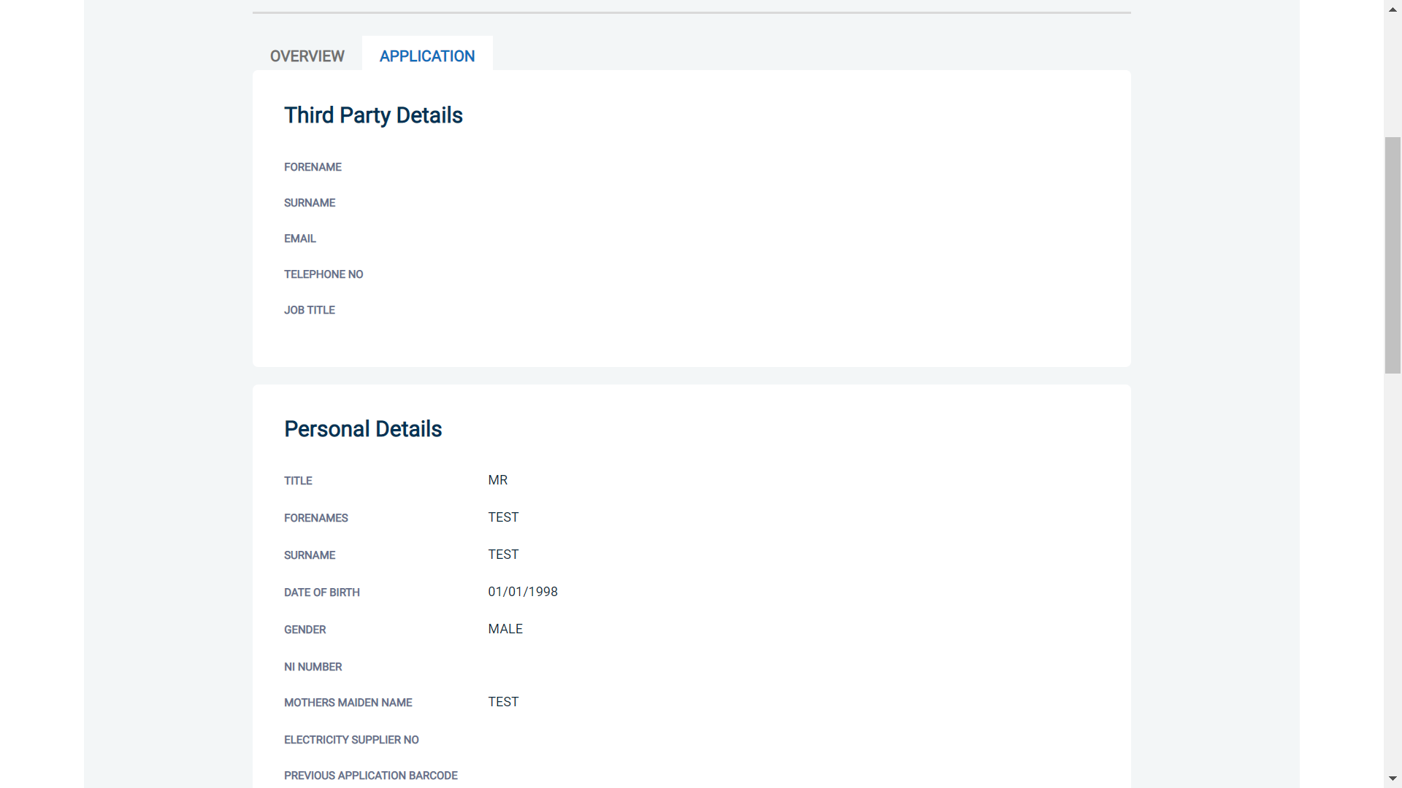
Screen Shot 8

Step 4 – Verifying ID

- You will notice a box at the top of the screen, which highlights if the ID has been verified or not (see screen shot 7 above), with a section completion date. It will say in red ‘Incomplete’ if the section has not been completed. If there is a date present, it means that this action has been completed and will show the date that this was carried out.
- To complete the ID verification section click on ‘Complete ID Check’ (see screen shot 7 above). Access to this section is located in two places – at the top of the screen or on the overview of the actual form itself. You will now be on the ID screen (see screen shot 8 below).

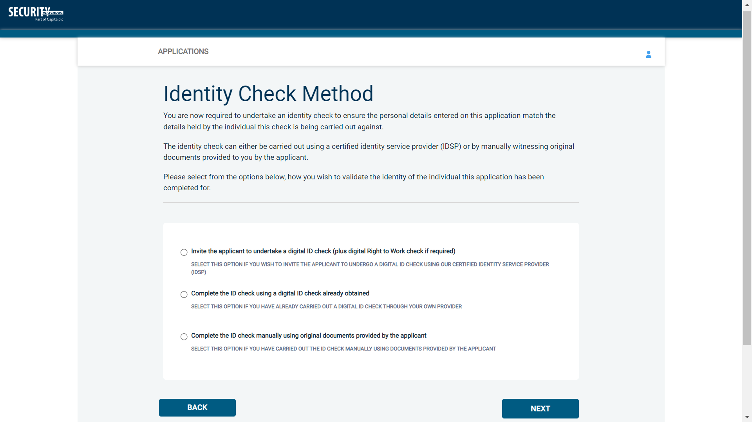
Screen Shot 9

Verifying identity using the eBulk digital ID integration

This facility allows for the identity verification to be performed digitally and remotely without the need for the applicant to present original documents to you to be verified. It also allows you to request a digital Right to Work check at the same time as performing the identity verification digitally. If you wish to carry out the identity check using our certified identity service provider, please select ‘Invite the applicant to undertake a digital ID check (plus digital Right to Work check if required)’ (see screen shot 9 above.)

You will now be taken to the digital invite page which will automatically populate the name and email address of the applicant where present (see screen shot 10 below.) To invite the applicant to undertake just a digital ID check, please select ‘Digital ID Check Only’ from the ‘Digital ID Check Type’ drop-down list and ensure their name and email address are populated along with selecting the email template to issue them. This will generate an email to the applicant allowing them to carry out their digital ID check via our certified IDSP.

To invite the applicant to undertake a digital ID check and a digital Right to Work Check, please select ‘Right to Work + Digital ID Check’ from the ‘Digital ID Check Type’ drop-down list and ensure their name and email address are populated along with selecting the email template to issue them. This will generate an email to the applicant allowing them to carry out their digital ID check and digital Right to Work check at the same time via our certified IDSP.

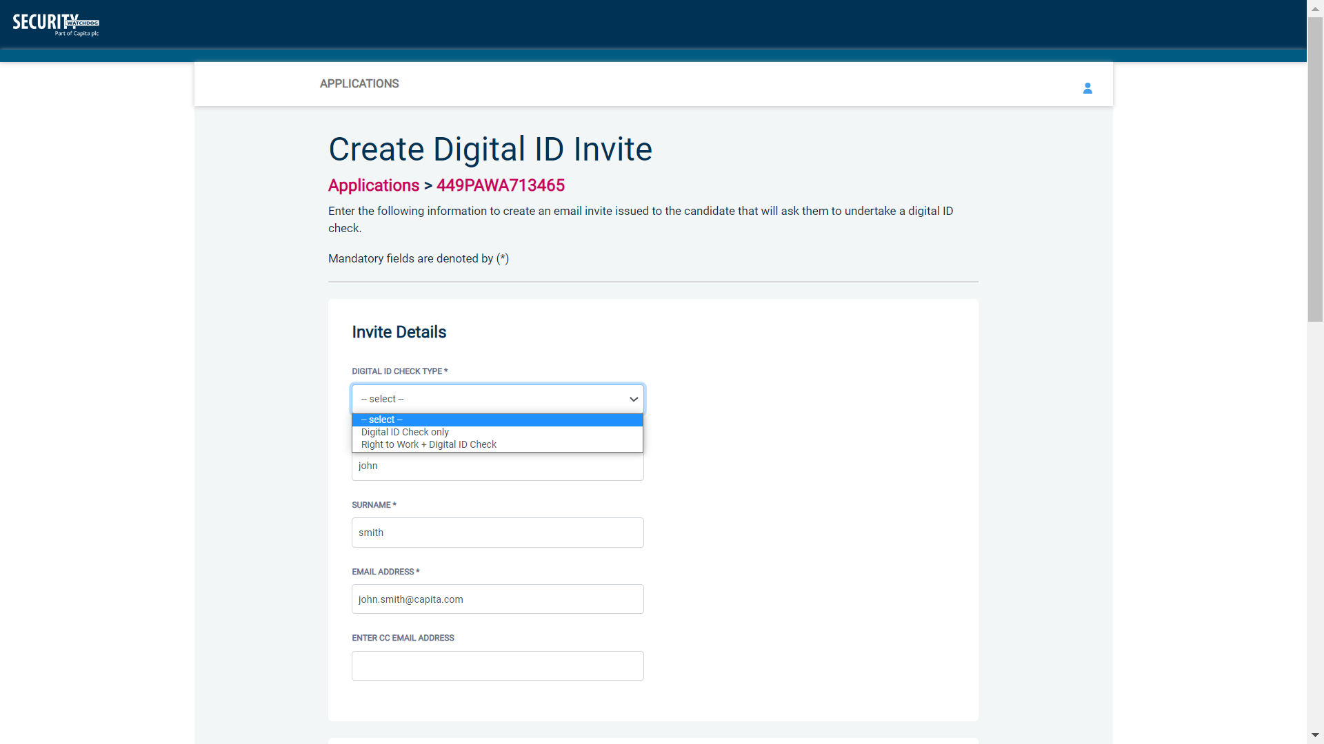
Screen Shot 10

Once the digital ID check has been carried out, the ID section of the application will be updated with either a pass or fail result and a PDF report of the digital ID check can be downloaded by clicking the ‘Download Digital ID Report’ button (see screen shots 11 & 12 below.)

If the result of the digital ID check is ‘FAIL’, you must read the digital ID report to understand why and verify their identity manually depending on the reason the digital ID check failed. To do this, click the ‘RESET ID CHECK’ button at the bottom of the ID screen to restart the identity process, this time selecting an alternative method.

If the result of the digital ID check is ‘PASS’, the ID section will be auto completed upon receipt of the digital ID check result and there will be nothing further to do in relating to the identity verification part of the process.

If a digital Right to Work check was also requested, a ‘RTW Check’ element will be added to the header of the application and will be updated with either a pass, fail or see report result and a PDF report of the digital Right to Work check can be downloaded by clicking the ‘Download Digital ID Report’ button from either the ID screen or the RTW screen.

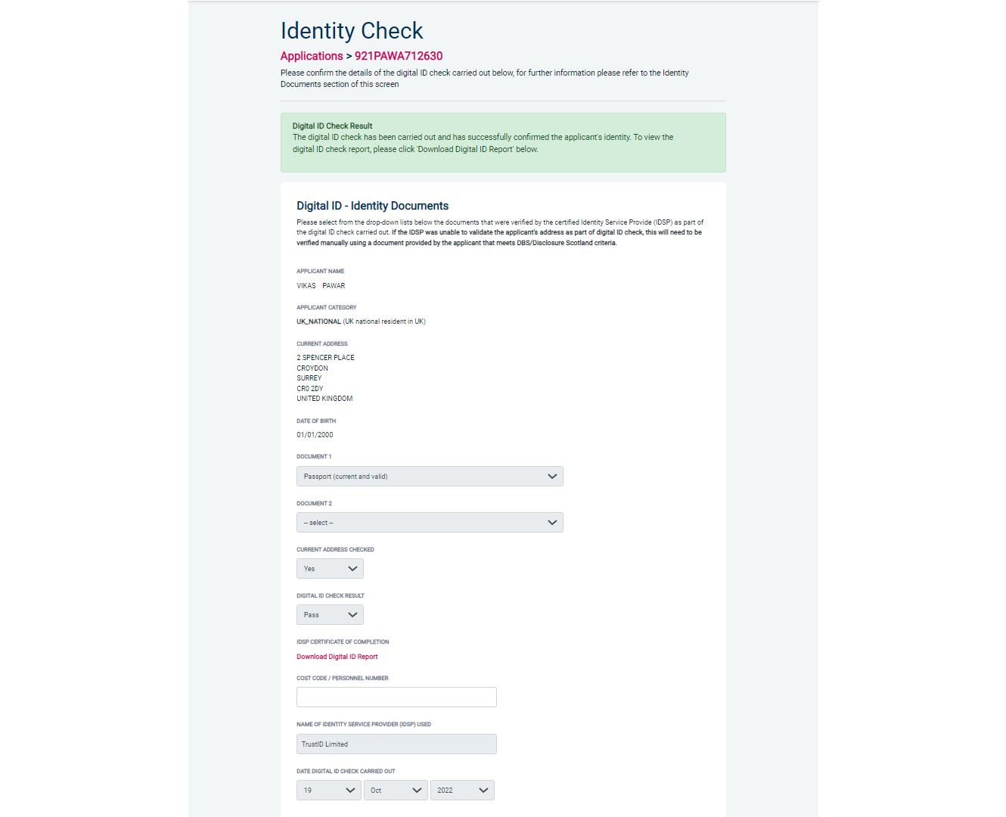
Screen Shot 11

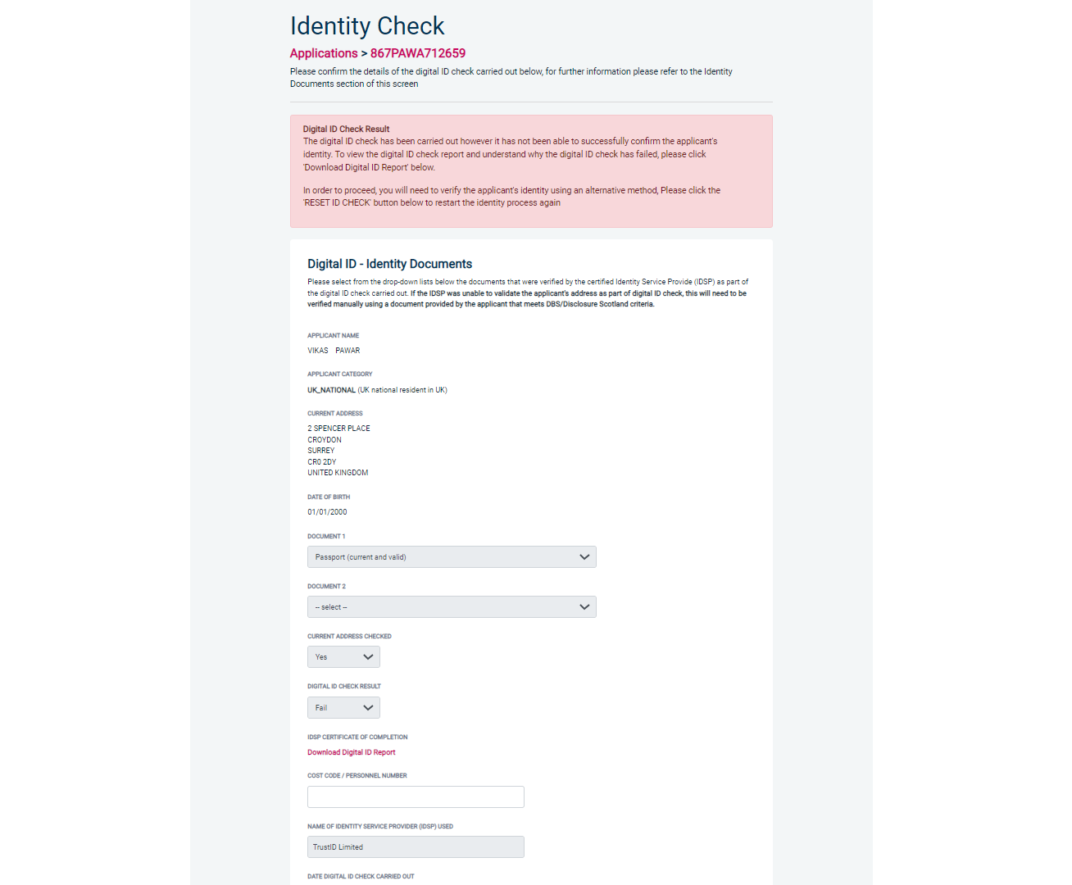
Screen Shot 12
Verifying identity using a digital ID check already obtained

This facility allows you to verify the identity using a digital ID check already obtained via your own IDSP outside of our platform. If you wish to verify the identity using this method, please select ‘Complete the ID check using a digital ID check already obtained’ (see screen shot 9 above and screen shot 13 below.)

- Please select the ID documents verified by the IDSP as part of the digital ID check undertaken.
- Ensure that you confirm from the drop-down boxes that they have verified the applicant’s address and also that they have verified a document containing their date of birth.
- Please upload a copy of the digital ID report obtained from your IDSP by clicking ‘Choose File’
- If a Cost Code or Personnel Number is required to be assigned to the specific application, this can be entered in the Cost Code / Personnel Number field.
- Now click ‘Save’ and then click the ‘Return to Application’ icon in the green box located at the top of the screen. Now you are ready to complete Section Y of the form (this is the equivalent to Section X on the new lilac paper DBS application forms).
- Once the ID Check has been saved, if you realise that it has been completed incorrectly or through the wrong route, you can reset the ID Check section and complete it again if required. Please note, you will only be able to do this if you have been assigned the appropriate user privilege to do so. To do this, go back into the ID Check screen and click the ‘Reset ID Check’ button found at the bottom of the screen.

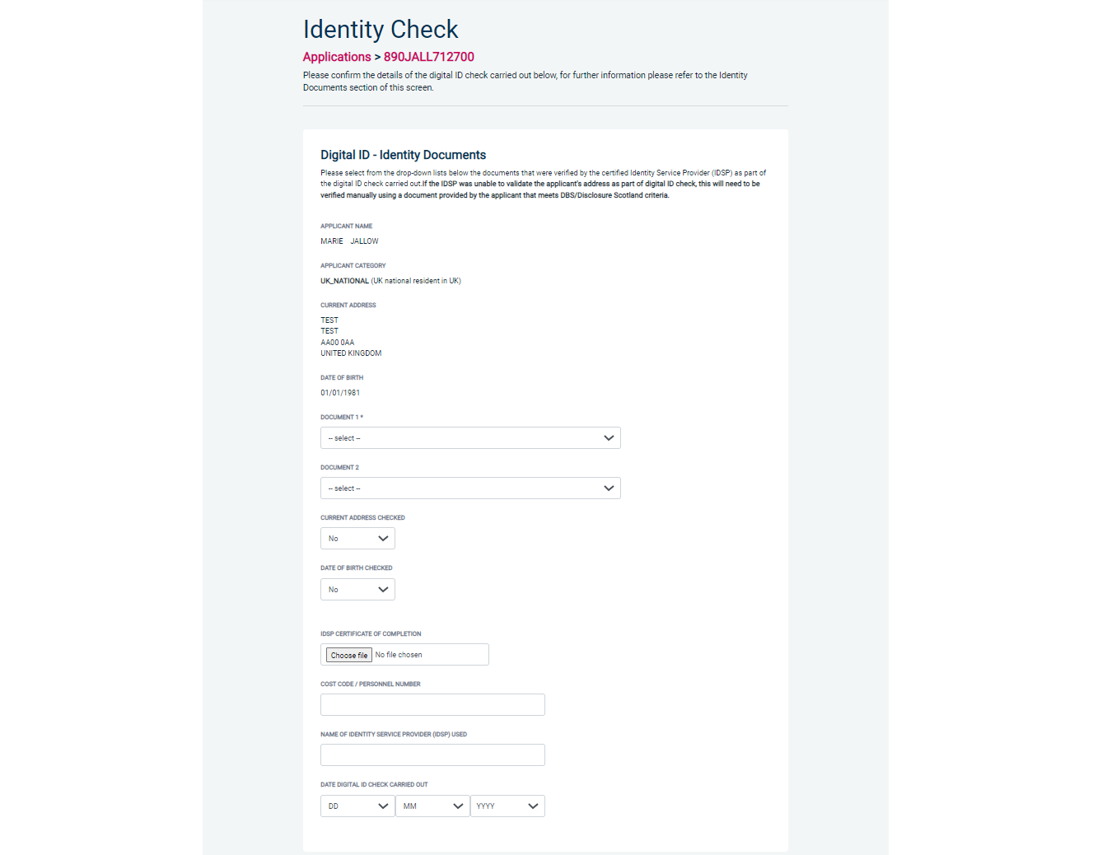
Screen Shot 13

Verifying identity using original documents provided to you by the applicant

If you do not wish to verify identity using a digital ID check, please select ‘Complete the ID check manually using original documents provided by the applicant’ (see screen shot 9 above and screen shot 14 below.)

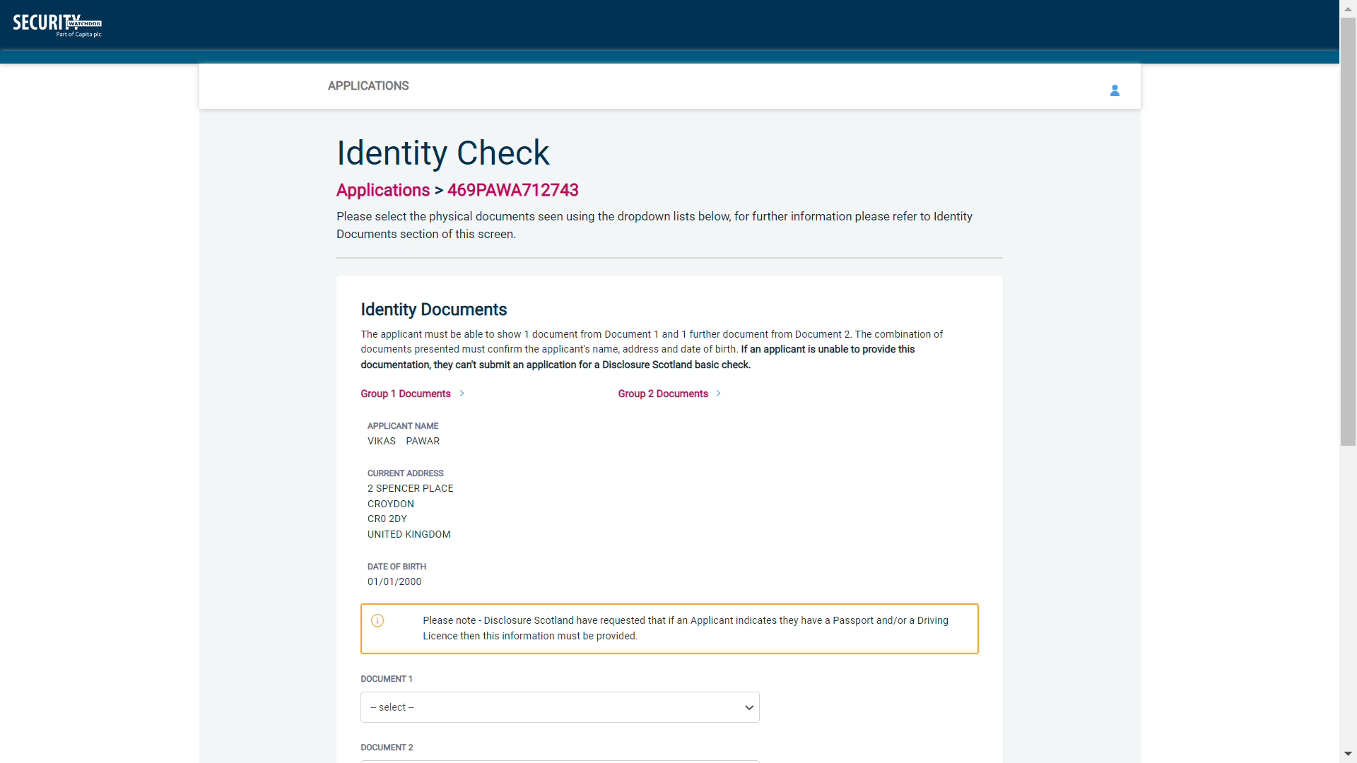
Screen Shot 14

- Please select the ID that the applicant has provided for you from the drop down boxes. Guidance notes can be found at the end of this document and are in accordance with Disclosure Scotland Code of Practice. Please ensure at all times that you follow the ID checking rules e.g. do not accept a bank statement if it is more than 12 months old, and do not accept an out of date passport.
- Ensure that you confirm from the drop down boxes that you have verified a document showing the applicant’s address, and also that you have verified their date of birth.
- If a Cost Code or Personnel Number is required to be assigned to the specific application, this can be entered in the Cost Code / Personnel Number field.
- Finally click ‘Save’ and then click the ‘Return to Application’ icon in the green box located at the top of the screen.

Once you have fully completed the applicant’s identity verification, you will then need to liaise with your appointed Applicant Managers/Countersignatories for the application to be approved. Please note, until the application has been approved, the application will not be able to be forwarded to Disclosure Scotland for processing.

Find an Application

Step 1 - Finding an individual application – see screen shots 15 & 16.

- To find an individual application from the list of applications that require identity verification, please click on ‘Find Application’

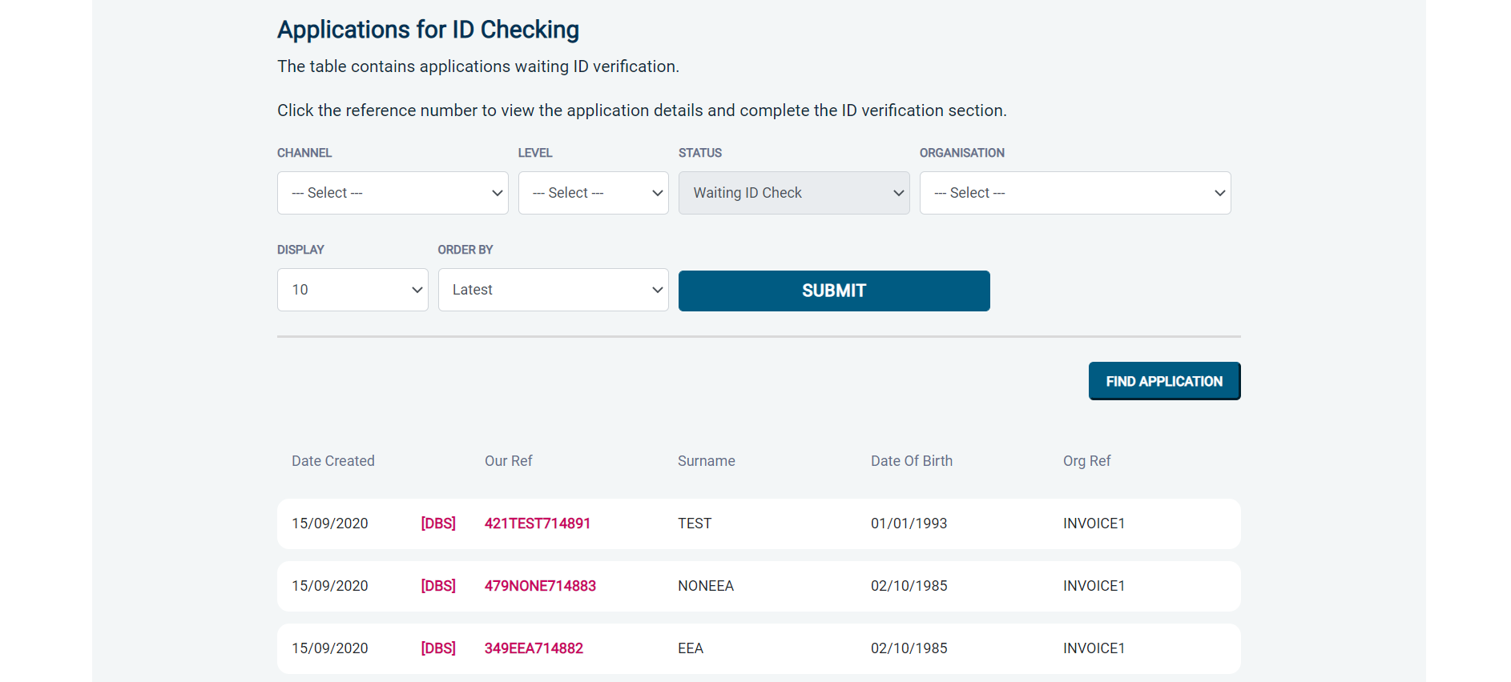
Screen Shot 15

- The following box will appear for you to enter as much of the applicant’s details as you have available. E.g. if you only enter the surname without date of birth or DBS reference, it will bring up a list of every applicant with that surname. However, if you enter their date of birth as well, then this will define the search results accordingly.

ALL USERS – PLEASE LOG OFF AT THE END OF YOUR SESSION. IF A SESSION IS INACTIVE FOR MORE THAN TEN MINUTES YOU WILL BE AUTOMATICALLY LOGGED OFF FOR SECURITY REASONS.

CONTACT DETAILS

If you experience any technical issues with the online system, please contact XXX. Lines open 9.00am-5.30pm Monday to Friday. Alternatively, you can contact us by e-mail at XXX

Disclosure Scotland List of Acceptable Identification

For all applicants
(2 documents to be seen)

1 ID document
1 further proof of address document

Combination of documents must confirm name, DOB & current address.

If unable to supply required documents, basic check cannot be submitted.

Identity Documents

- Current valid Passport
- Biometric Residence Permit (UK)
- Current Driving Licence – photo card (Full or Provisional)
- Birth Certificate (UK / Isle of Man / Channel Islands)
Full or short form acceptable including those issued by UK authorities overseas, such as Embassies, High Commissions & HM Forces. (Photocopies are not acceptable)
- Adoption Certificate (UK / Channel Islands)
- Marriage / Civil Partnership Certificate (UK / Channel Islands)
- HM Forces ID Card (UK)
- Fire Arms Licence (UK / Isle of Man / Channel Islands)
- NHS Card
- EEA National ID Card
- National Identity Card from a country outside the European Economic Area (EEA)

Proof of Address Documents
Issued within the last 12 months
- Mortgage Statement
- Bank/Building Society Statement
Online statements are acceptable however Monzo statements are not acceptable
- Bank/Building Society Account Opening Confirmation Letter (UK)
- Credit Card Statement (Online statements are acceptable)
- Financial Statement e.g. pension, endowment, ISA (UK)
- P45/P60 Statement (UK / Channel Islands)
- Council Tax Statement (UK / Channel Islands)
- Tenancy Agreement (must be typed, not handwritten)
- Utility Bill - Not Mobile Phone (Online statements are acceptable)
- Insurance policy document or letter
- TV Licence letter (UK / Isle of Man / Channel Islands)
- Benefit Statement (UK) e.g. Child Allowance, Pension
- Document from Central/ Local Government/ Government Agency/ Local Authority (UK / Channel Islands)
e.g. DWP, Employment Service, HMRC, Job Centre, NHS
- Letter from Head Teacher or College Principal (16-19 year olds in full time education in the UK)
- Current Driving Licence – photo card (Full or Provisional)
- Fire Arms Licence (UK / Isle of Man / Channel Islands)

