Applicant Guidance Notes

Right to Work Online Disclosure Guide (eBulkPlus)

Contents
Applicant Guidance Notes 2
Logging onto the System 3
Section 1 – About You 4
Section 2 – Current Address 5
Section 3 – Confirmation and Consent 6
Complete Application and Next Steps 7

Applicant Guidance Notes

A digital Right to Work application can be completed by accessing the internet from any device that has this facility. This includes a smart phone, tablet, laptop or PC. It is supported on the latest versions of all modern browsers; however, we do not recommend access via Internet Explorer as this browser is unsupported both by our technology and soon by Microsoft also. If you do not own your own computer, you can go to any internet café or local library. Please be aware that you must complete your application form in full as part completed applications form cannot be saved.

Starting your application

You will have received an email invitation from our eBulk system containing a direct link to completing your application, simply click the link contained in your email to start your application.
The application will open directly within your browser without needing to login/authenticate your session.
(Please do not share the link to your application with anyone else as it is unique to you.)
- The application form is a simple 5 step process. Please complete all fields.
- Mandatory fields are denoted by (*)

Mistakes on the application form will cause delays in processing.

Section 1 – About You

Third Party Details
If you are completing the application on behalf of someone else, please ensure you answer ‘Yes’ to the first question within the ‘Third Party Details’ section. Please then provide your personal details within the ‘Third Party Details’ section but the details of the person you are completing it on behalf of, for the rest of the application.

Applicant’s Details
Please enter your personal details.
Any missing information from this or any other section can delay the processing of your Right to Work check.

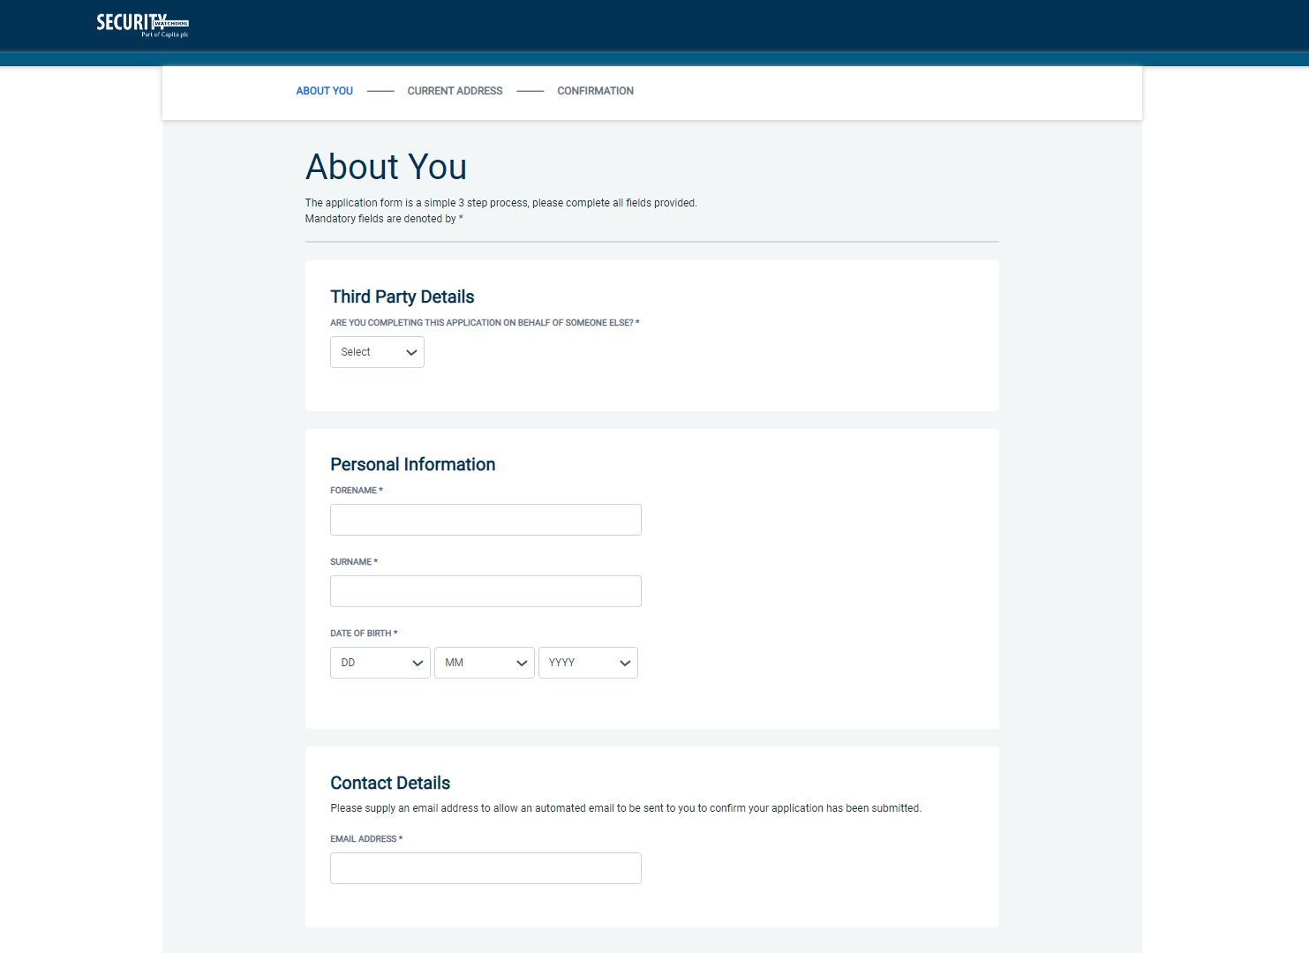

Once you have completed this section click ‘Next’.

Section 2 – Address History

Please enter your current address either using the address lookup tool or manually.

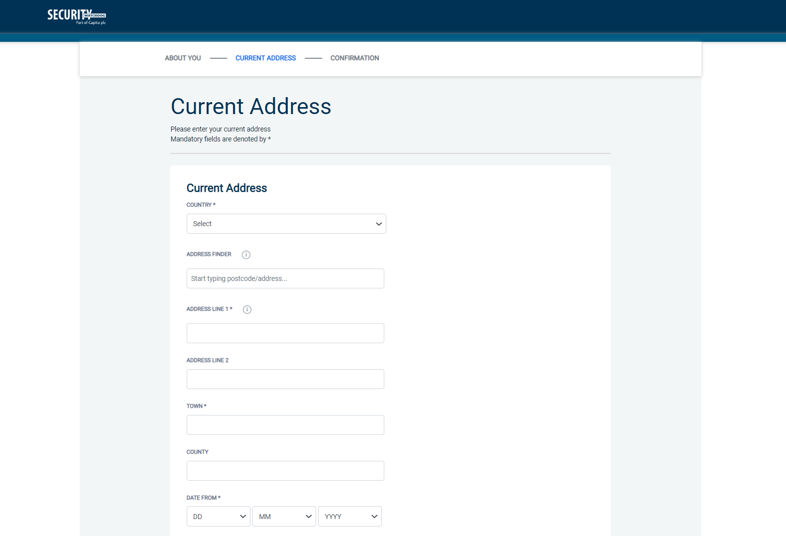

Postcode
Please ensure that a UK address has a full postcode; if you cannot remember your postcode please use the address lookup tool to populate the address by searching using the first line of your address.

Once you have completed this section click ‘Next’.

Section 3 – Confirmation and Consent

Now please read through your application to ensure that there are no omissions/errors before you submit your application. If you wish to edit a section of your application, click on ‘edit’ next to the section of the form that requires changes.
At the end of the application please make sure that you complete the Applicant Consent section.

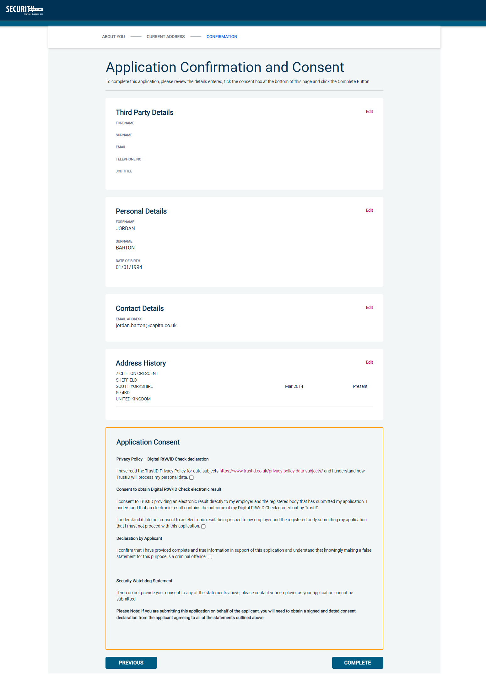

Now click ‘Complete’.

Complete Application

You have now completed your application form and you will be given a submission reference number. Please make a note of this number for reference purposes. You will also receive a confirmation email containing these details and a link to carry out your digital Right to Work check.

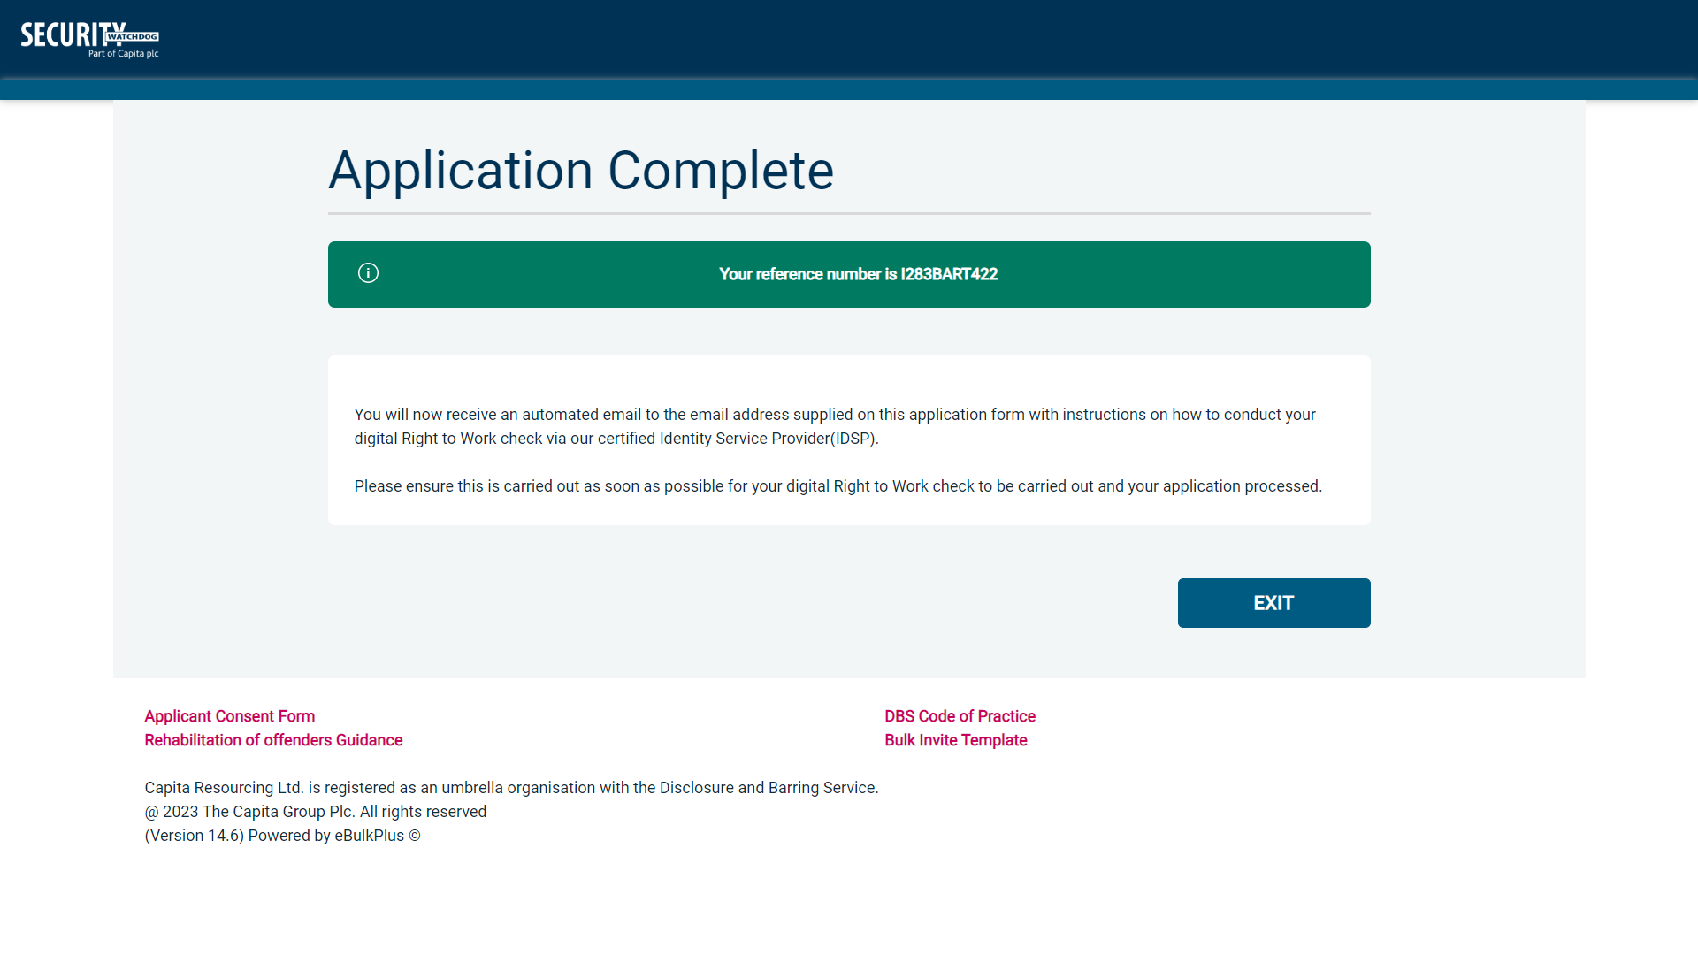

Your application form will be processed once you have carried out your digital Right to Work check via our certified identity service provider (IDSP). Please see below for guidance on what to do next.

Next step – Digital Right to Work Check
You will now receive an automated email upon submission of your application, this will contain your application reference number and a new link to submit your digital Right to Work check.

Please now click this link using a smartphone and follow the on-screen instructions for uploading photos of the necessary documents and your selfie. Once completed your digital Right to Work check will be carried out and the result of this check will be automatically added/uploaded to your Right to Work application.

An email notification will be automatically issued to your employer advising the result of the digital Right to Work check has been added to your application.

CONTACT DETAILS
Please contact XXX if you have any queries regarding the Right to Work application process. If you experience any technical issues with the online system, please contact XXX. Lines open 9.00am-5.30pm Monday to Friday. Alternatively, you can contact us by e-mail at XXX

